

**AWS Project**

**Group Name:** Strangers

**Team Members**:

Siddharth Singh Rathour

Swati Suman

Sahana M

Anmol Kumar Singh

**Problem Statement shown in the diagram:**

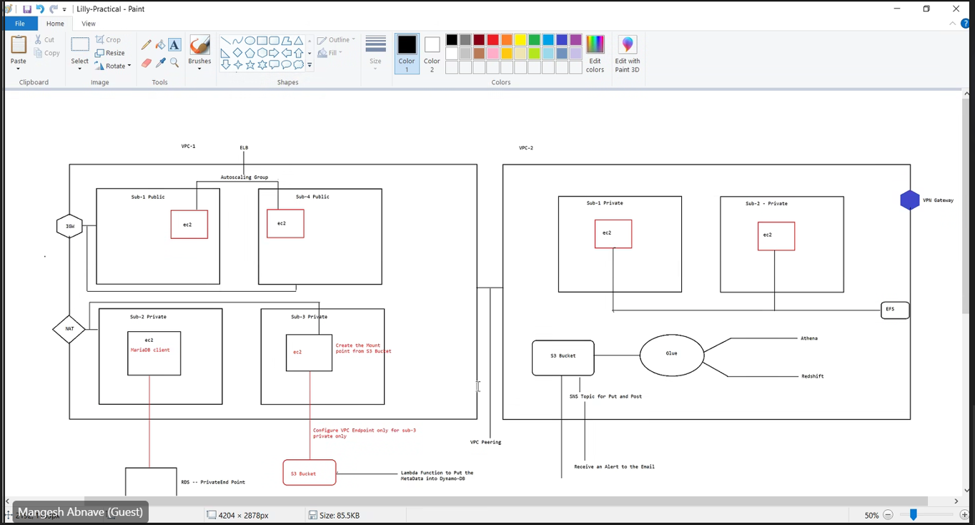

**Step 1:** Created a public VPC. VPC Name: Stranger-vpc1

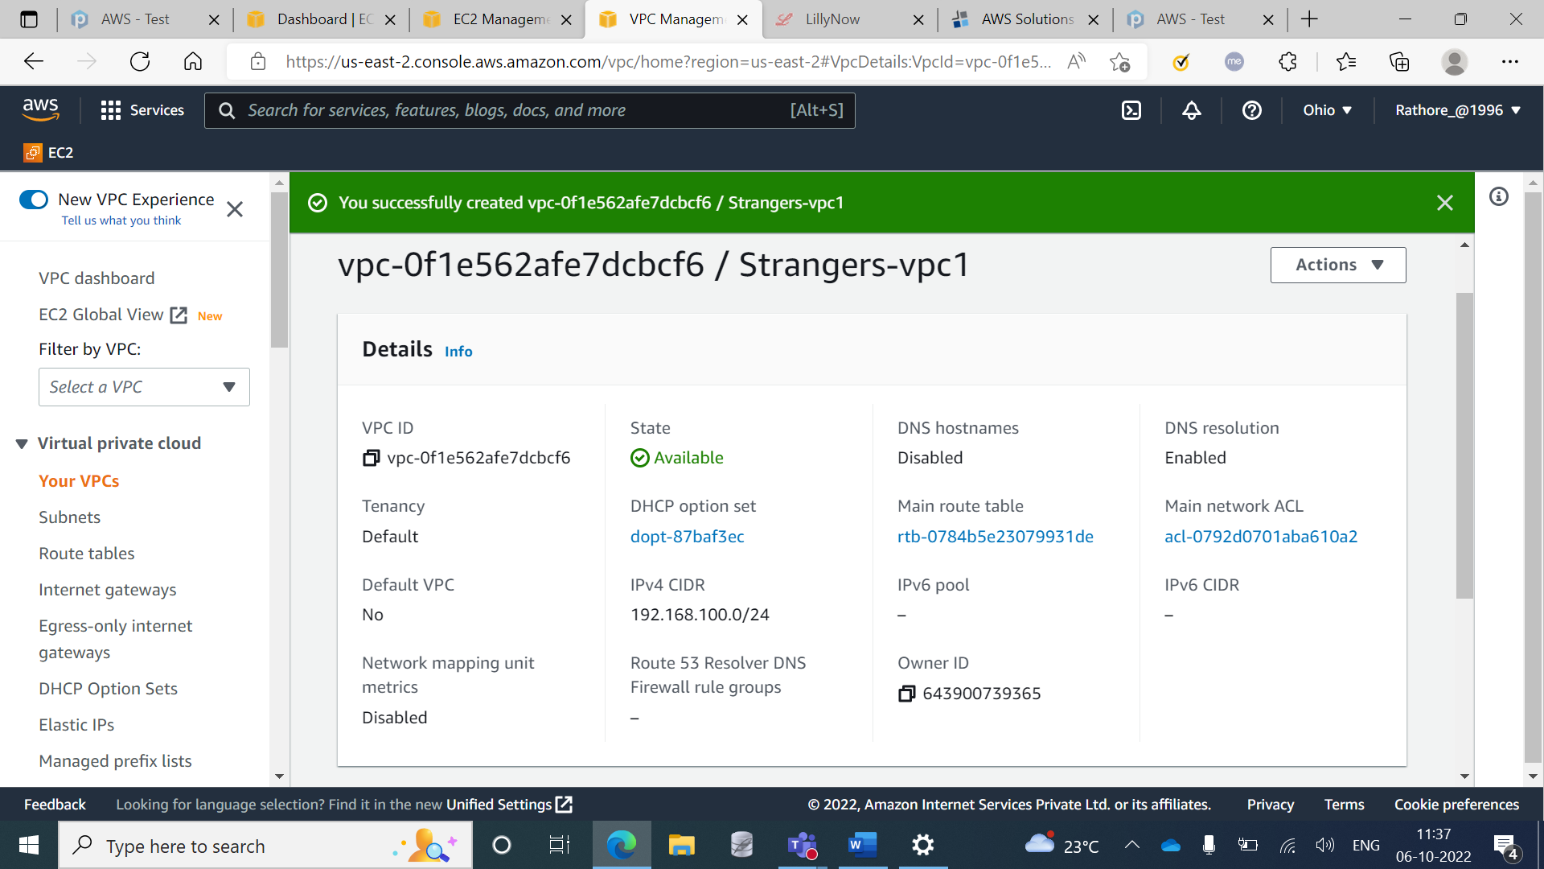

**Step 2:** Created a public VPC. VPC Name: Strangers-vpc2

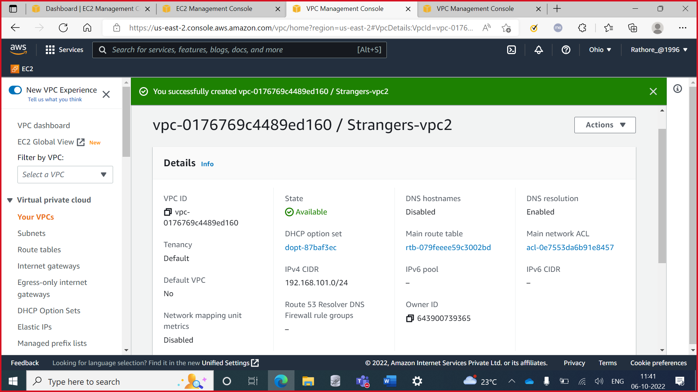

**Step 3:** Created two public subnets. Subnet Name: strangers-public1 and strangers-public2

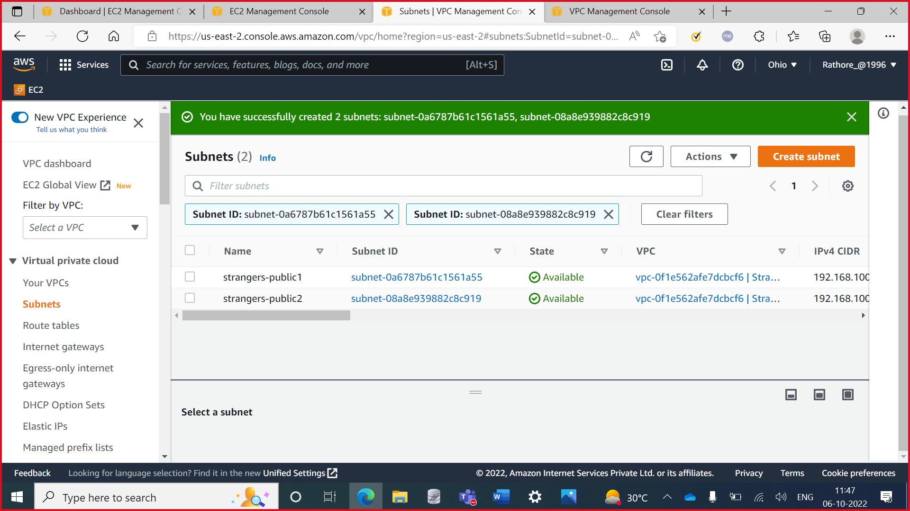

**Step 4:** Created two private subnets. Subnet Name: strangers-private1 and strangers-private2

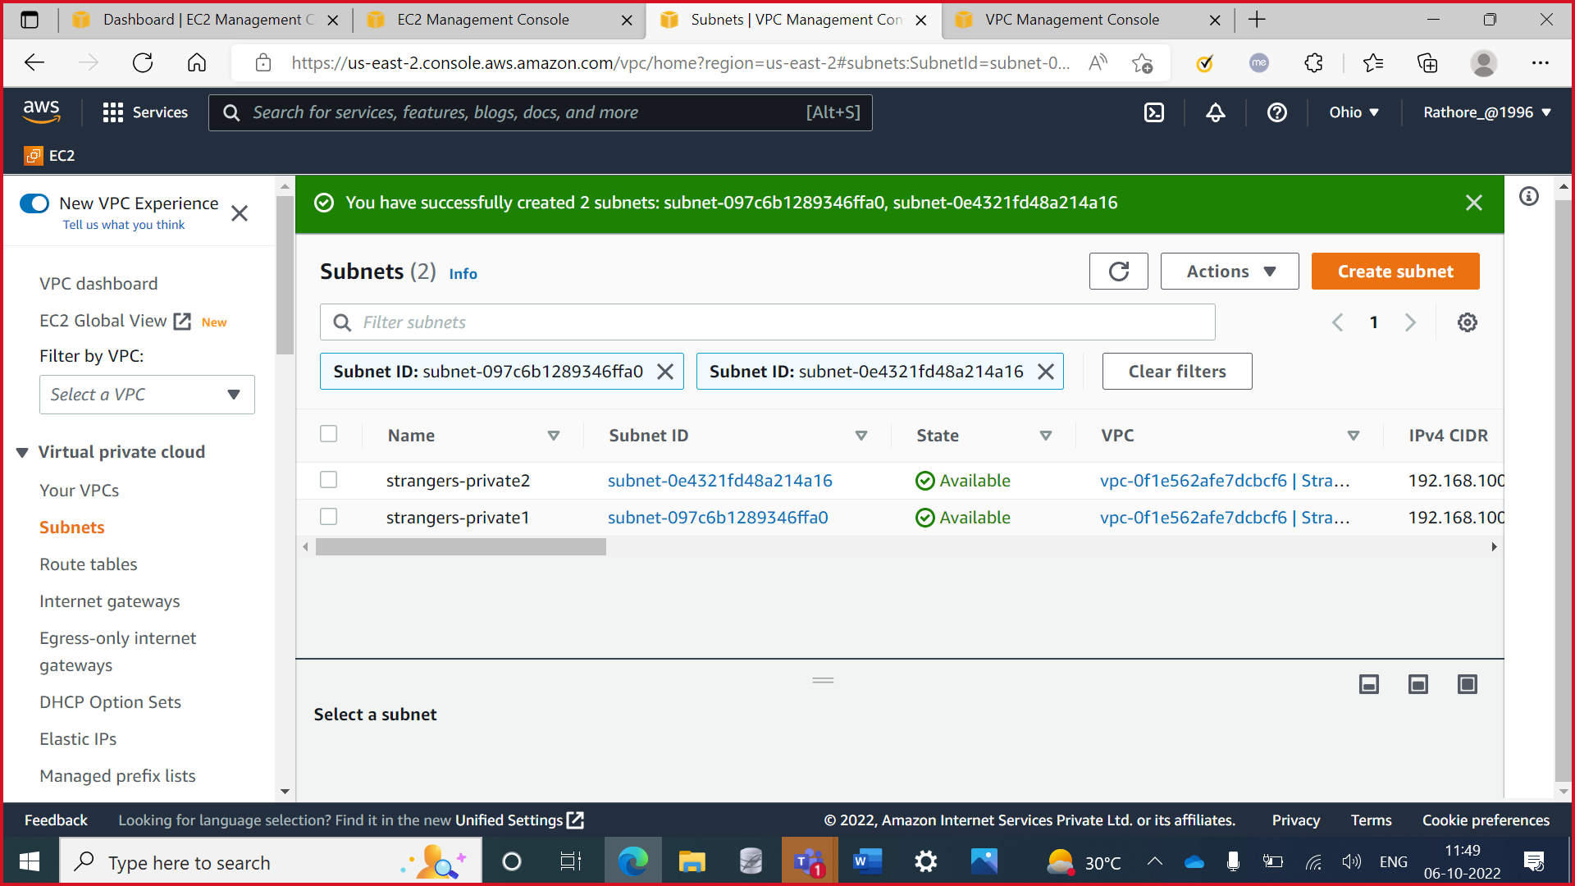

**Step 5:** Created security group. Security group name: strangers-security-group

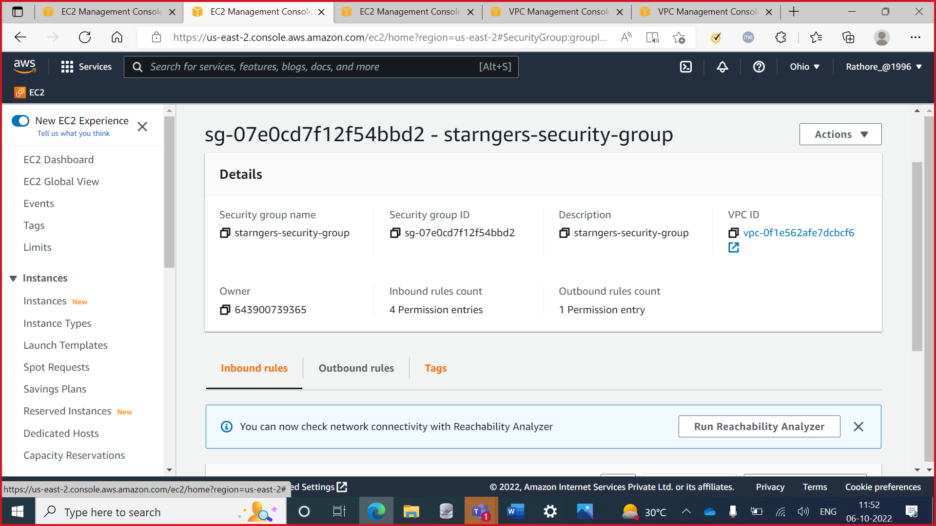

**Step 5:** Public Instance1

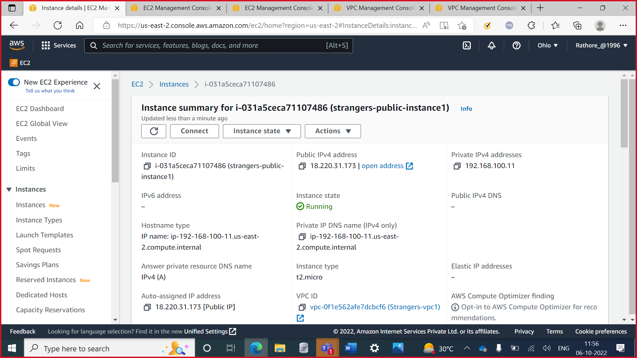

**Step 6:** Public Instance2

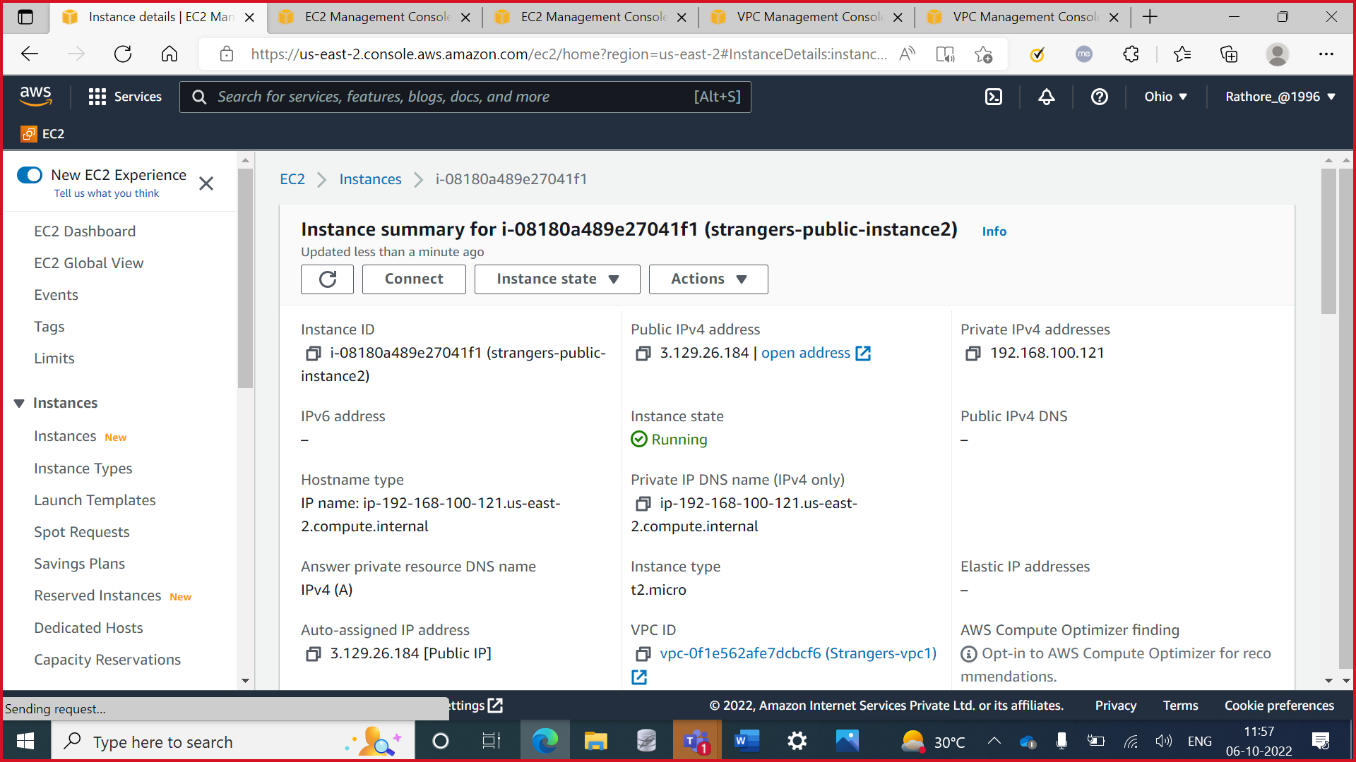

**Step 7:** Private Instance1

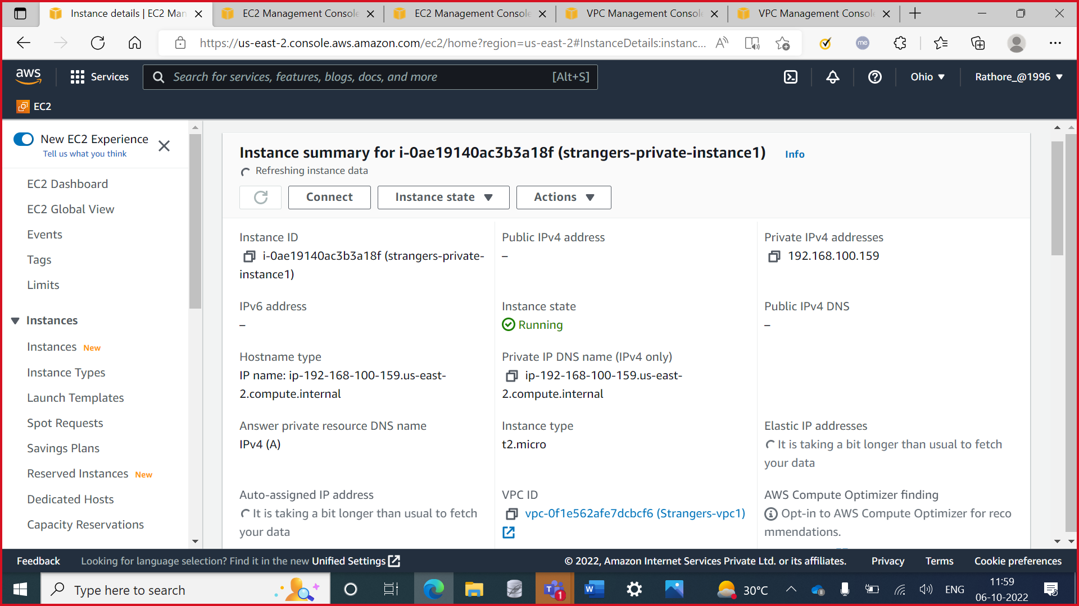

**Step 8:** Private Instance2

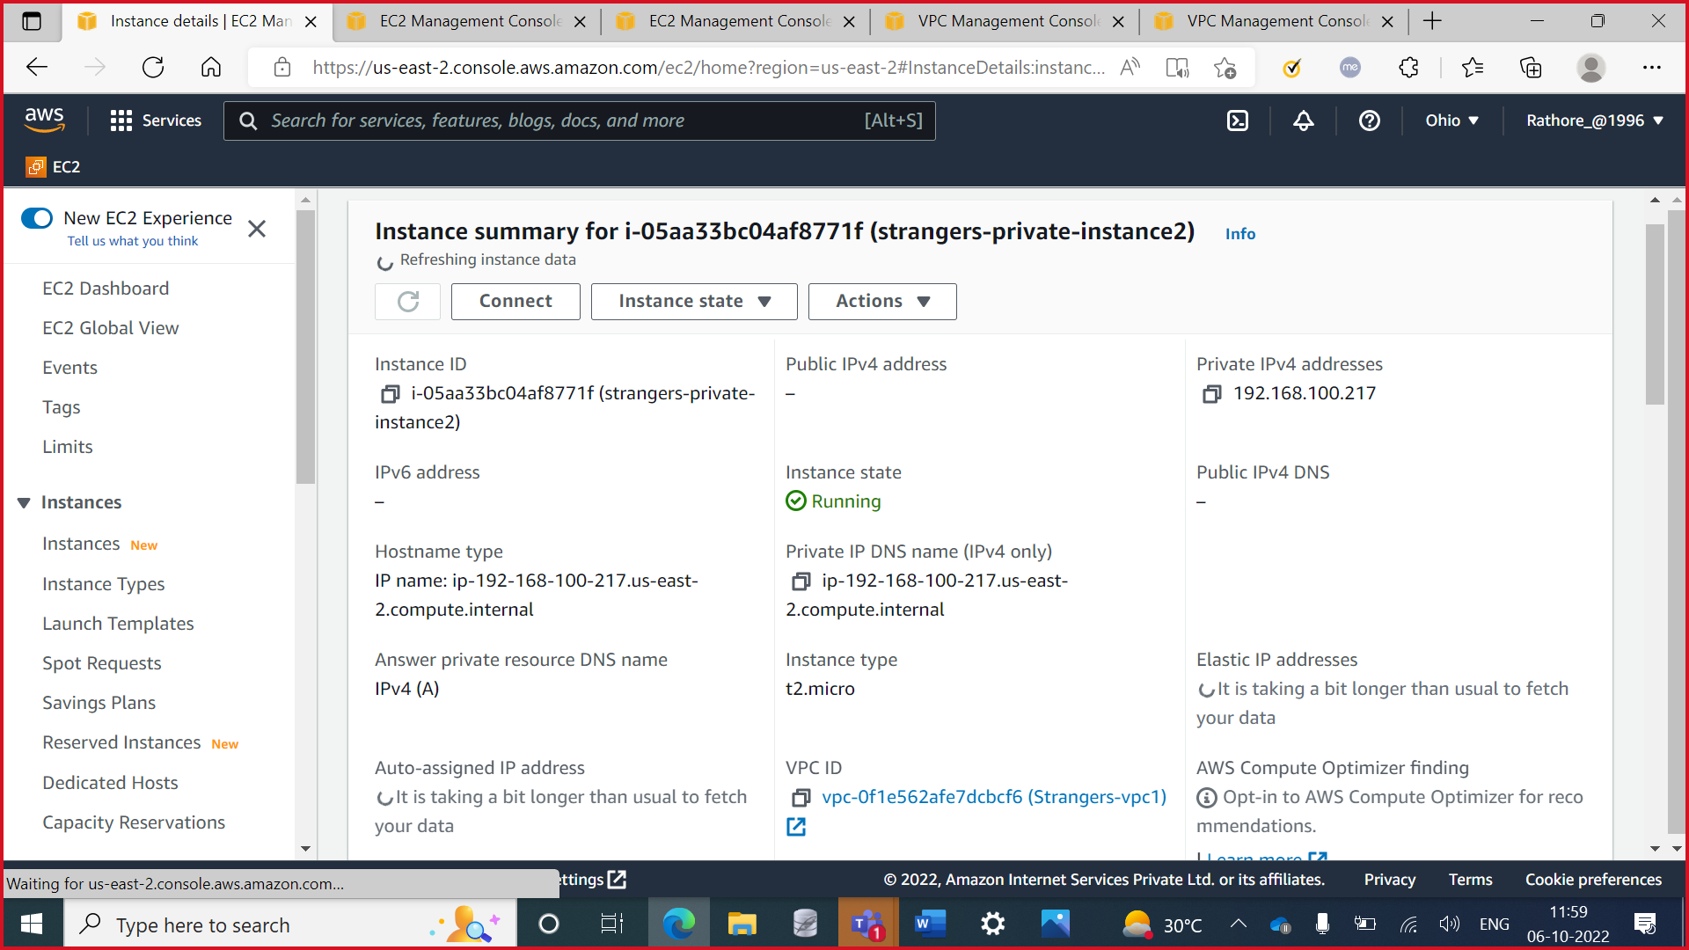

**Step 8:** Private Instance2

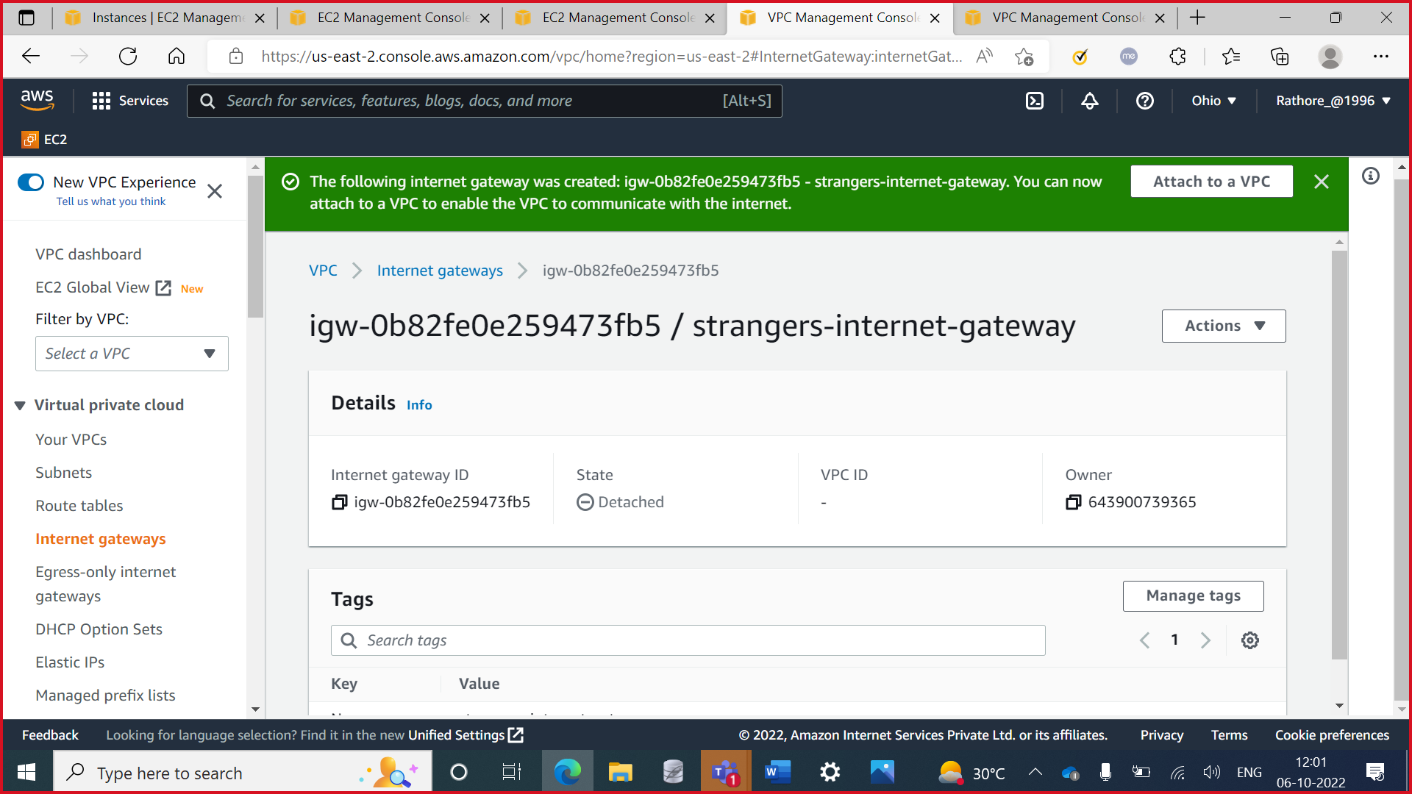

**Step 9:** Route table for private subnets

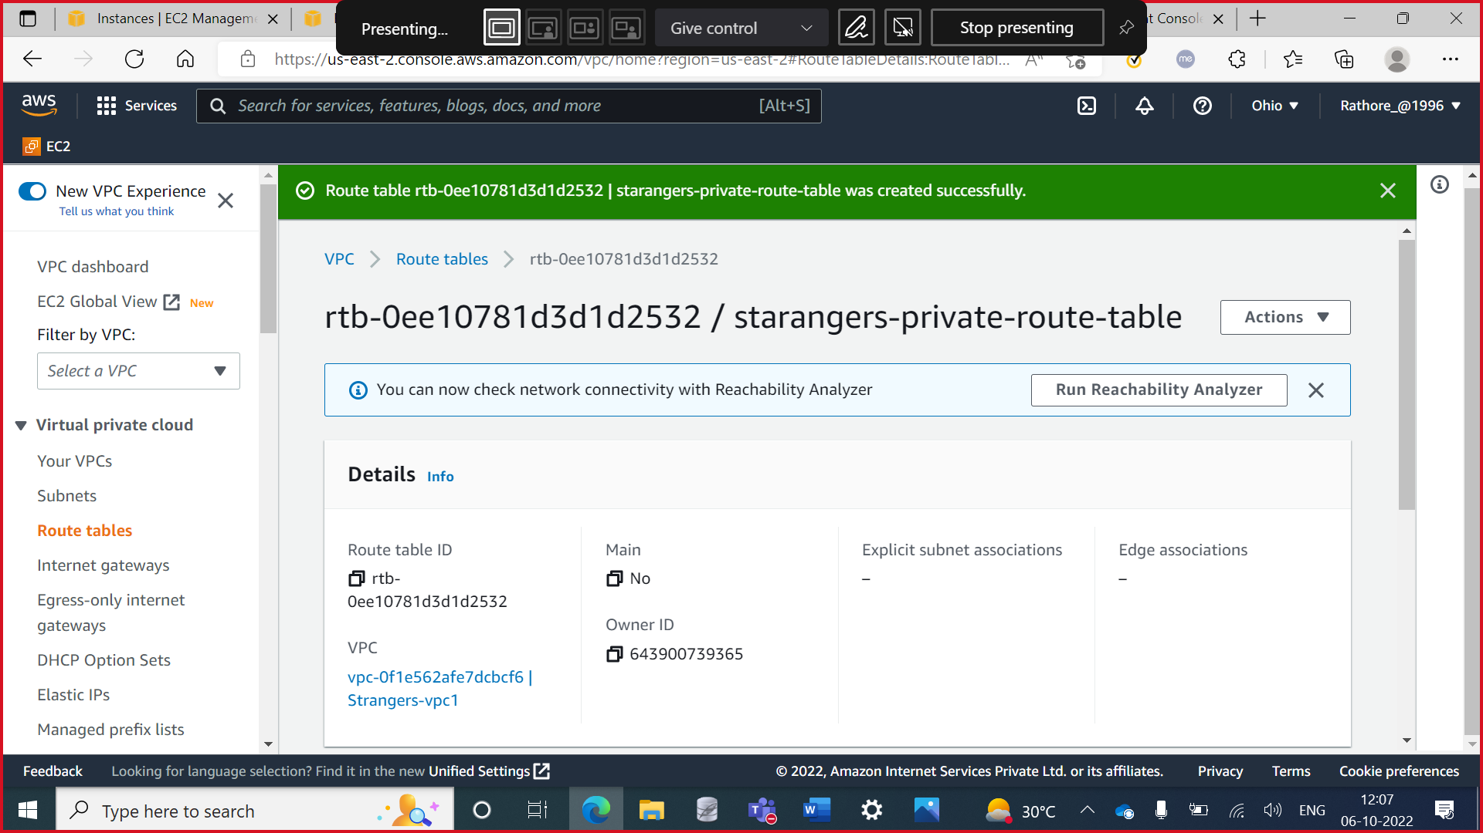

**Step 10:** Route table for public subnets

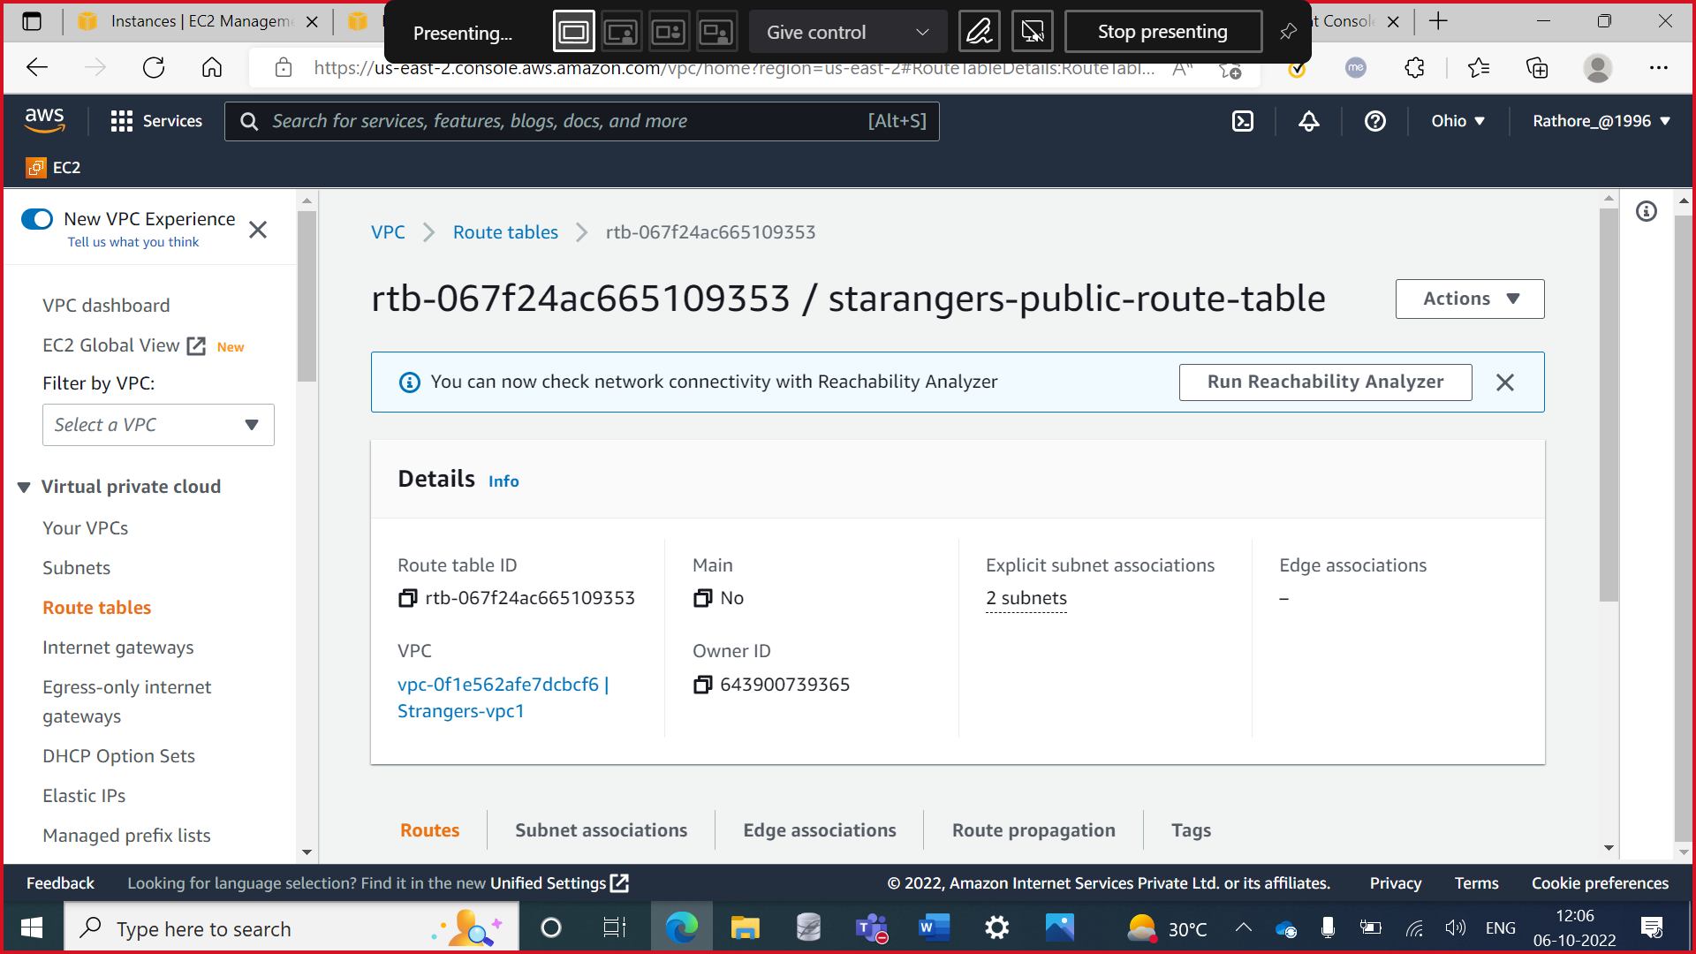

**Step 11:** Internet gateway for public route table

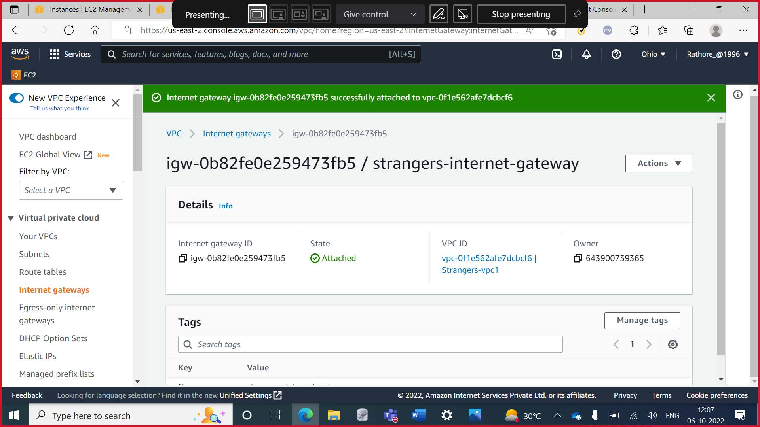

**Step 11:** NAT gateway for private route table

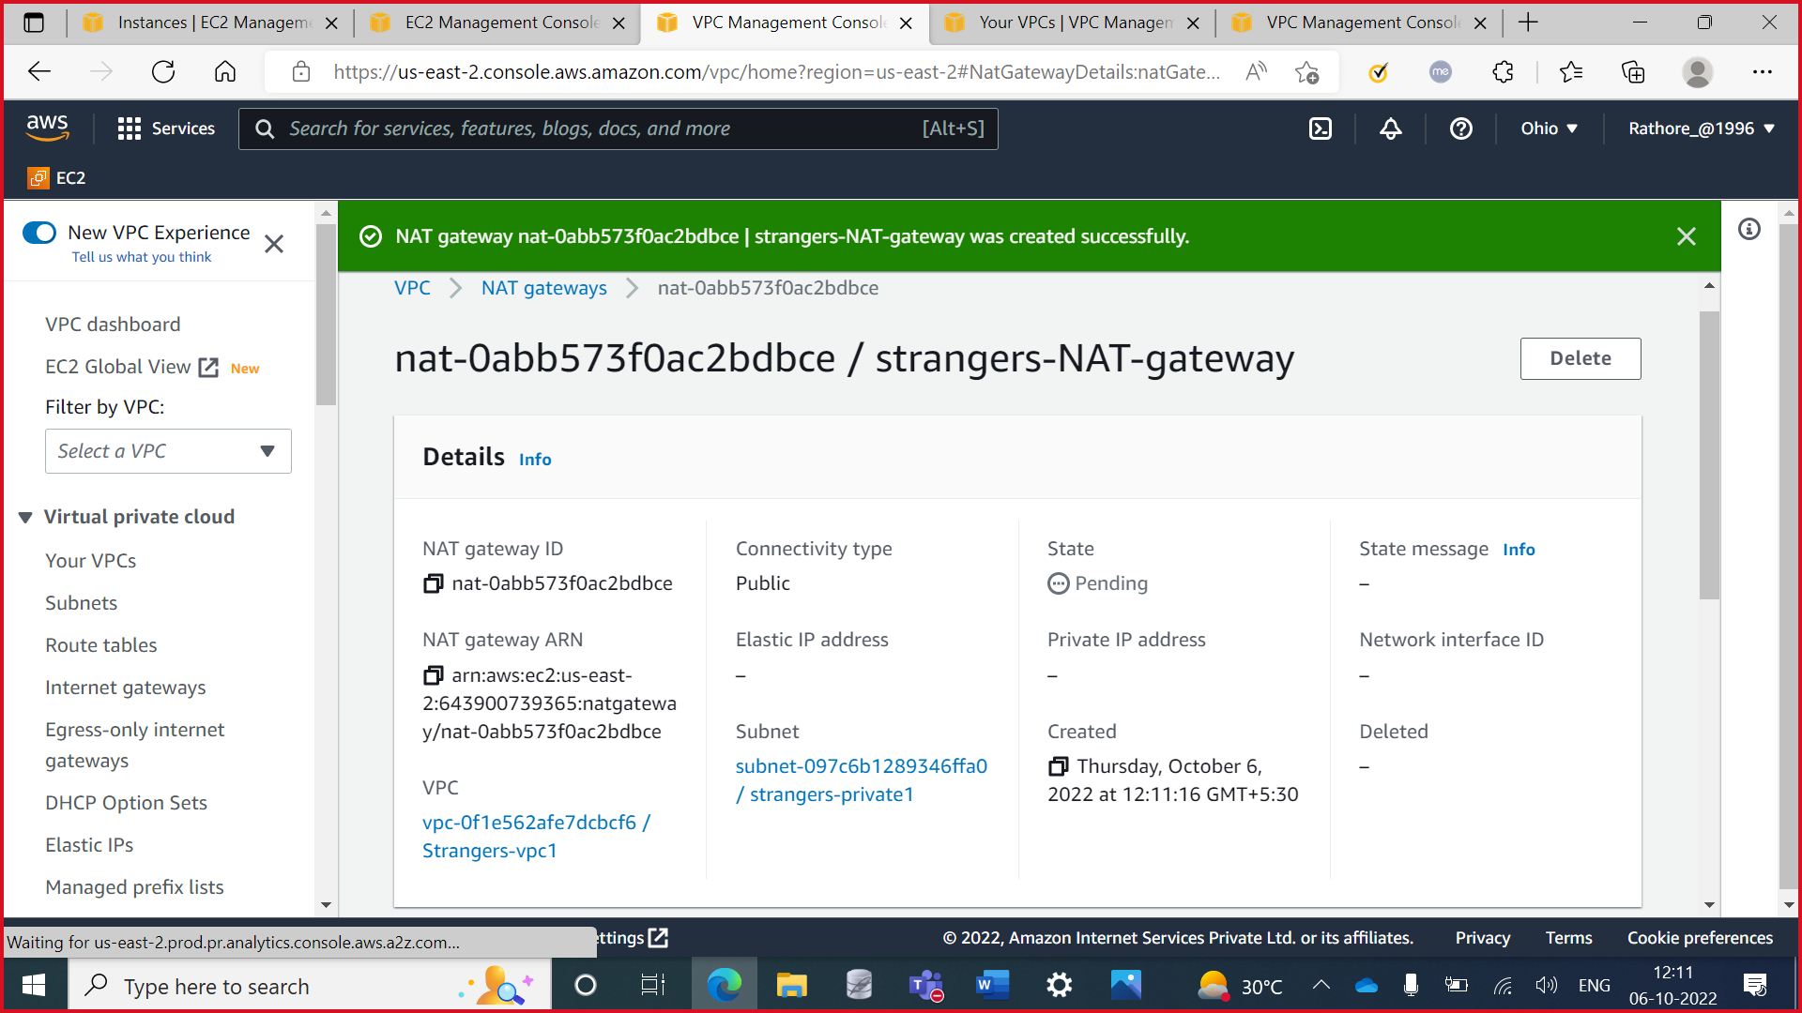

**Step 12:** Subnets associations for private route table

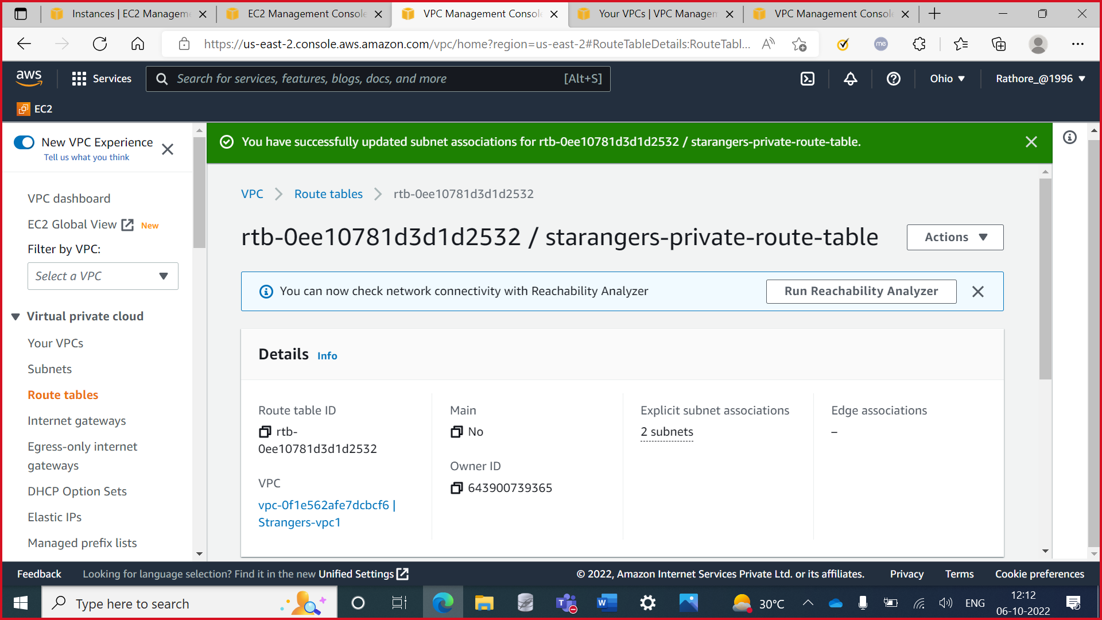

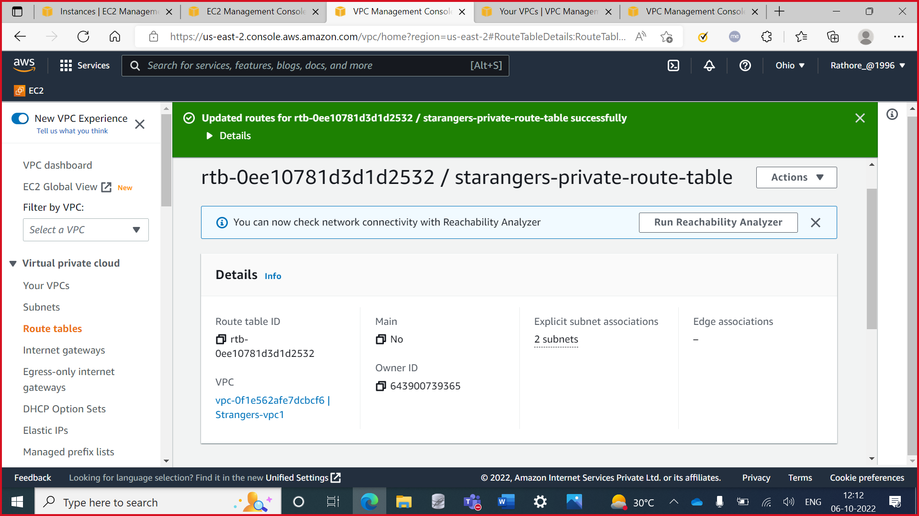

**Step 13:** Connected EC2 instance using ssh

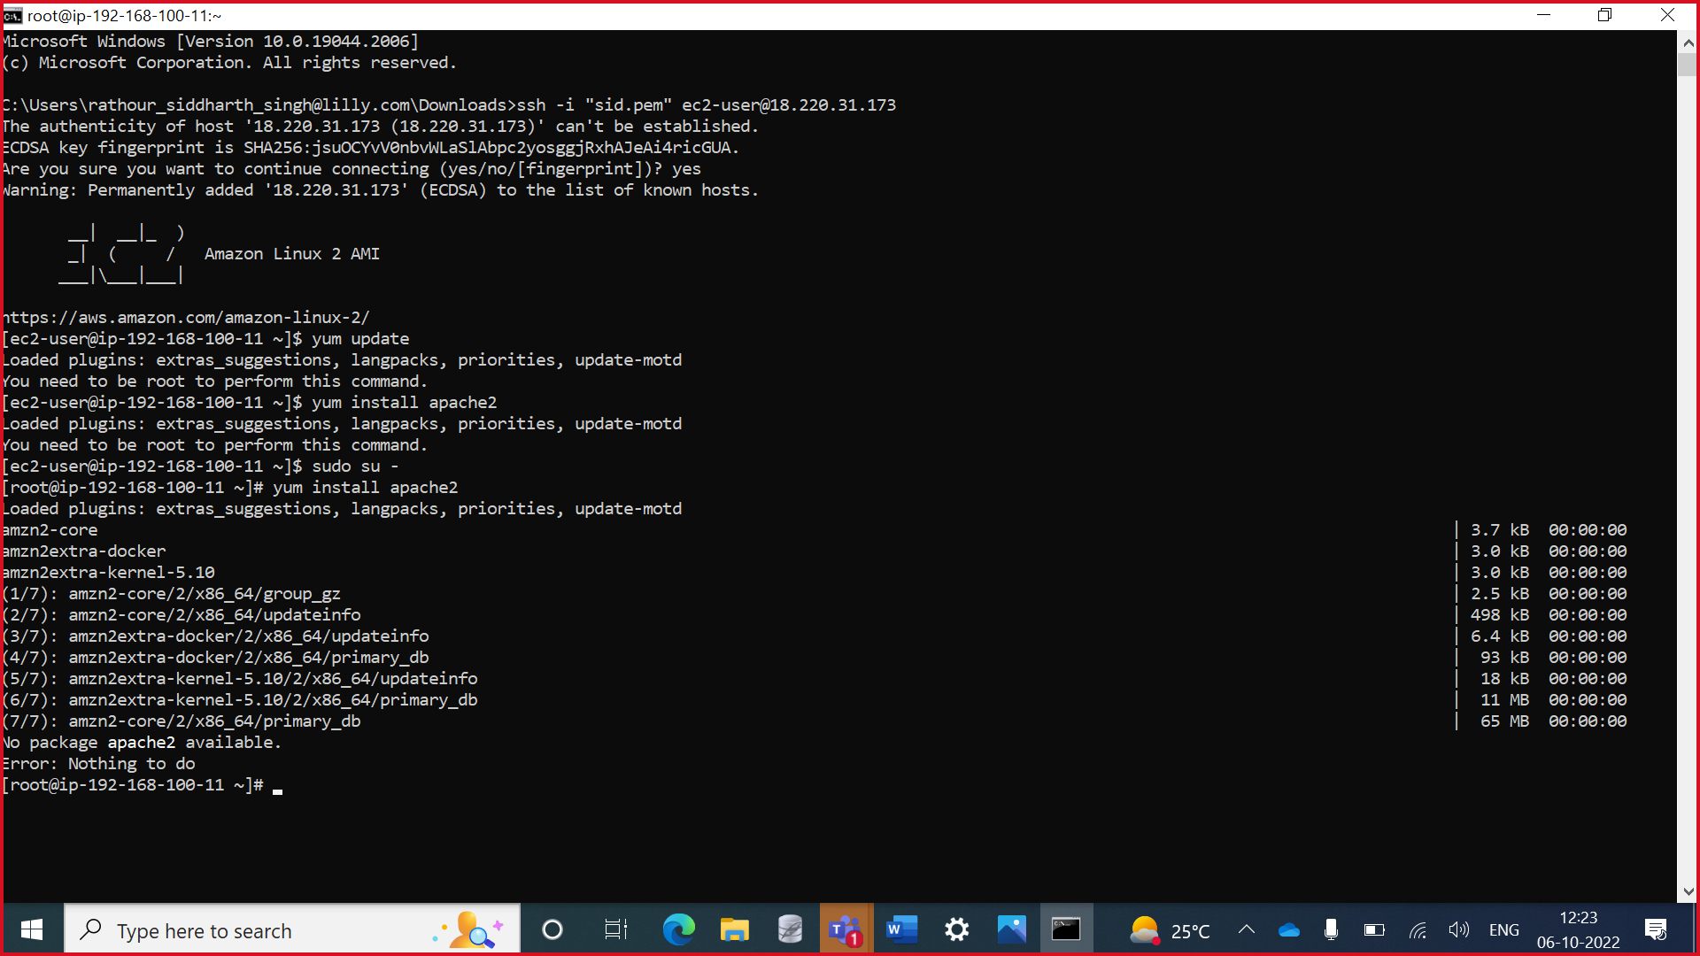

**Step 12:** Installing the dependencies

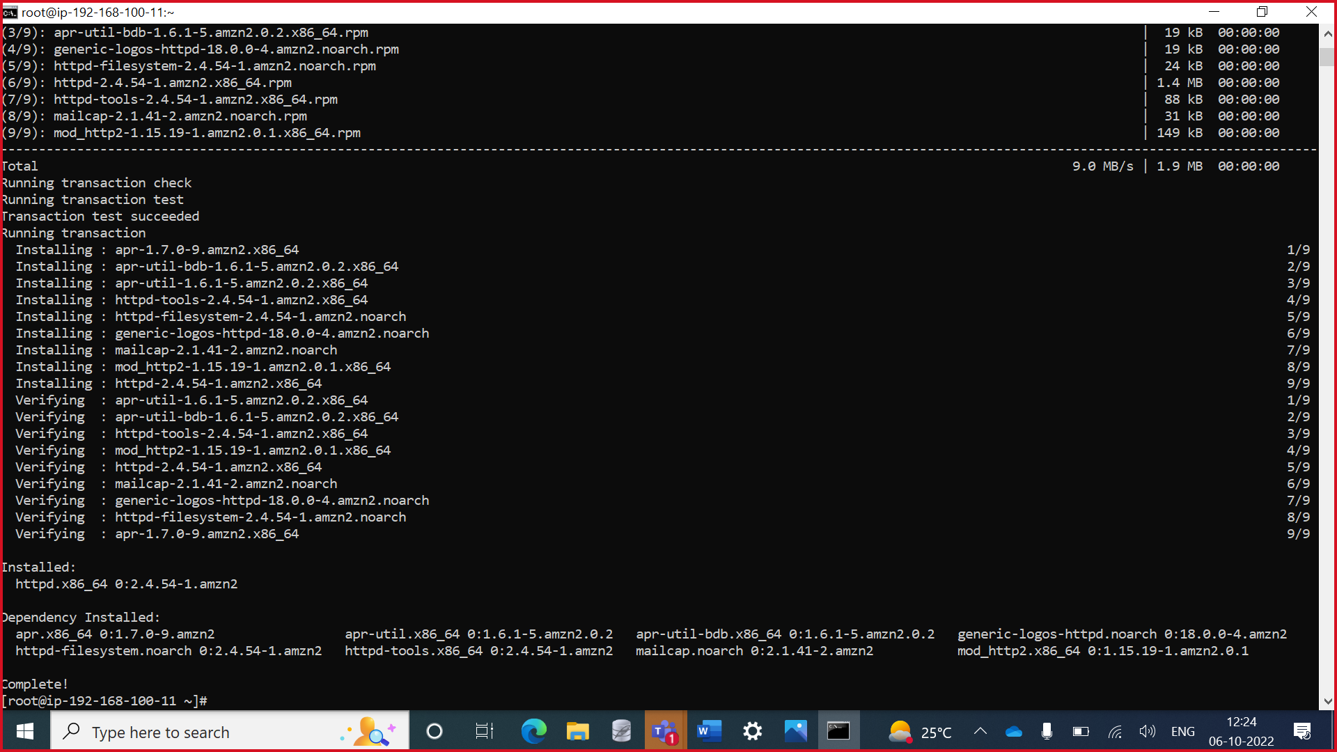

**Step 13:** Checking the status of httpd

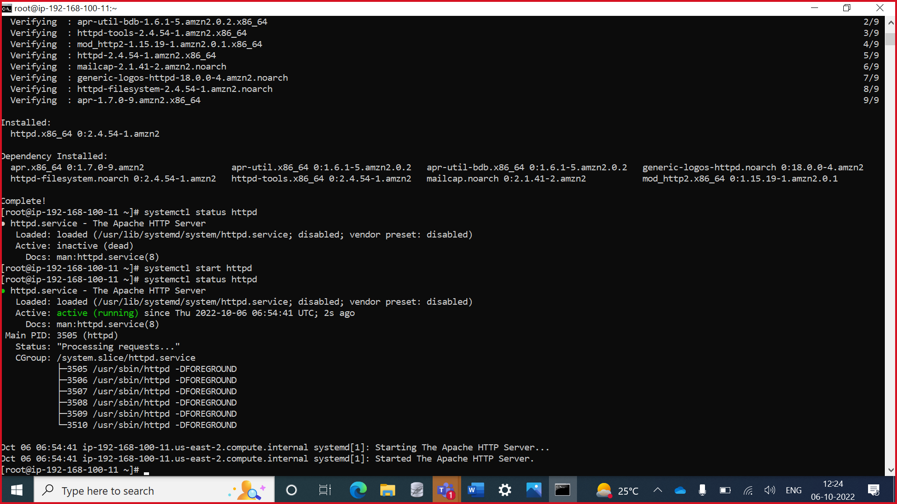

**Step 14:** Enabling the httpd server

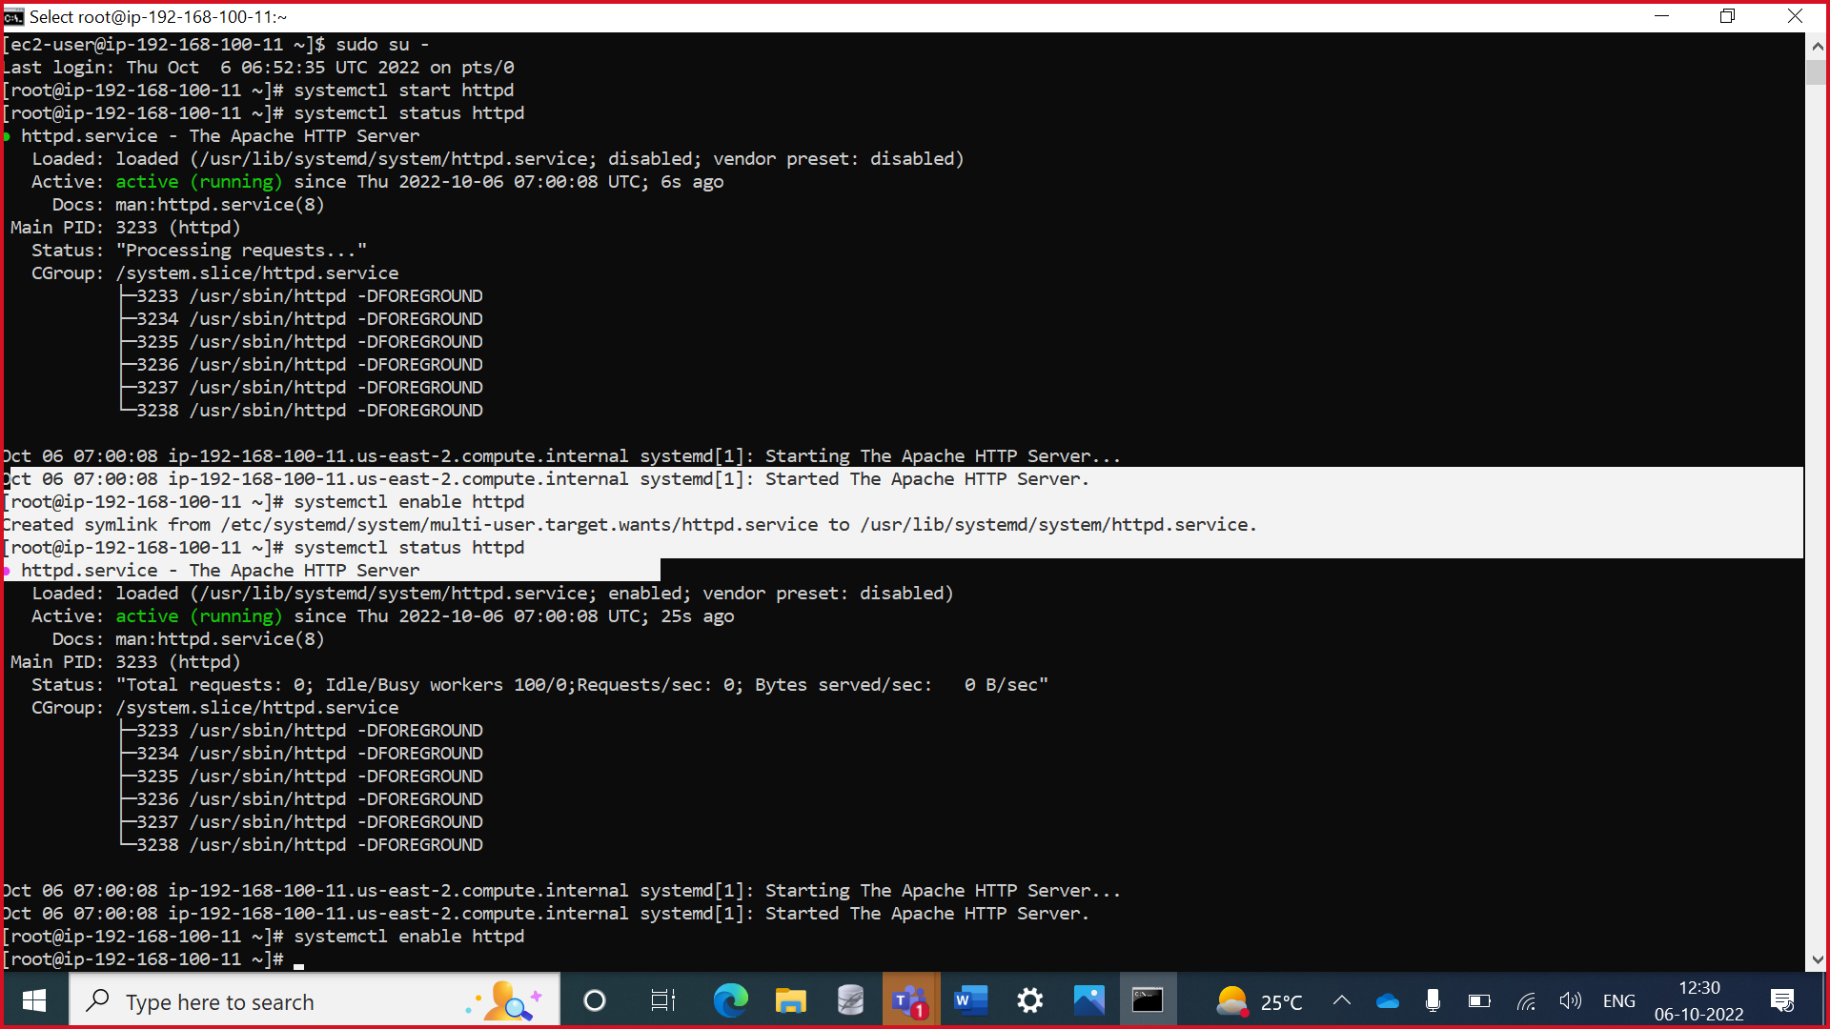

**Step 15:** Image of the public Instance 1

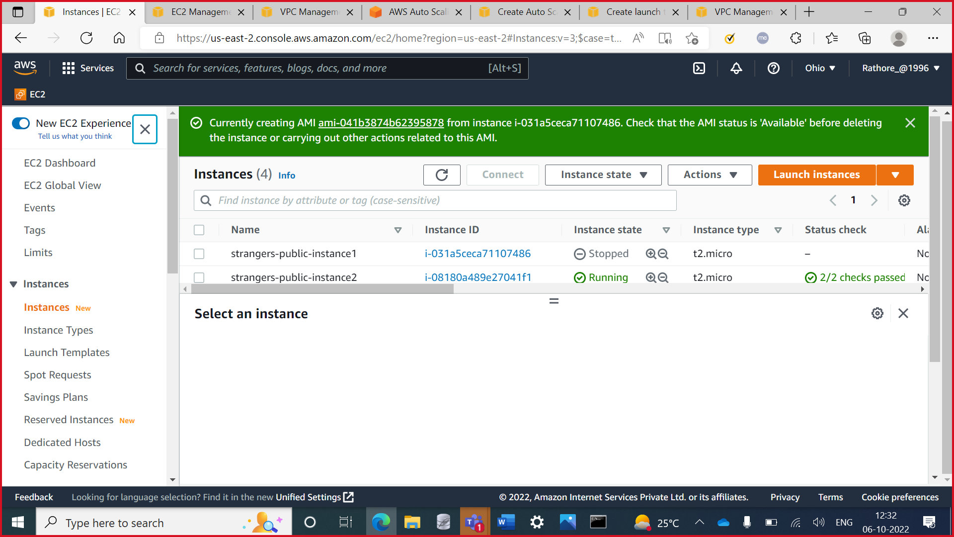

**Step 16:** Template required for the auto-scaling

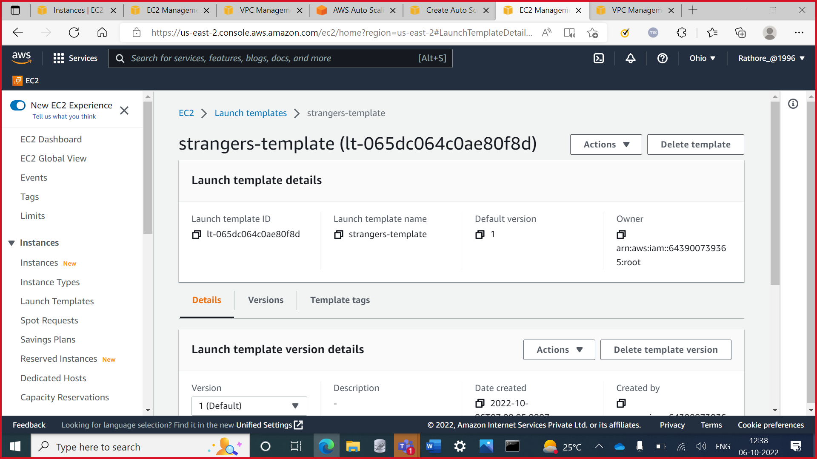

**Step 17:** Target group

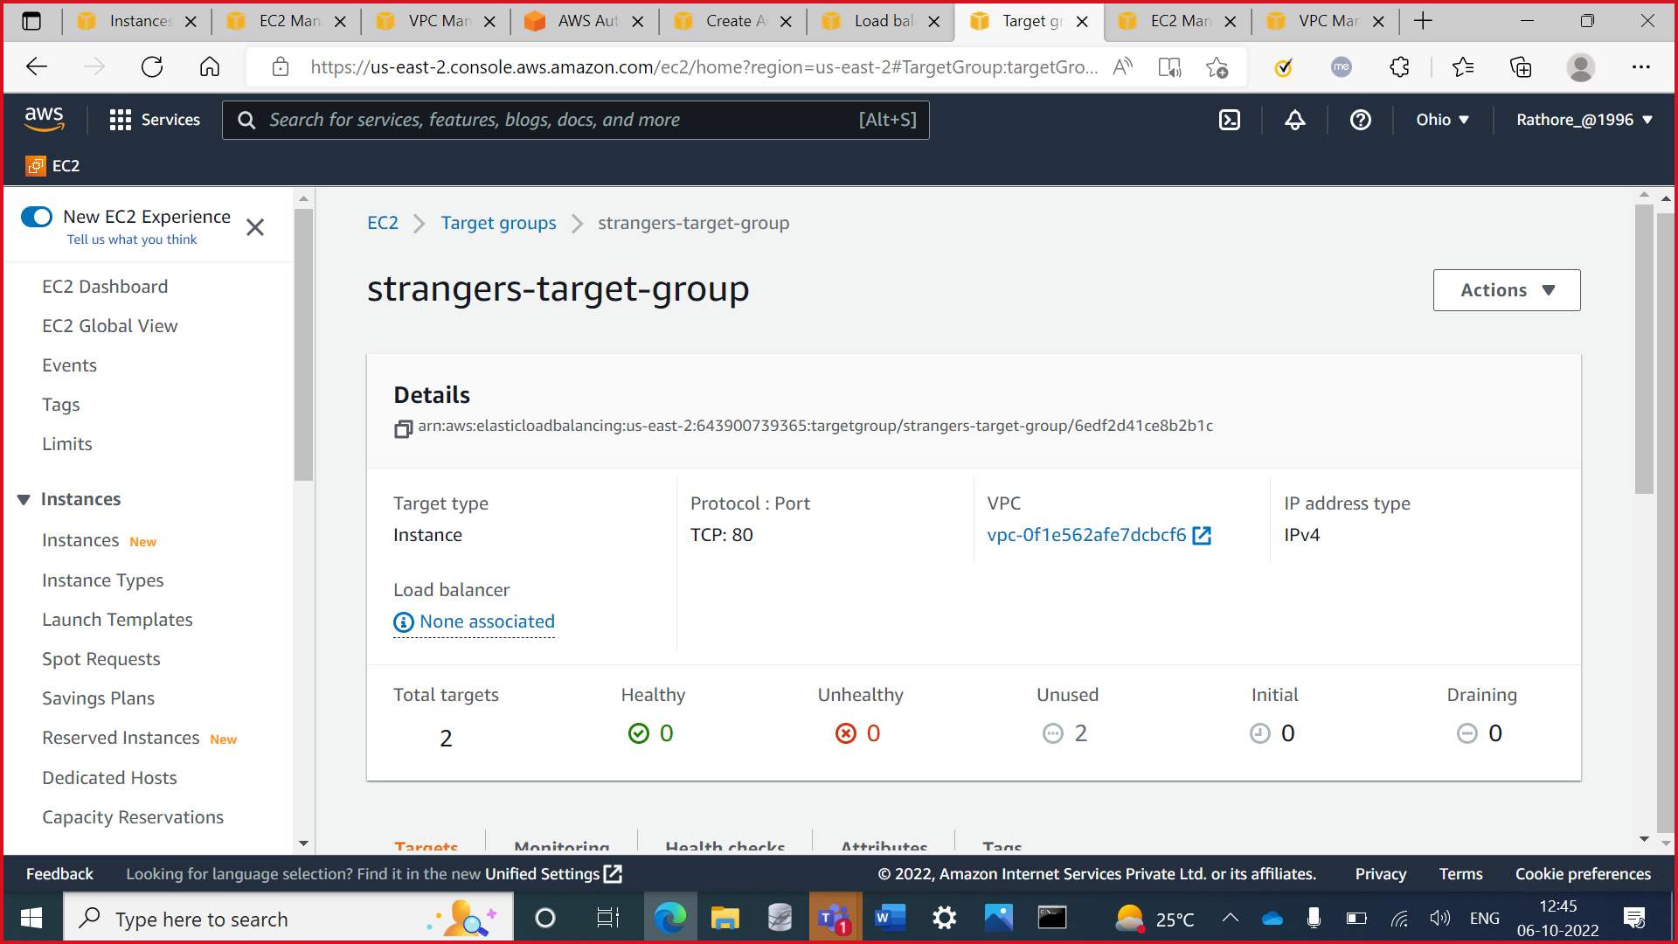

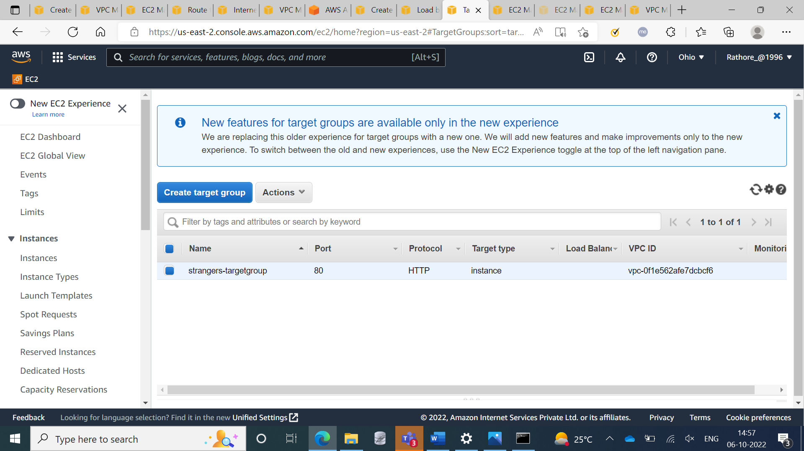

**Step 18:** Load Balancer

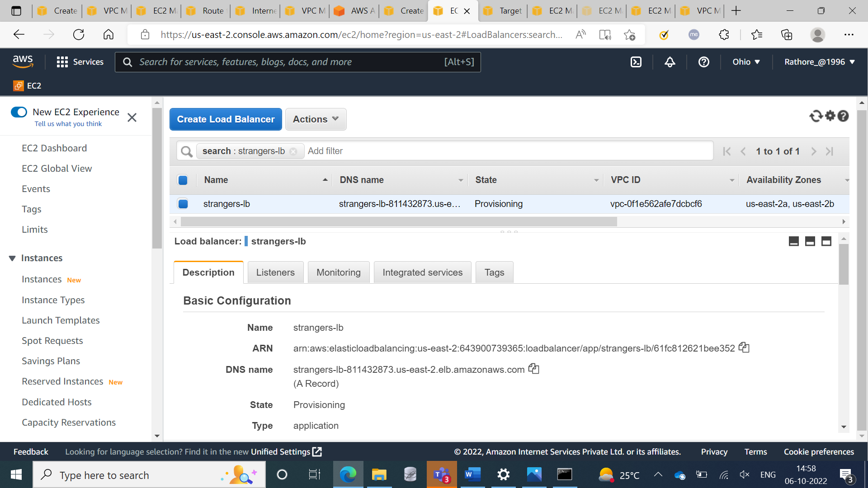

**Step 18:** Auto Scaling group

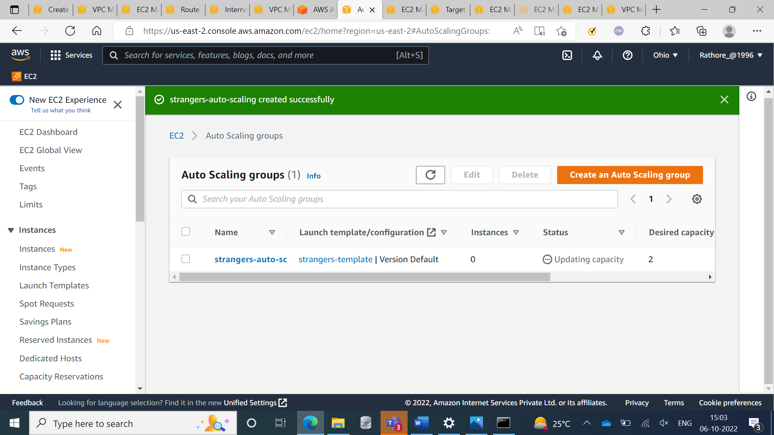

**Step 19:** Auto Scaling group

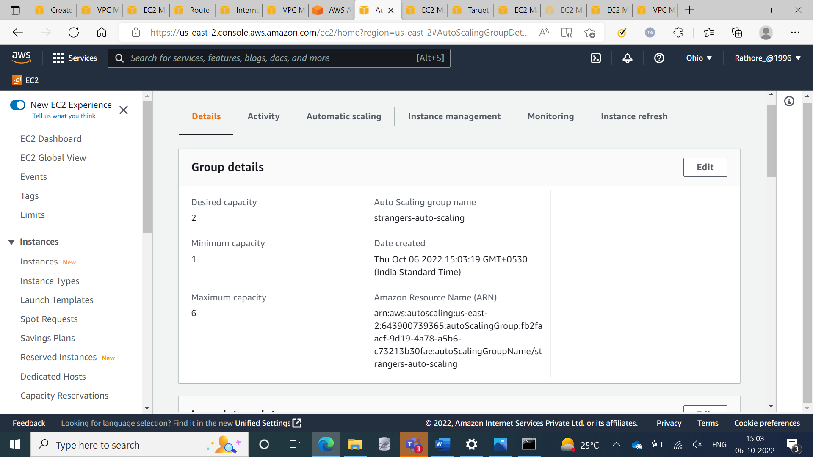

**Step 20:** Showing the Instances

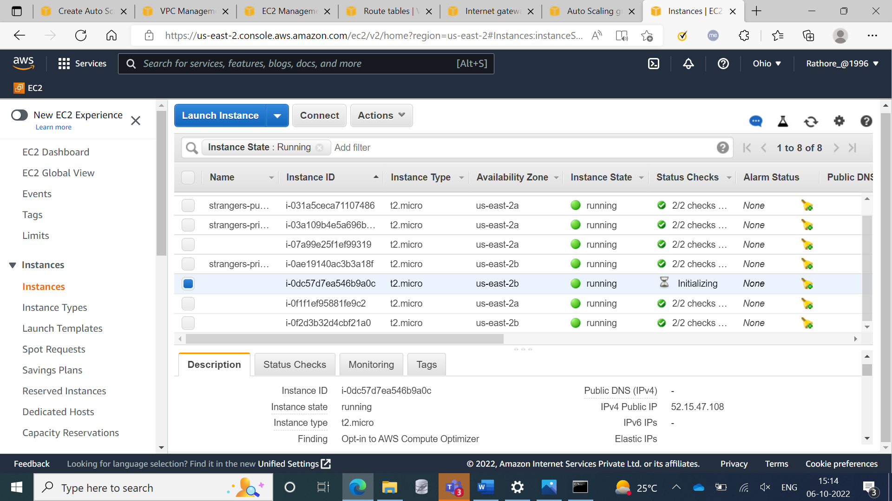

**Step 21:** Testing the Auto Scaling

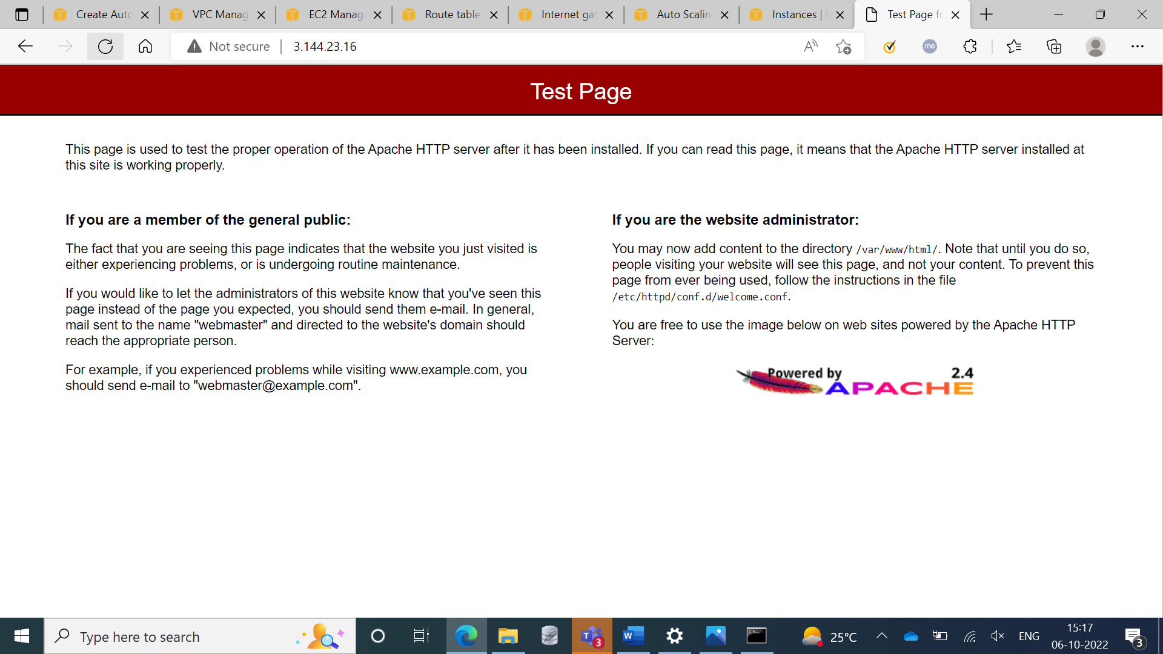

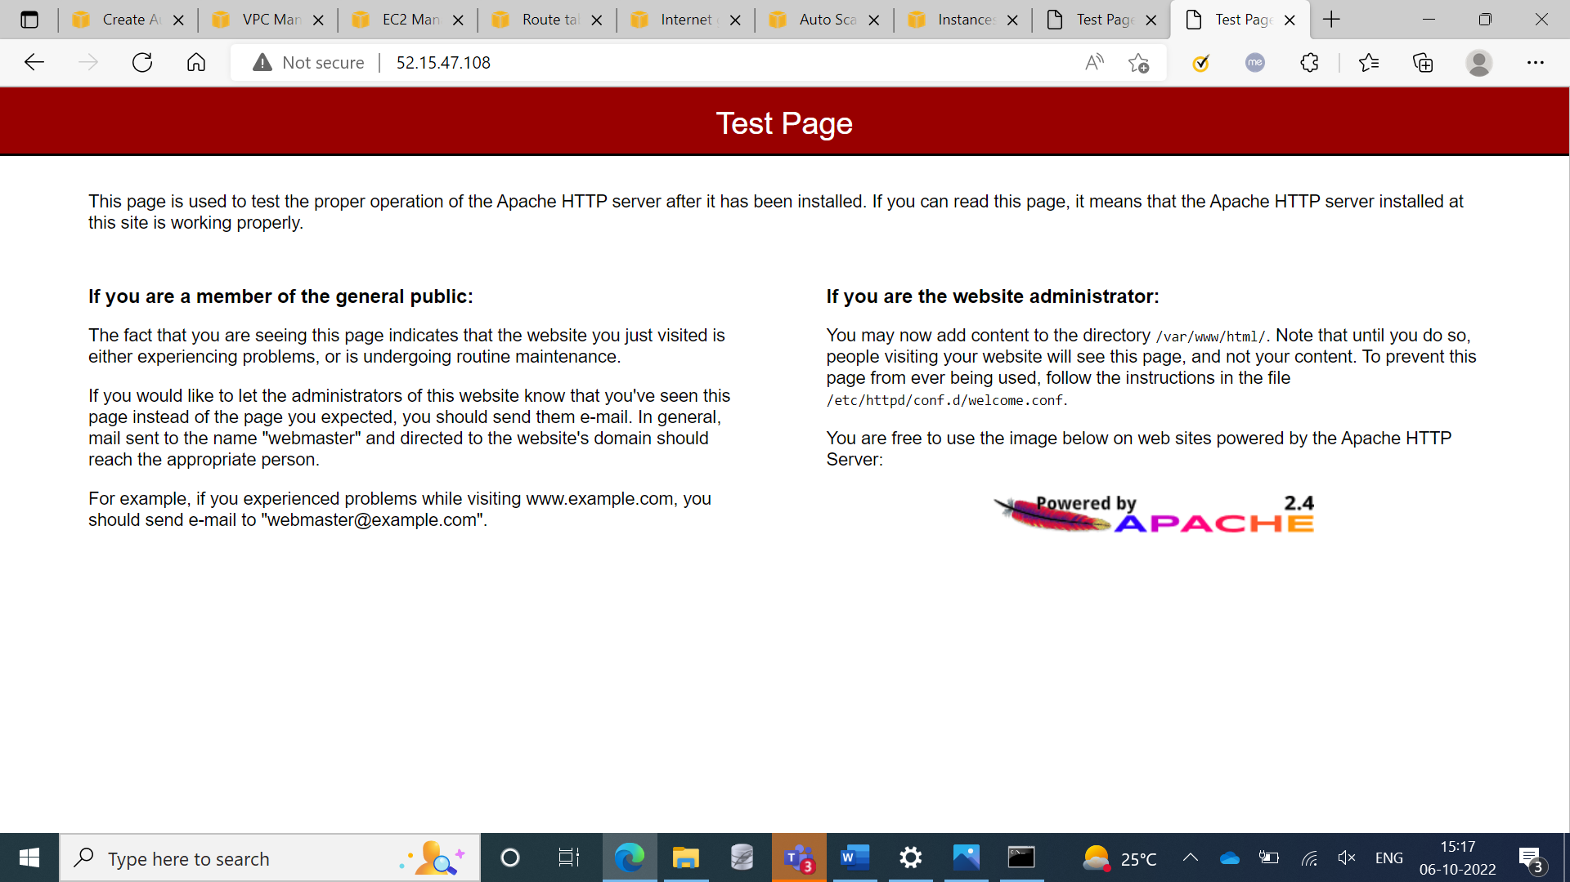

**Step 22:** Showing the Auto Scaling

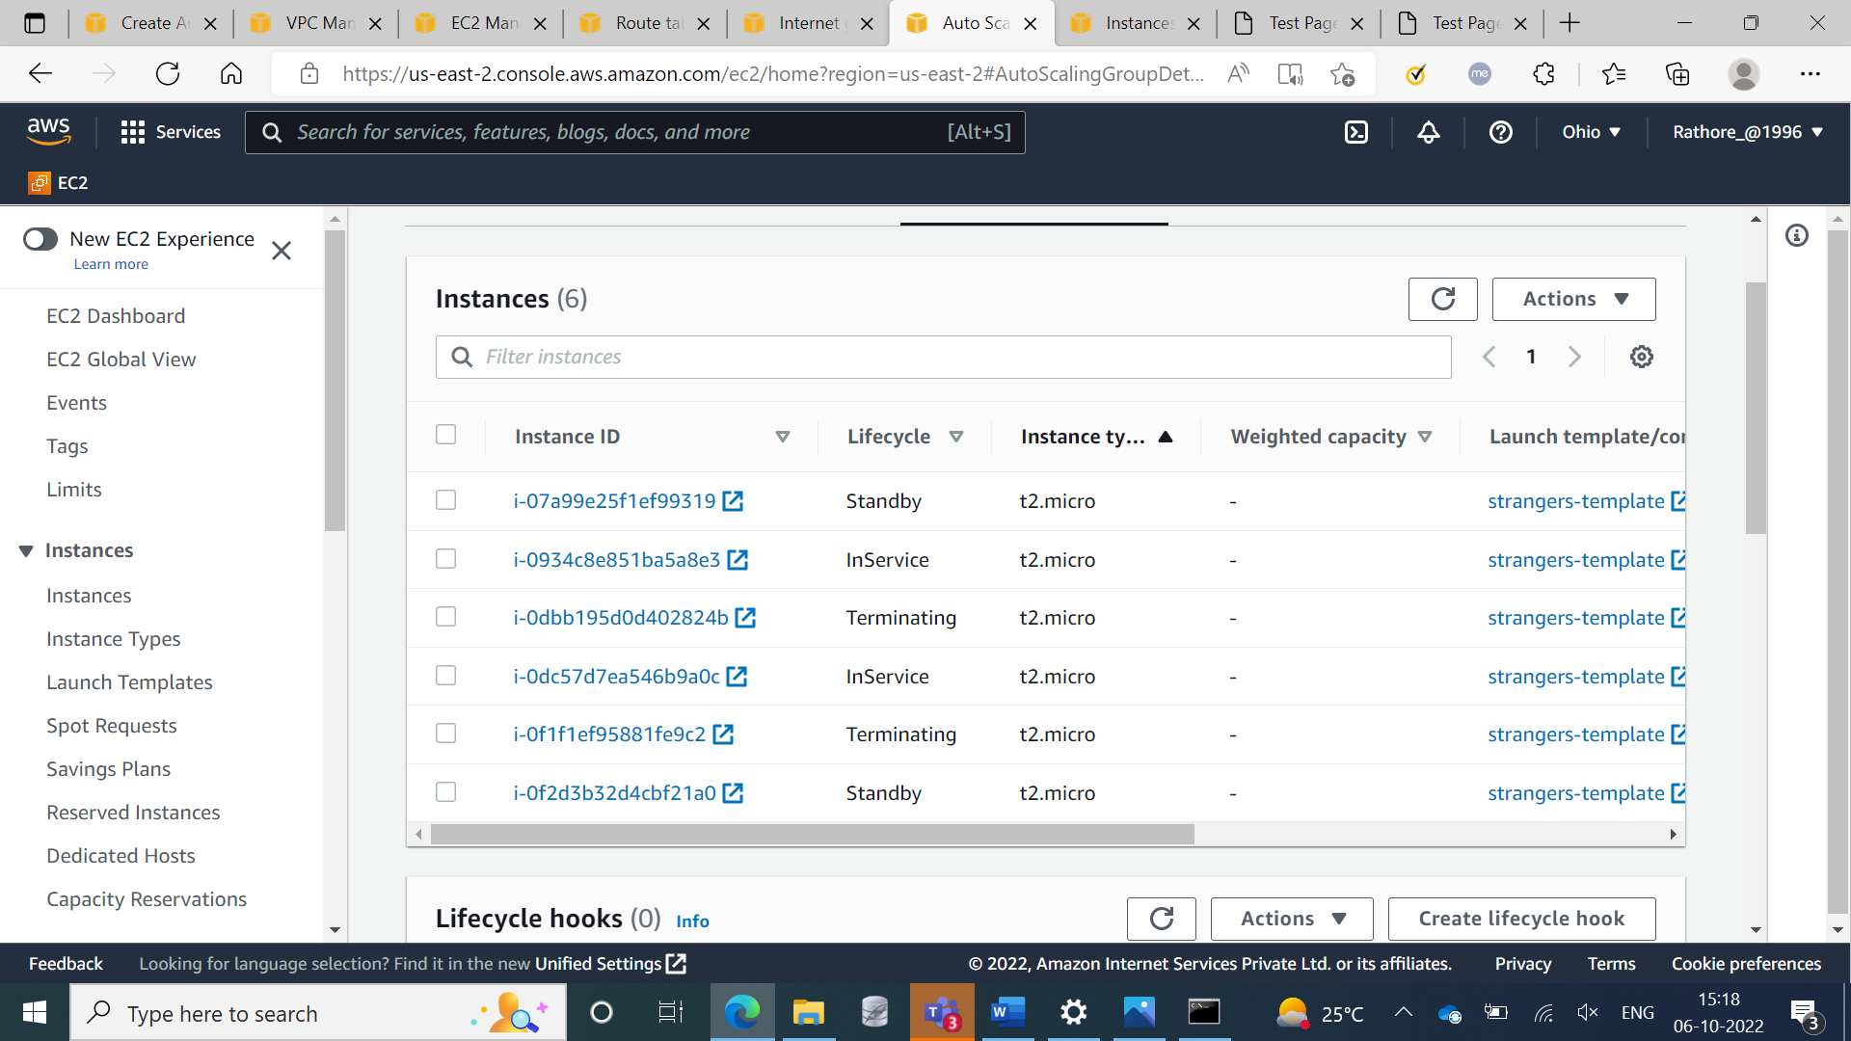

**Step 23:** Created Endpoints

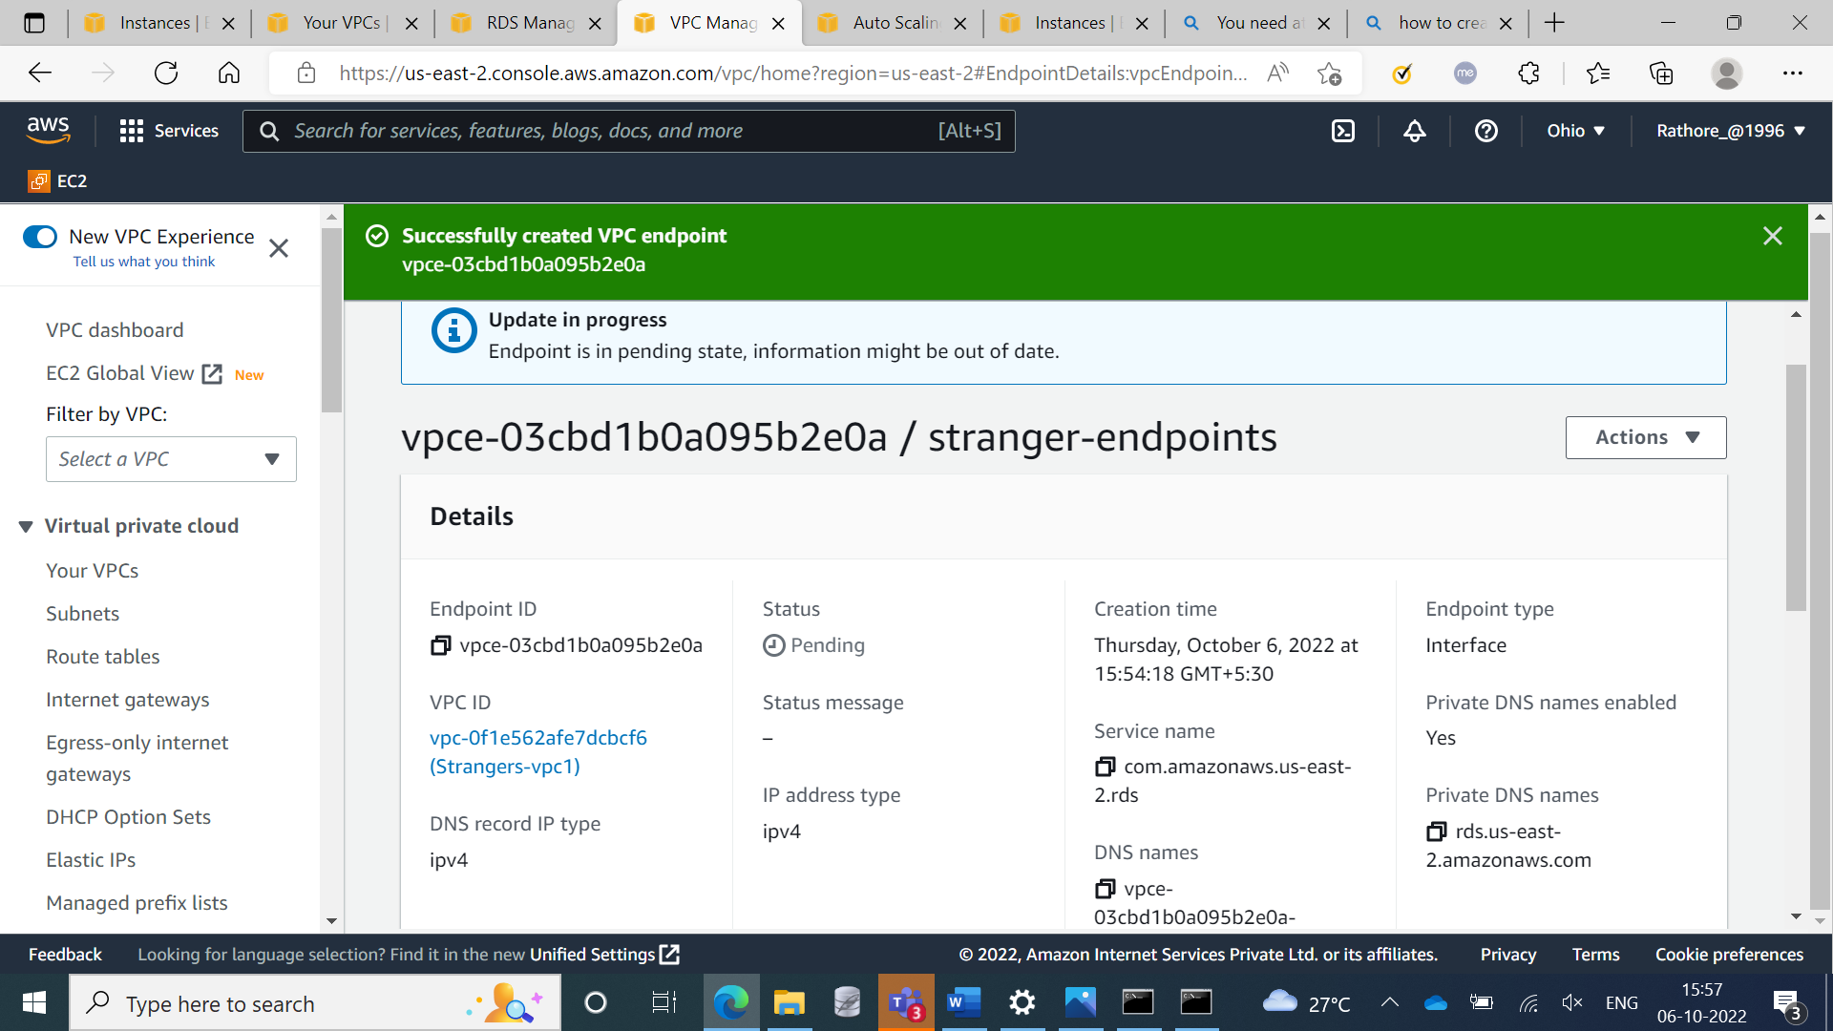

**Step 24:** Created RDS

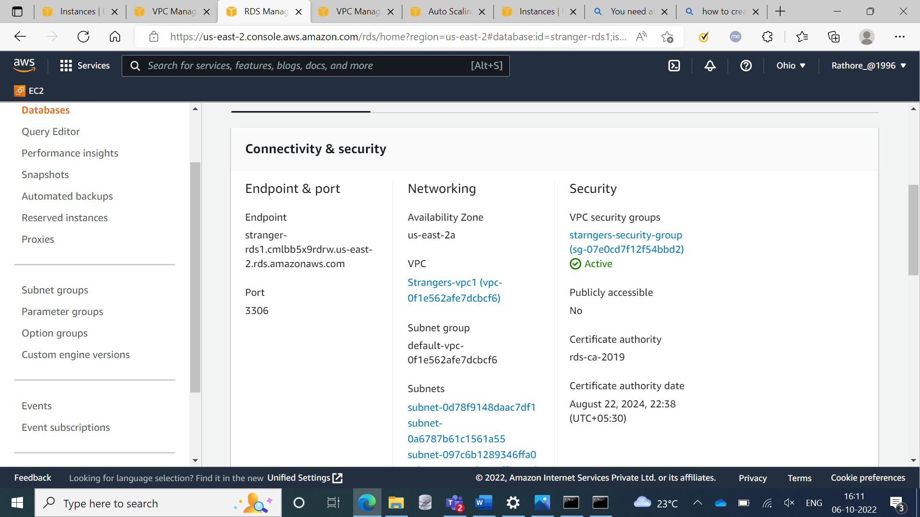

**Step 25:** Connected RDS with EC2 Instances

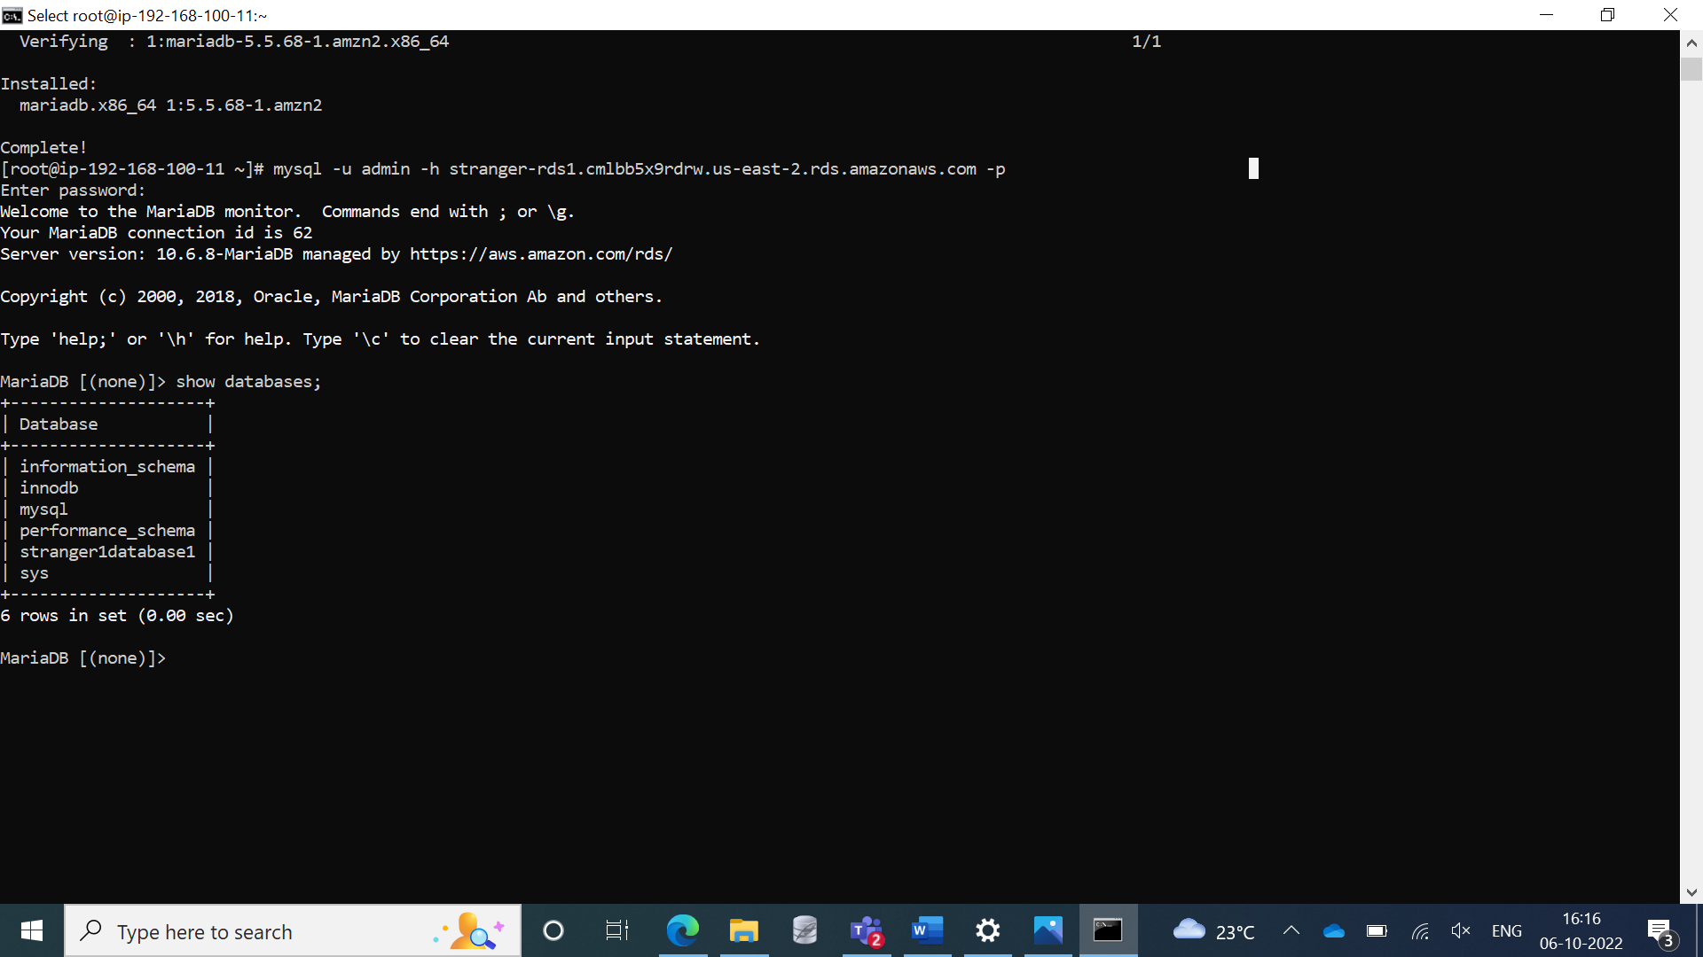

**Step 26:** Showing the database

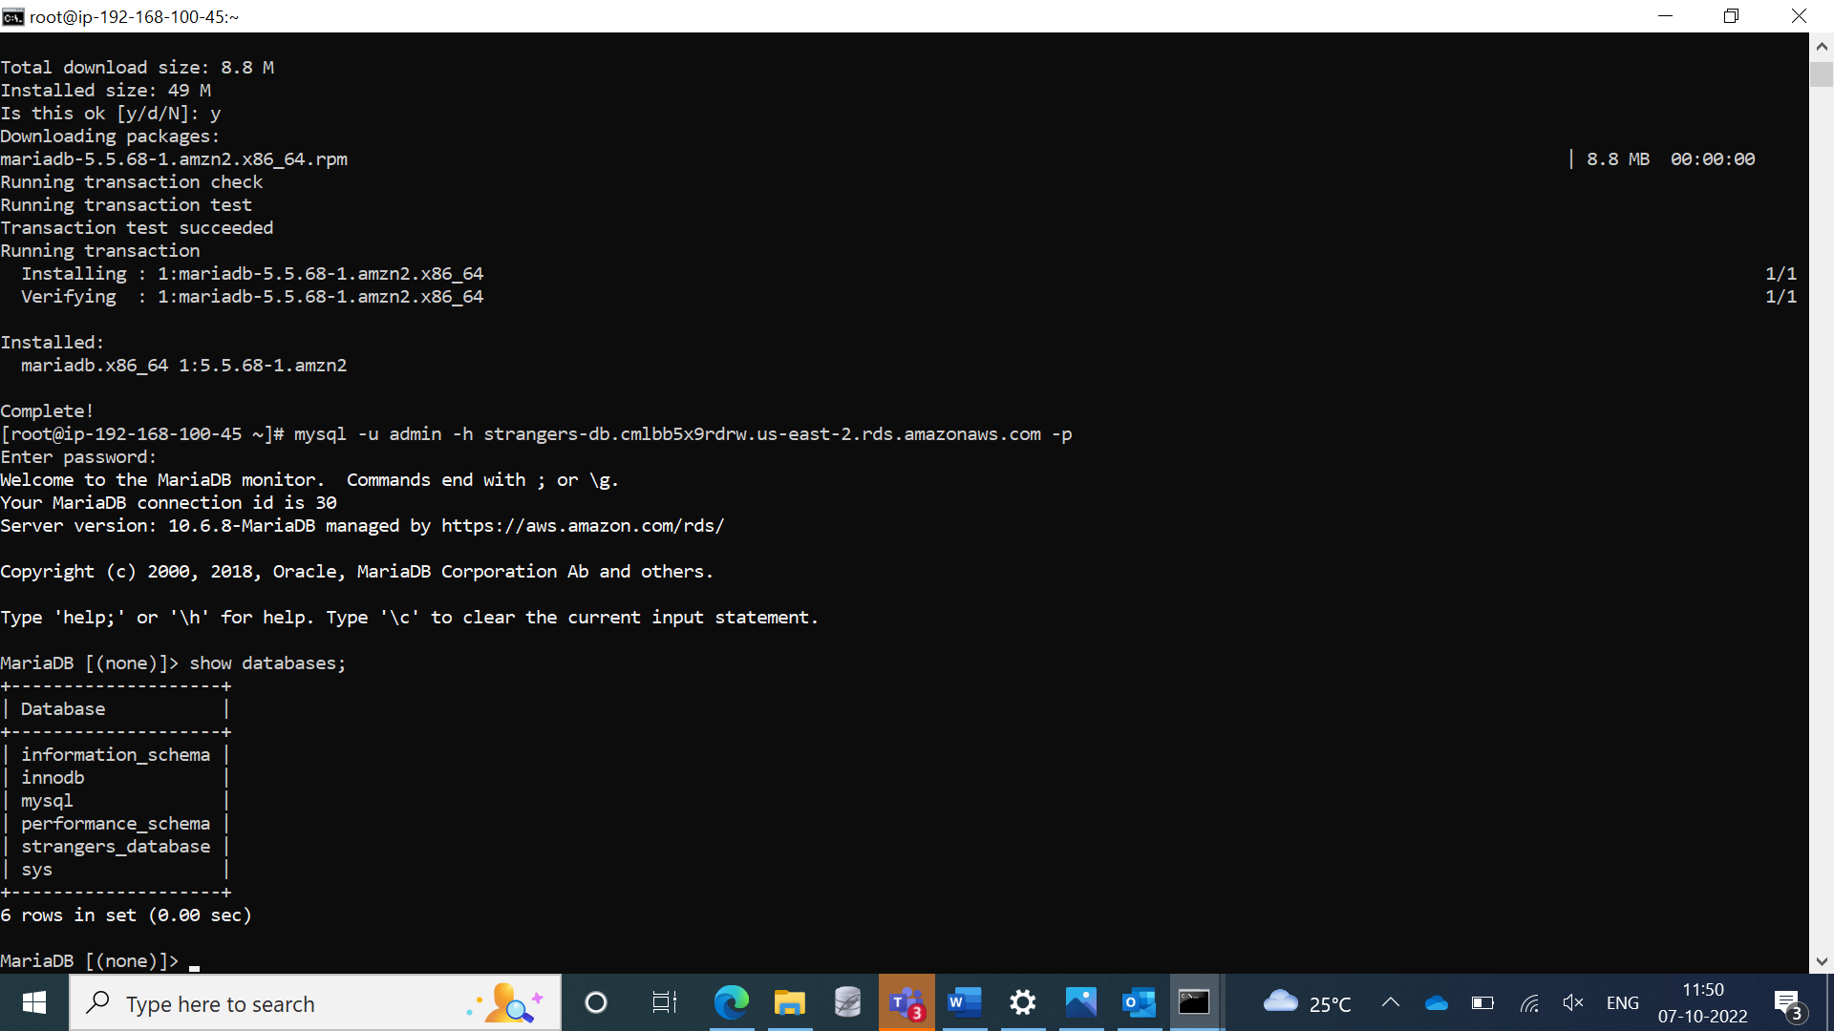

**Step 27:** Created S3 bucket for mounting

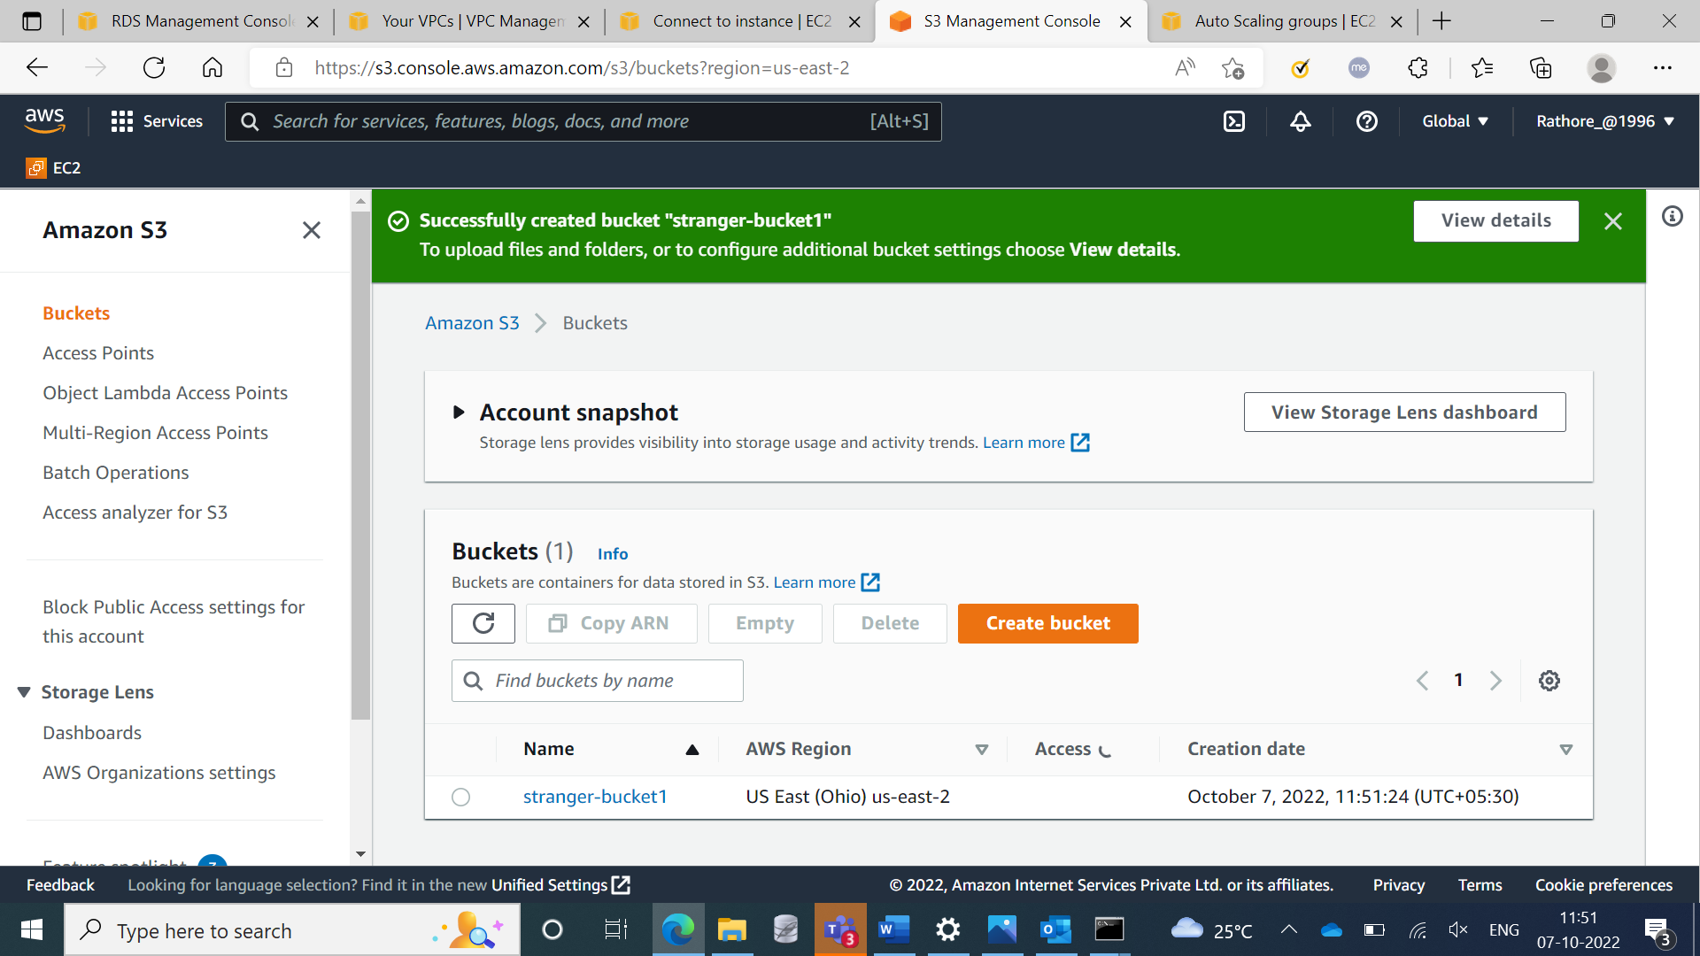

**Step 28:** uploaded a file in S3 bucket

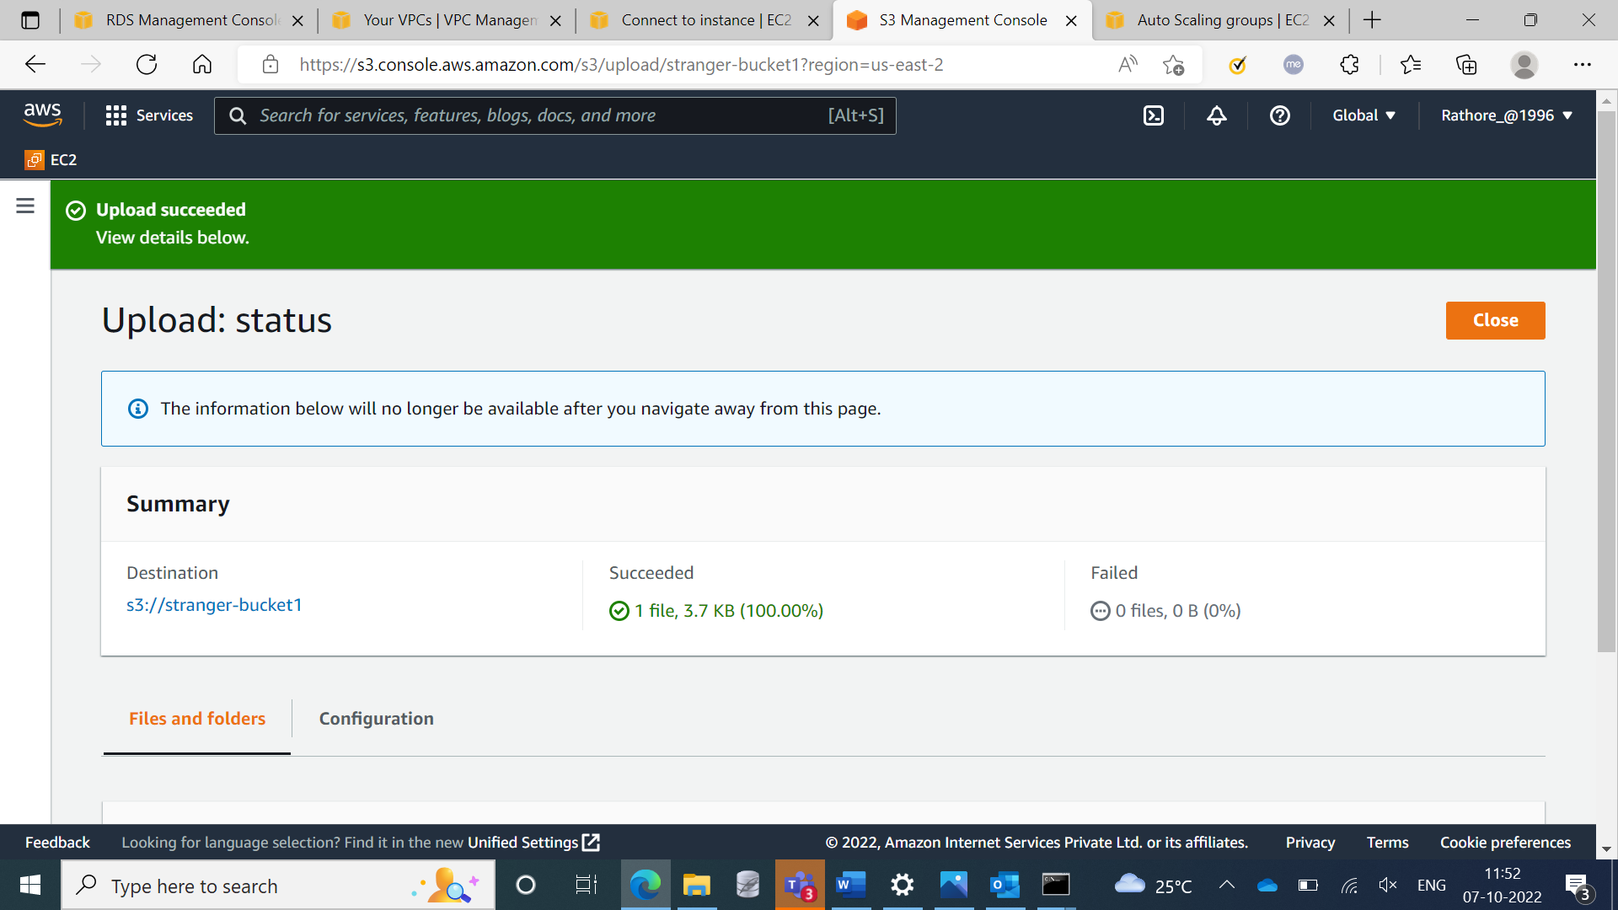

**Step 29:** Created a Lambda function

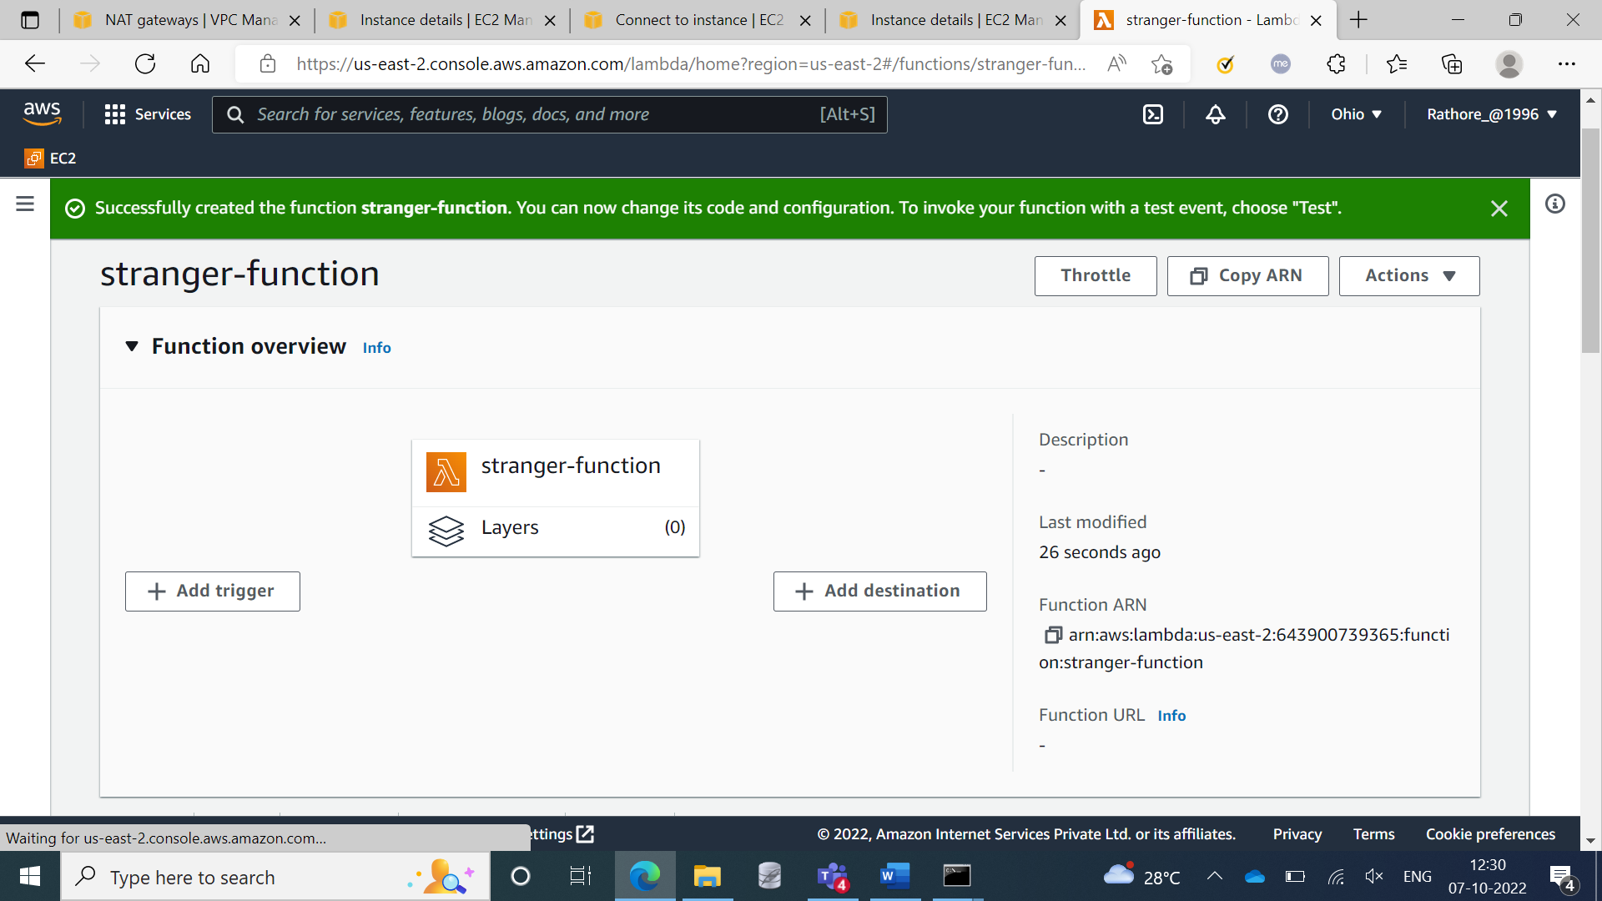

**Step 30:** Deploying a code in lambda function

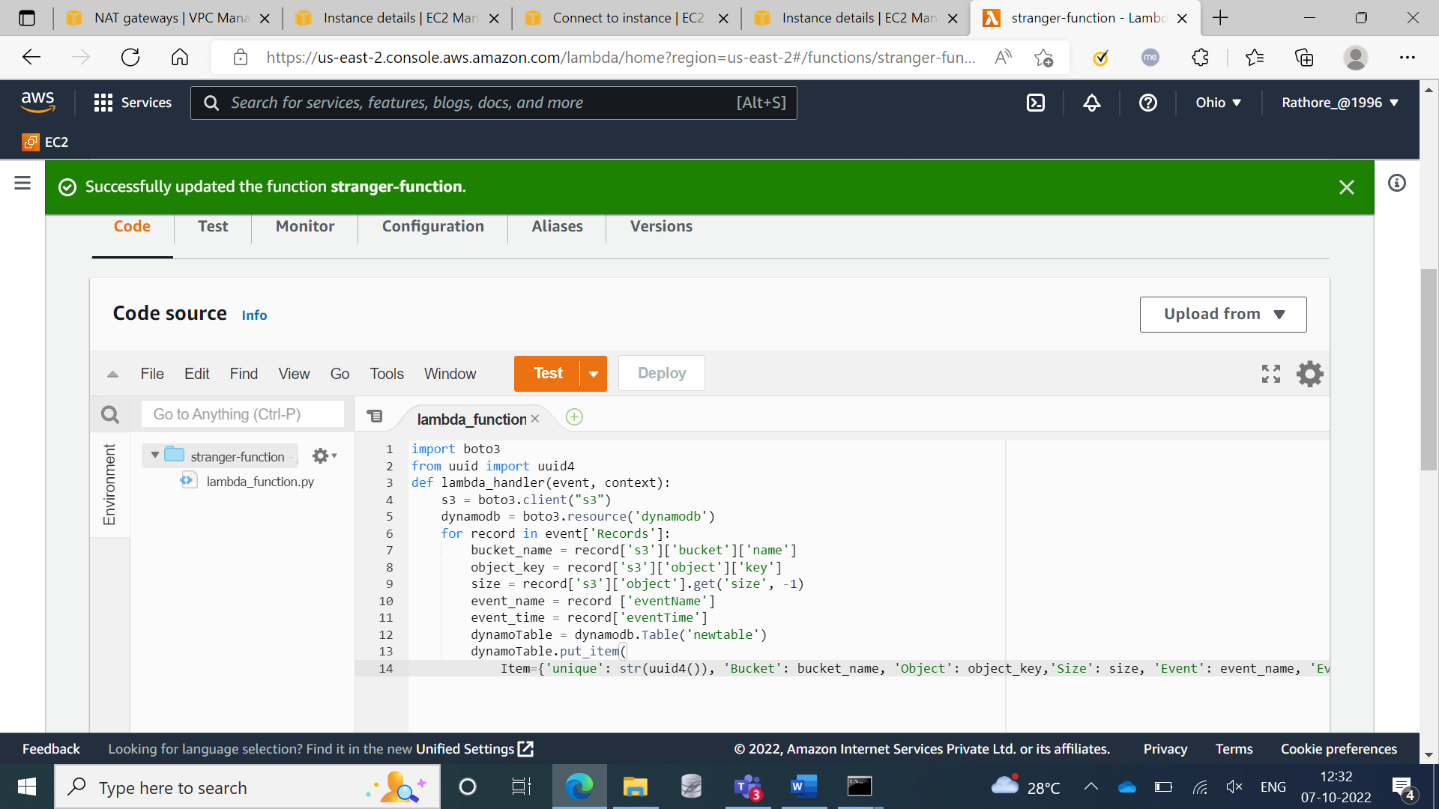

**Step 31:** Triggering S3 bucket in lambda function

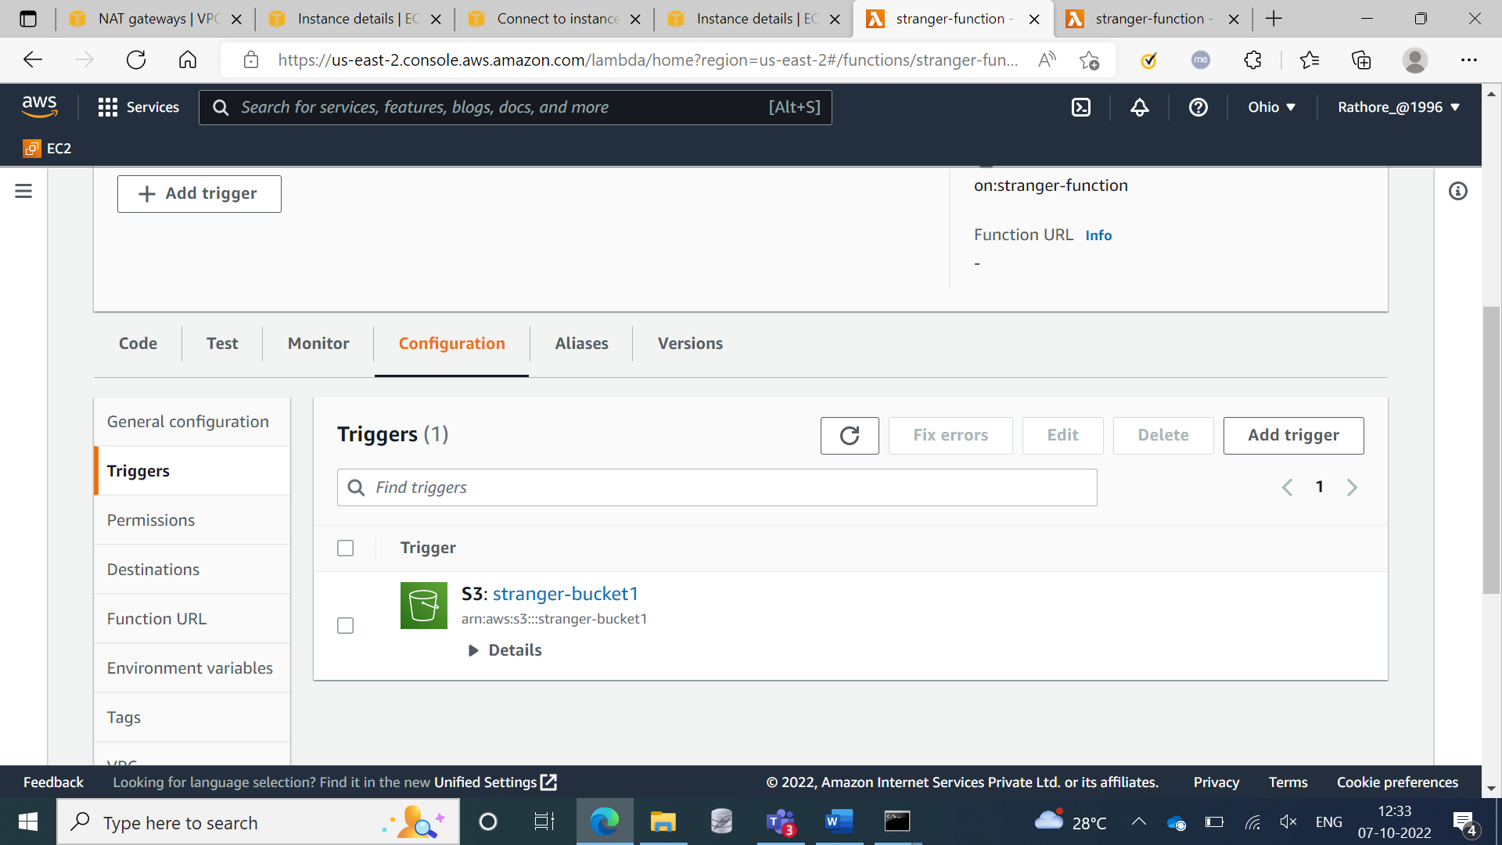

**Step 32:** Dynamo Db Table

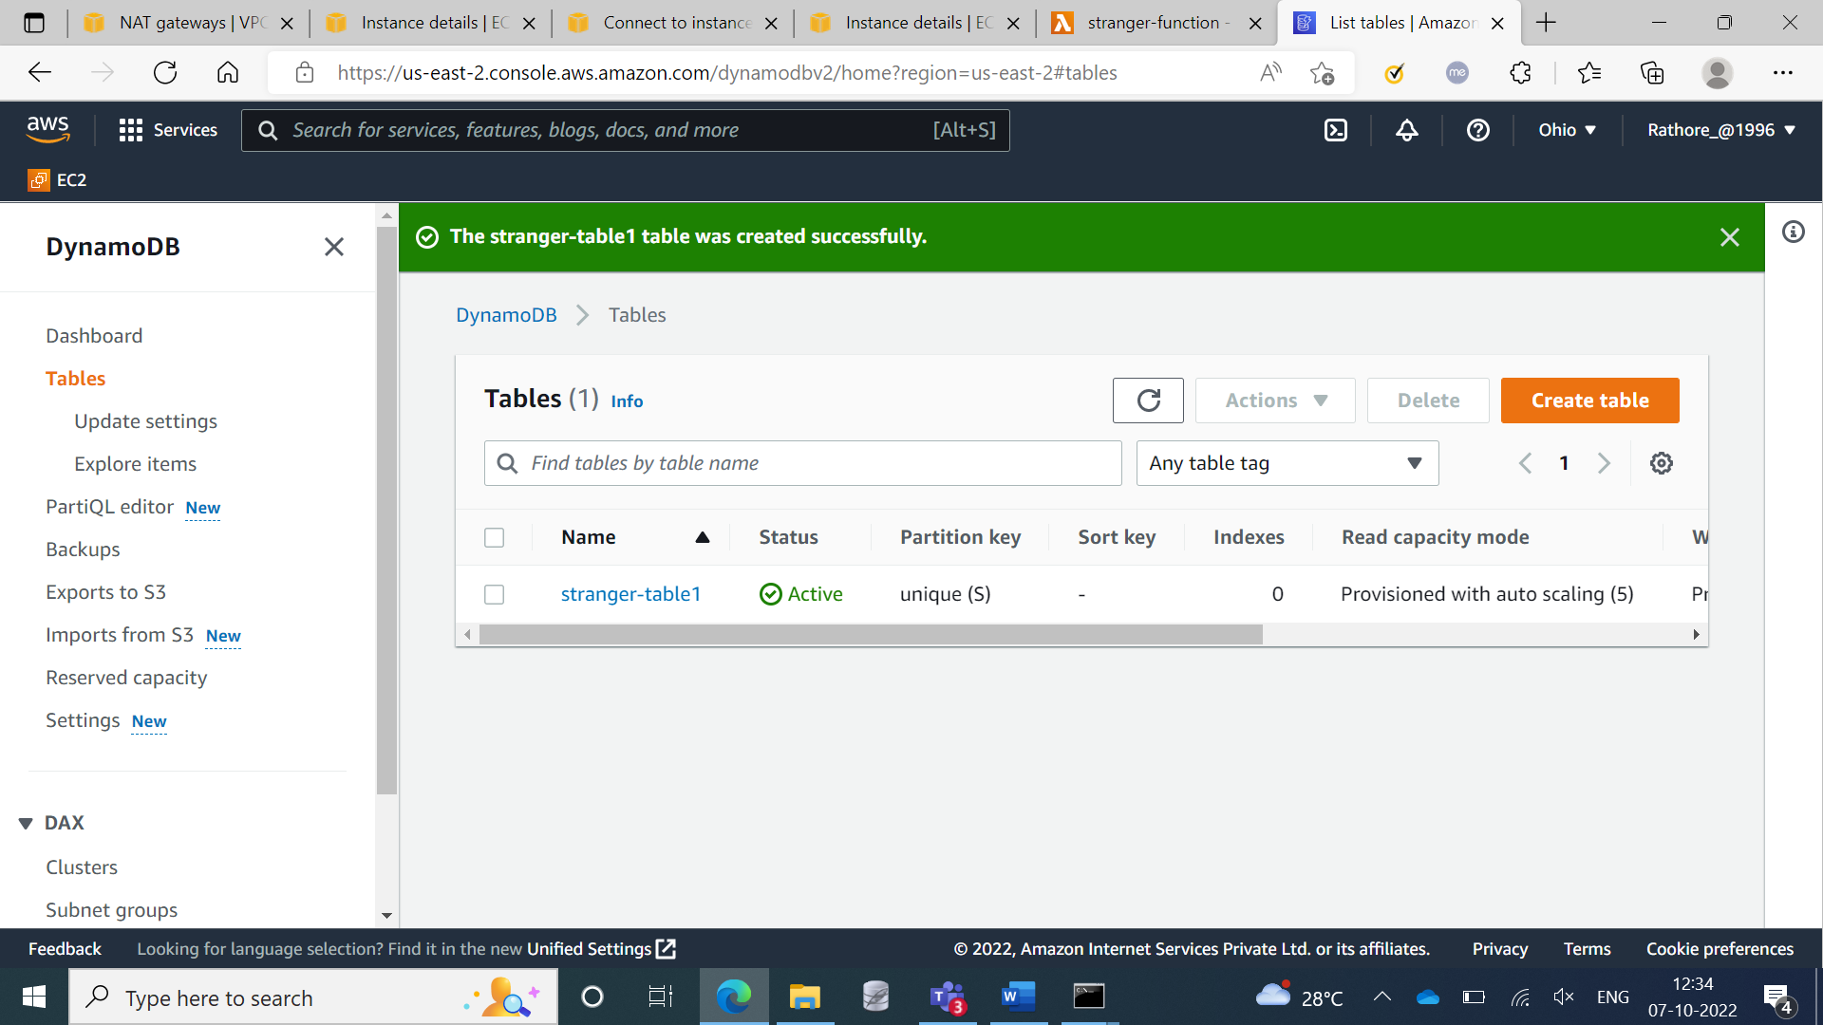

**Step 33:** Applying the roles for dynamodb

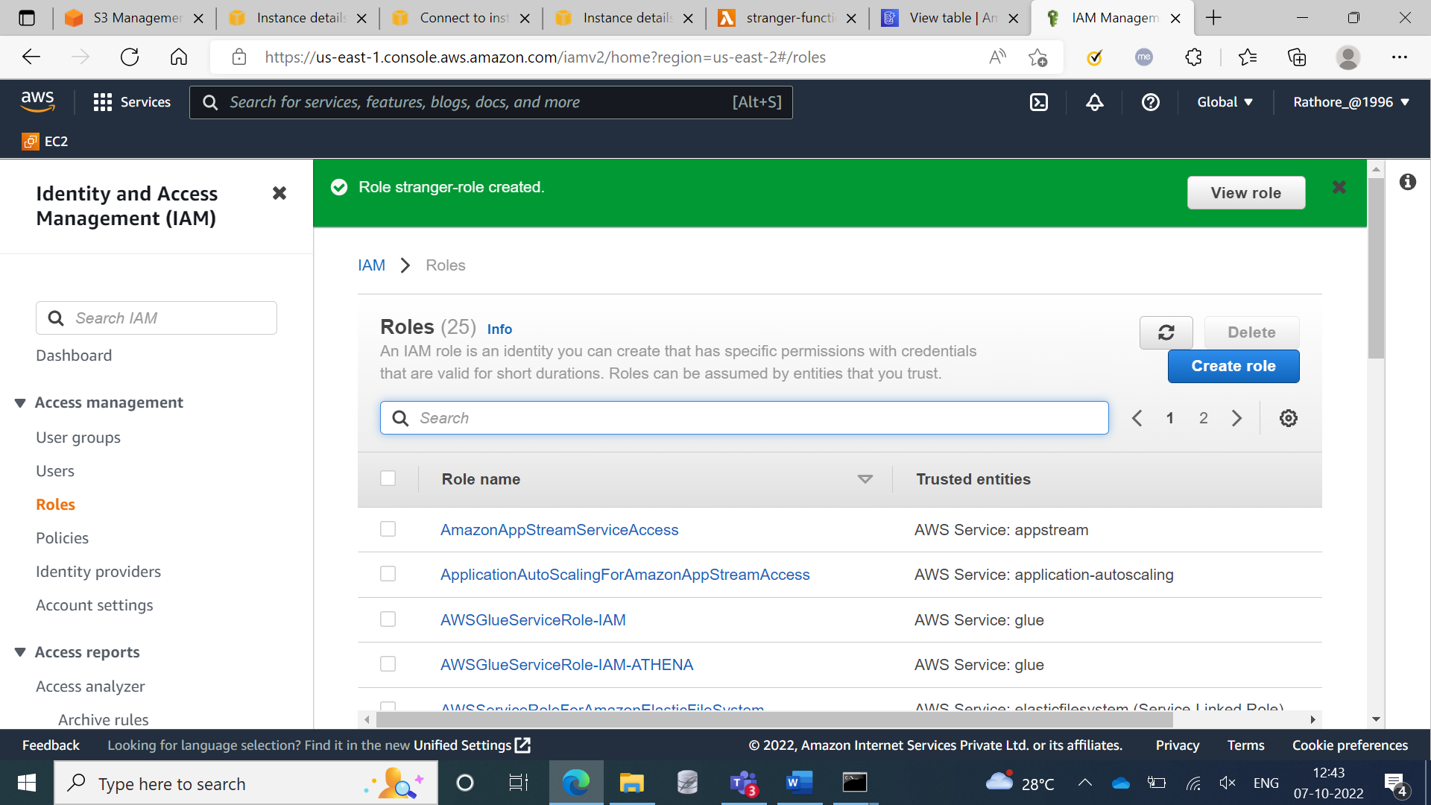

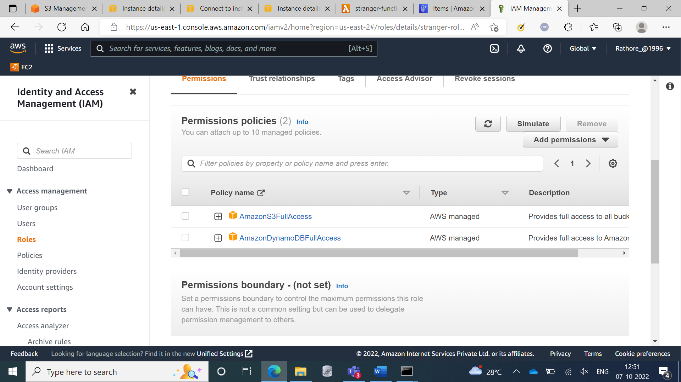

**Step 34:** Showing the files of S3 bucket in dynamodb table

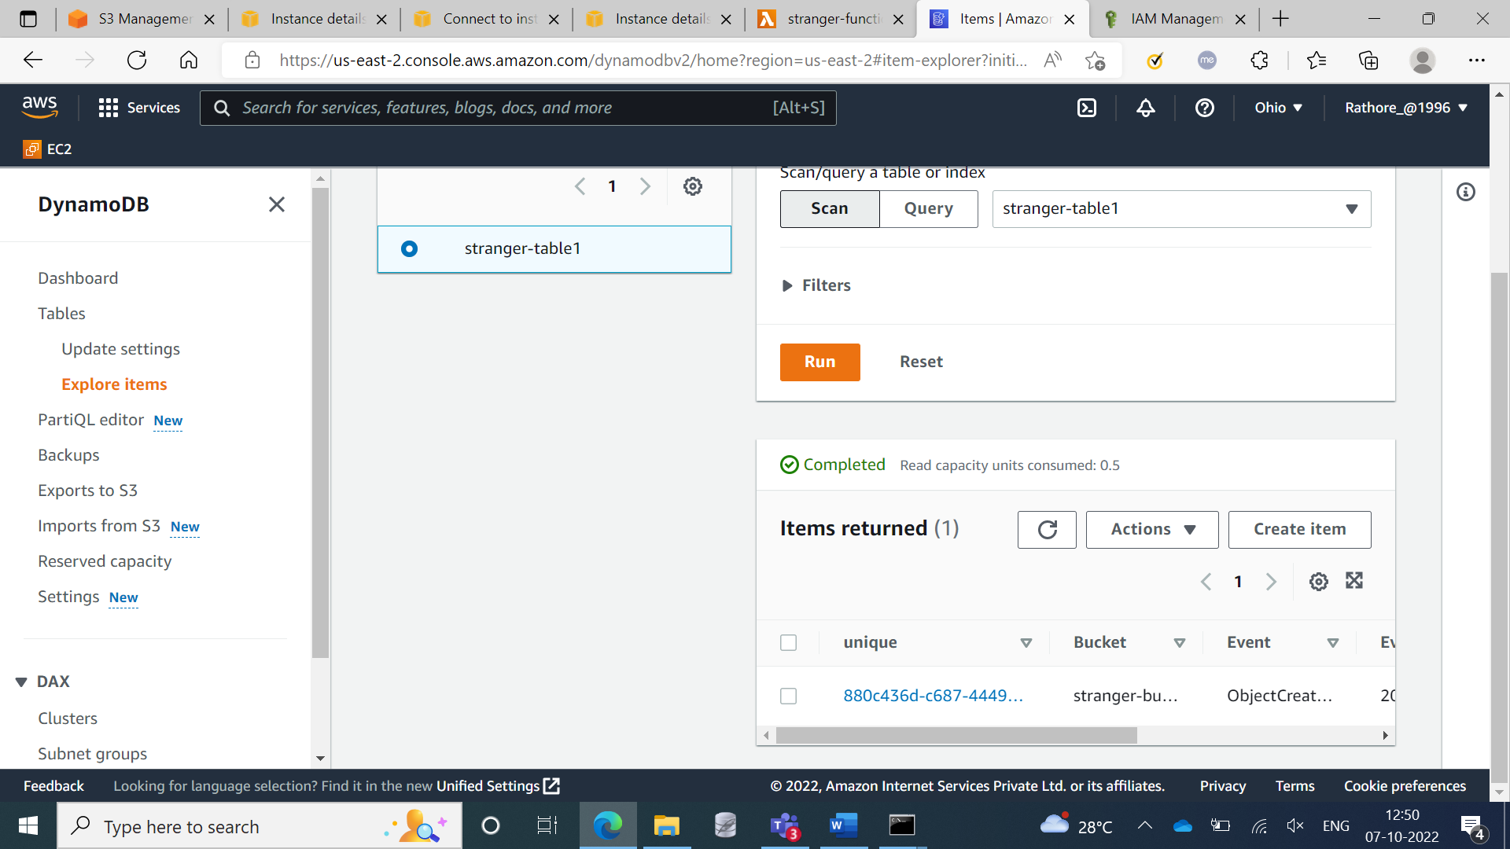

**Step 35:** Installing the dependencies in EC2 Instance for mounting the instance with S3 bucket

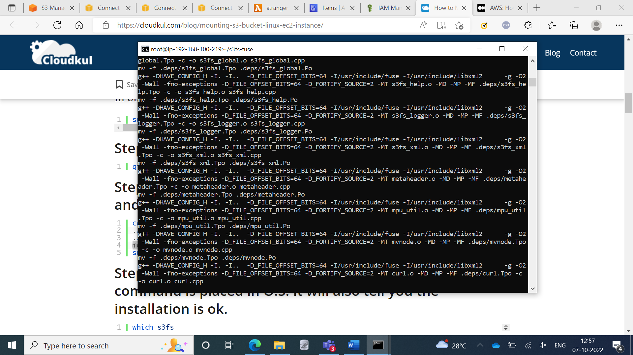

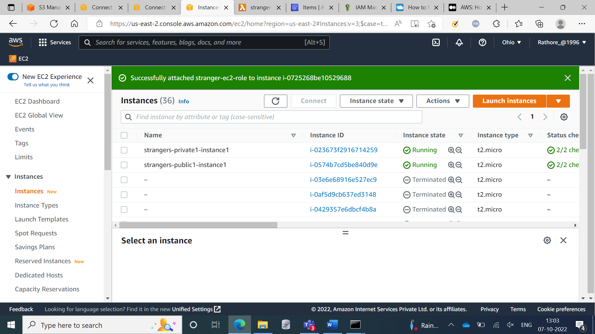

**Commands for mounting with the results**

drwxr-xr-x 8 root root 4096 Oct 7 07:29 s3fs-fuse

[root@ip-192-168-100-219 ~]# s3fs

s3fs: missing BUCKET argument.

[root@ip-192-168-100-219 ~]# s3fs

s3fs: missing BUCKET argument.

[root@ip-192-168-100-219 ~]# mkdir -p /var/s3fs-demofs

[root@ip-192-168-100-219 ~]# ls -l

total 4

drwxr-xr-x 8 root root 4096 Oct 7 07:29 s3fs-fuse

[root@ip-192-168-100-219 ~]# ls -l

total 4

drwxr-xr-x 8 root root 4096 Oct 7 07:29 s3fs-fuse

[root@ip-192-168-100-219 ~]# mkdir sir

[root@ip-192-168-100-219 ~]# mkdir stranger

[root@ip-192-168-100-219 ~]# ls -l

total 4

drwxr-xr-x 8 root root 4096 Oct 7 07:29 s3fs-fuse

drwxr-xr-x 2 root root 6 Oct 7 07:36 sir

drwxr-xr-x 2 root root 6 Oct 7 07:36 stranger

[root@ip-192-168-100-219 ~]# s3fs -o iam_role="stranger-ec2-role" stranger-bucket1 stranger

[root@ip-192-168-100-219 ~]# df -h

Filesystem Size Used Avail Use% Mounted on

devtmpfs 474M 0 474M 0% /dev

tmpfs 483M 0 483M 0% /dev/shm

tmpfs 483M 444K 483M 1% /run

tmpfs 483M 0 483M 0% /sys/fs/cgroup

/dev/xvda1 8.0G 1.9G 6.2G 23% /

tmpfs 97M 0 97M 0% /run/user/1000

s3fs 16E 0 16E 0% /root/stranger

[root@ip-192-168-100-219 ~]# cd stranger/

[root@ip-192-168-100-219 stranger]# ls -l

total 6

-rw-r----- 1 root root 3778 Oct 7 06:22 employees.csv

-rw-r----- 1 root root 1166 Oct 7 07:19 sidtable1.csv

**Step 36:** S3 bucket mounted successfully with EC2 Instance

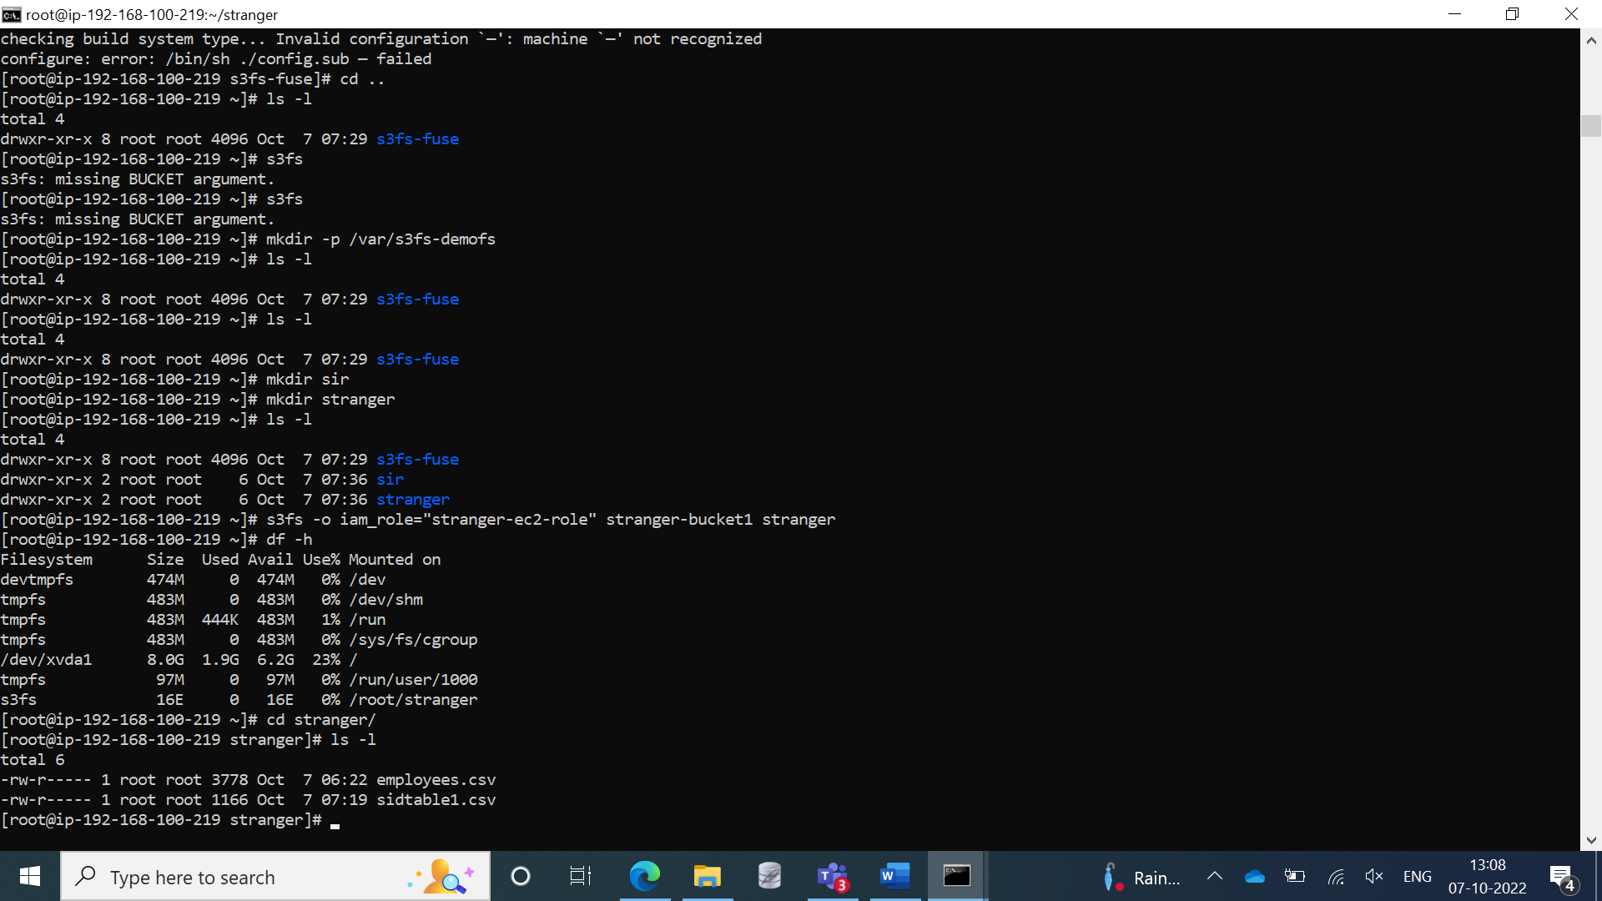

**Step 37:** Created 2 more private subnets for VPC-2

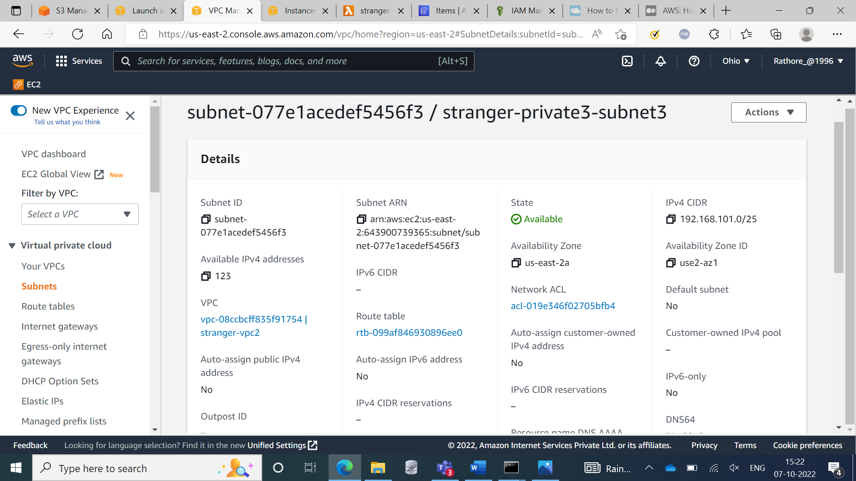

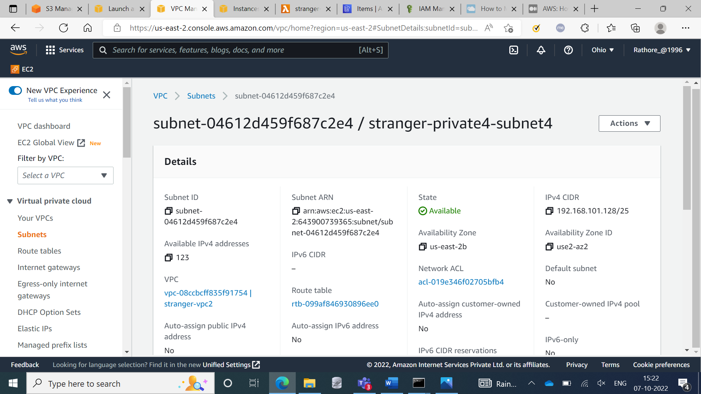

**Step 38:** Created Security group forVPC-2

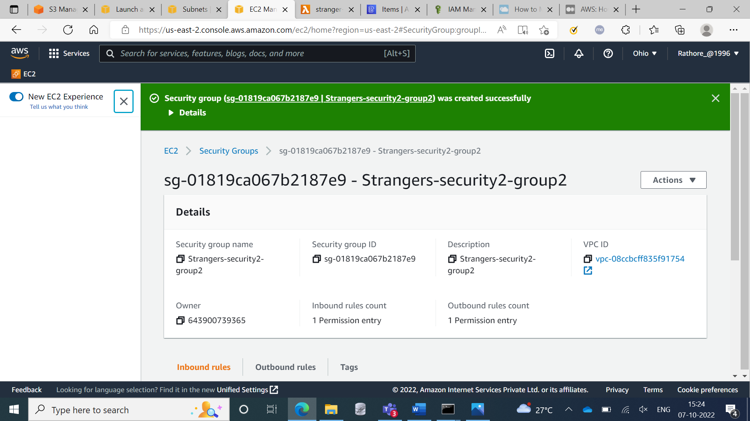

**Step 39:** Private Instance1 for VPC2

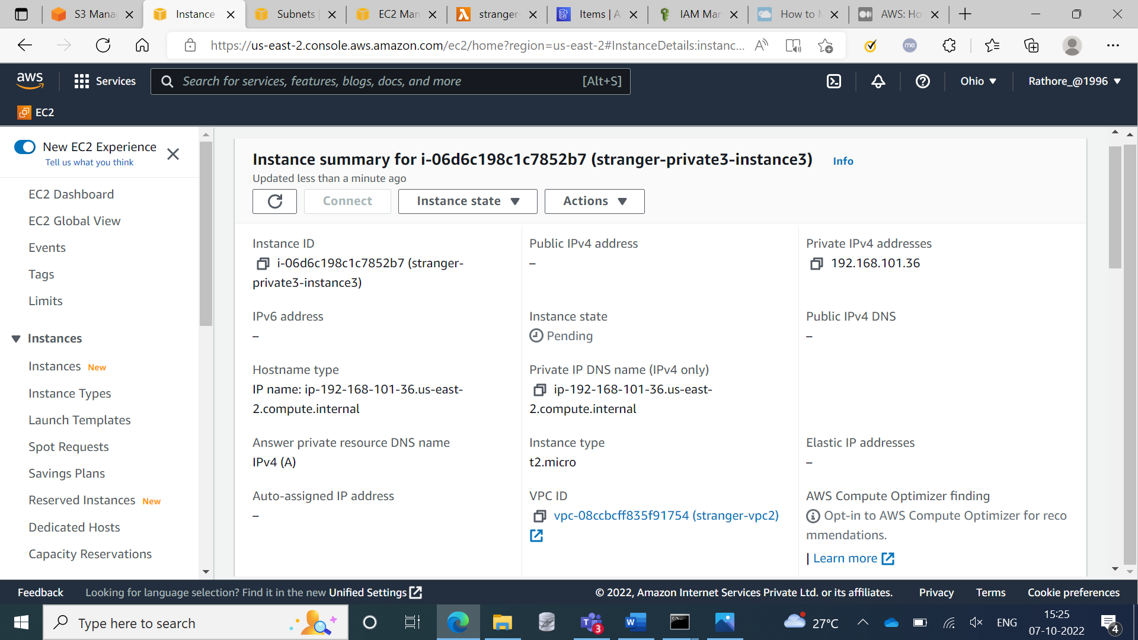

**Step 39:** Private Instance2 for VPC2

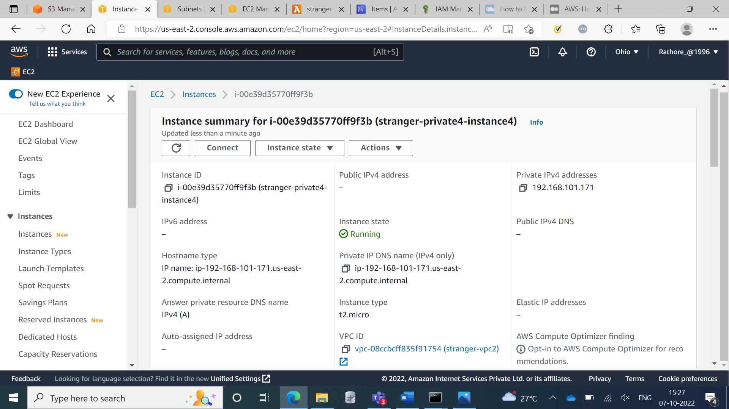

**Step 40:** Created EFS(Elastic File System)

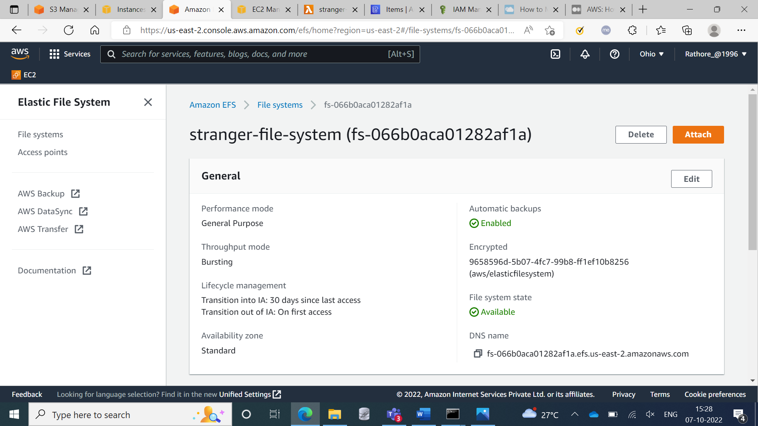

**Step 41:** Created peering between two VPC’s i.e VPC1 & VPC2

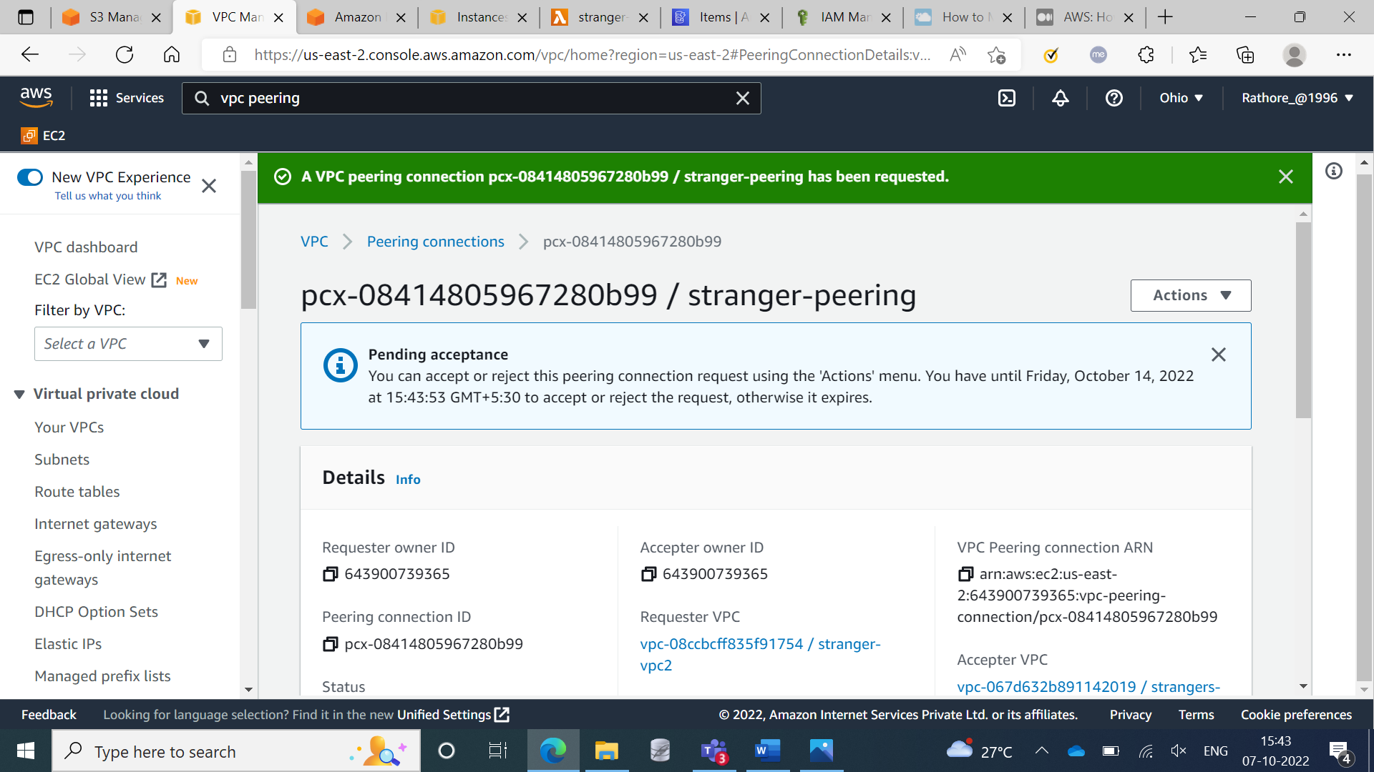

**Step 42:** Created route table for VPC2

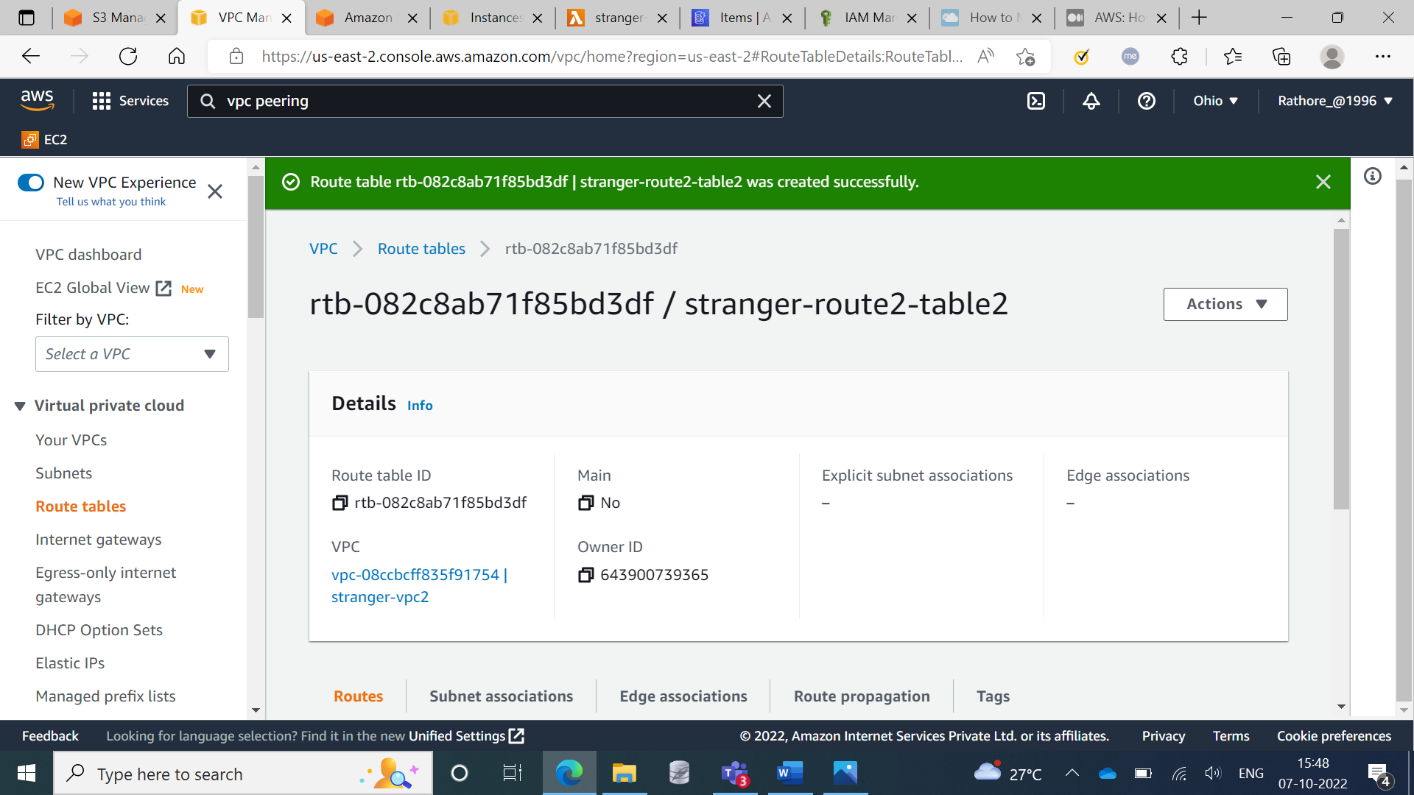

**Step 43:** Pinging the VPC2’s private EC2 Instance to VPC1’s EC2 Instance

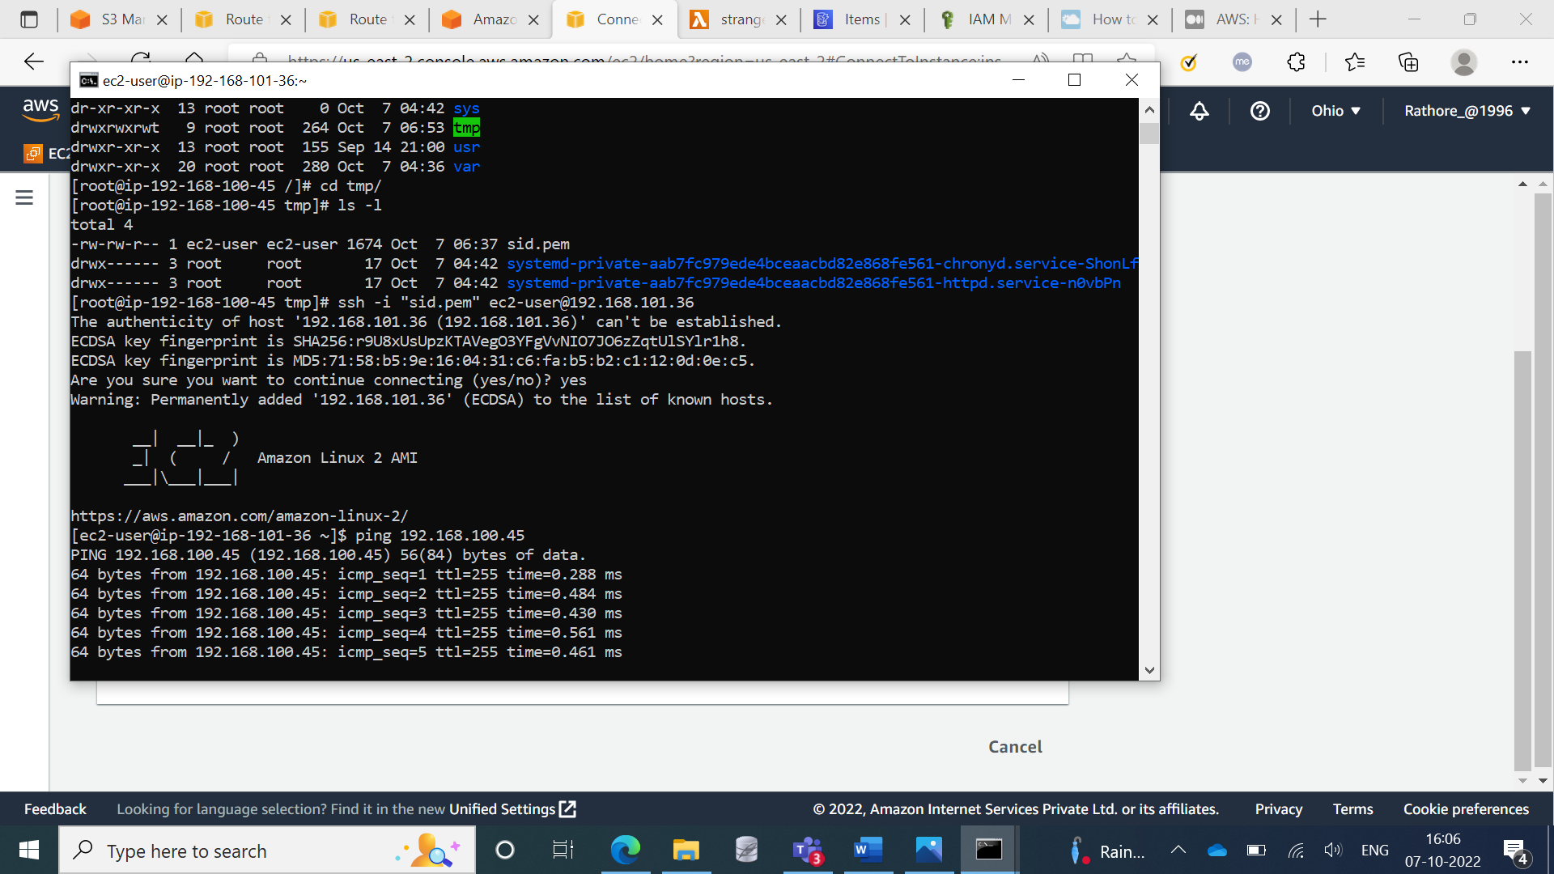

**Step 44:** By Going inside of VPC1 EC2 Instance, connecting the VPC2 private EC2 Instance

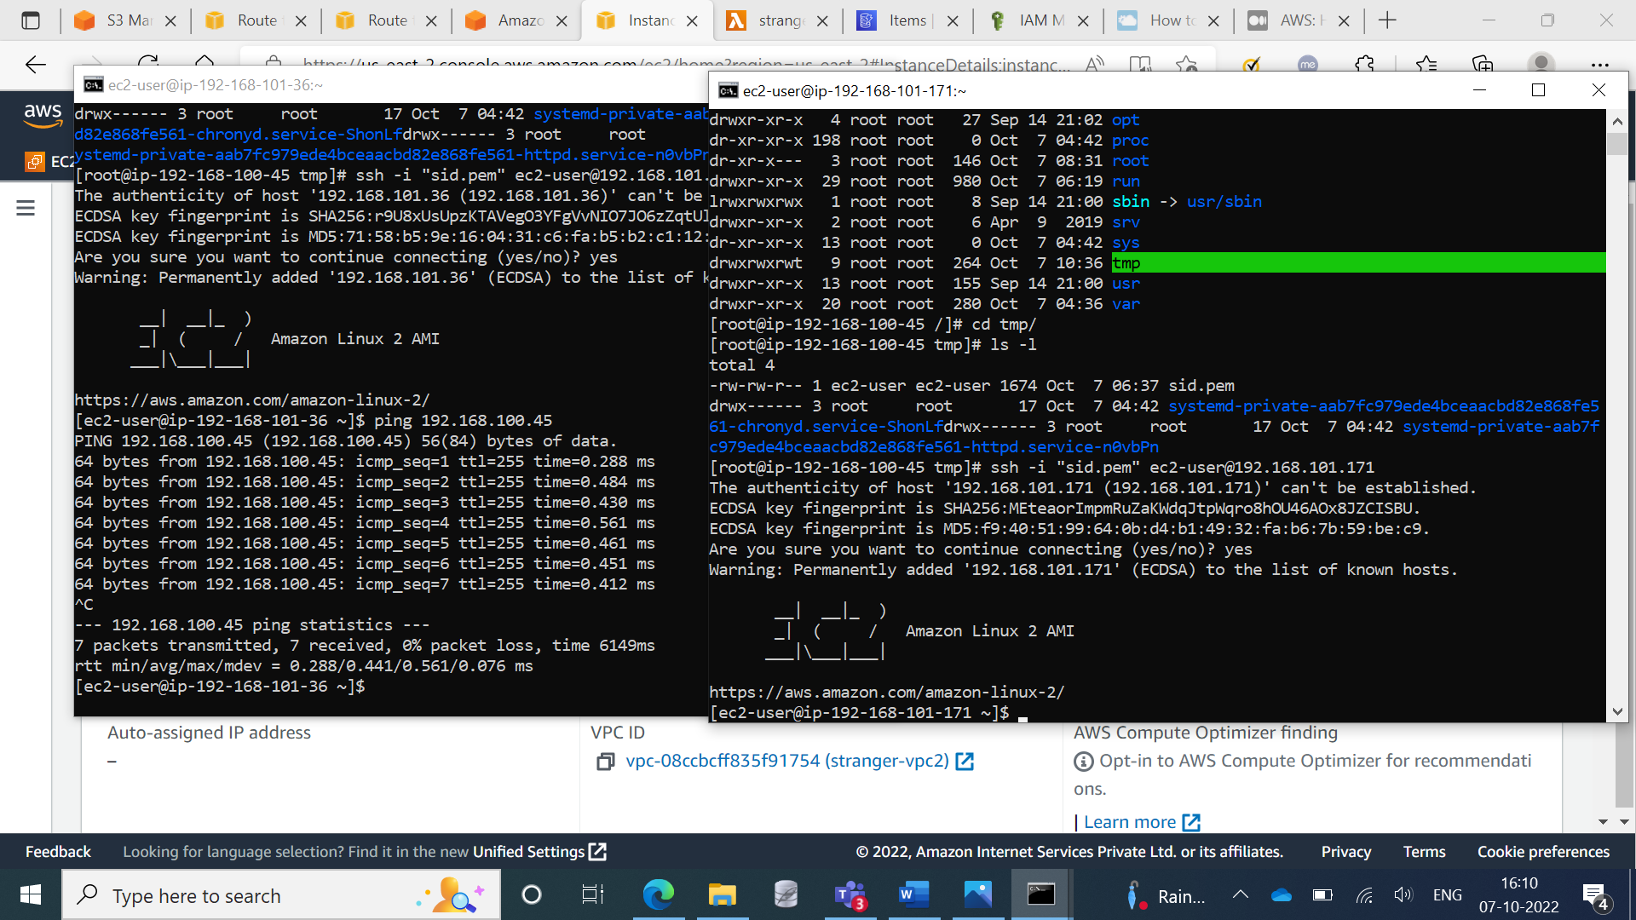

**Step 45:** Copied the .pem file

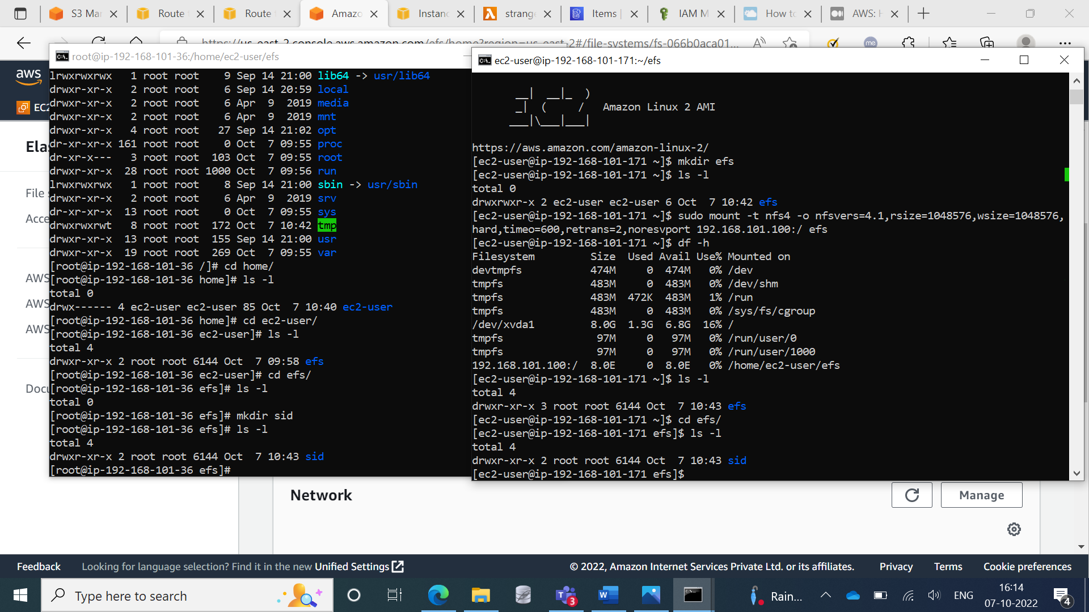

**Glue With Athena**

**Step 1:** Creating Crawlers

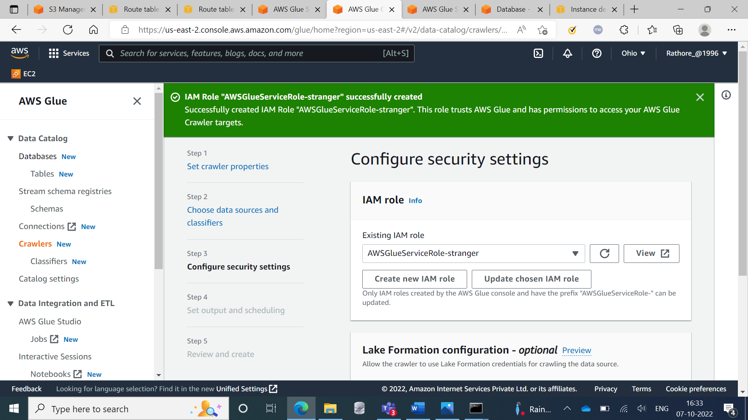

Creating Crawlers

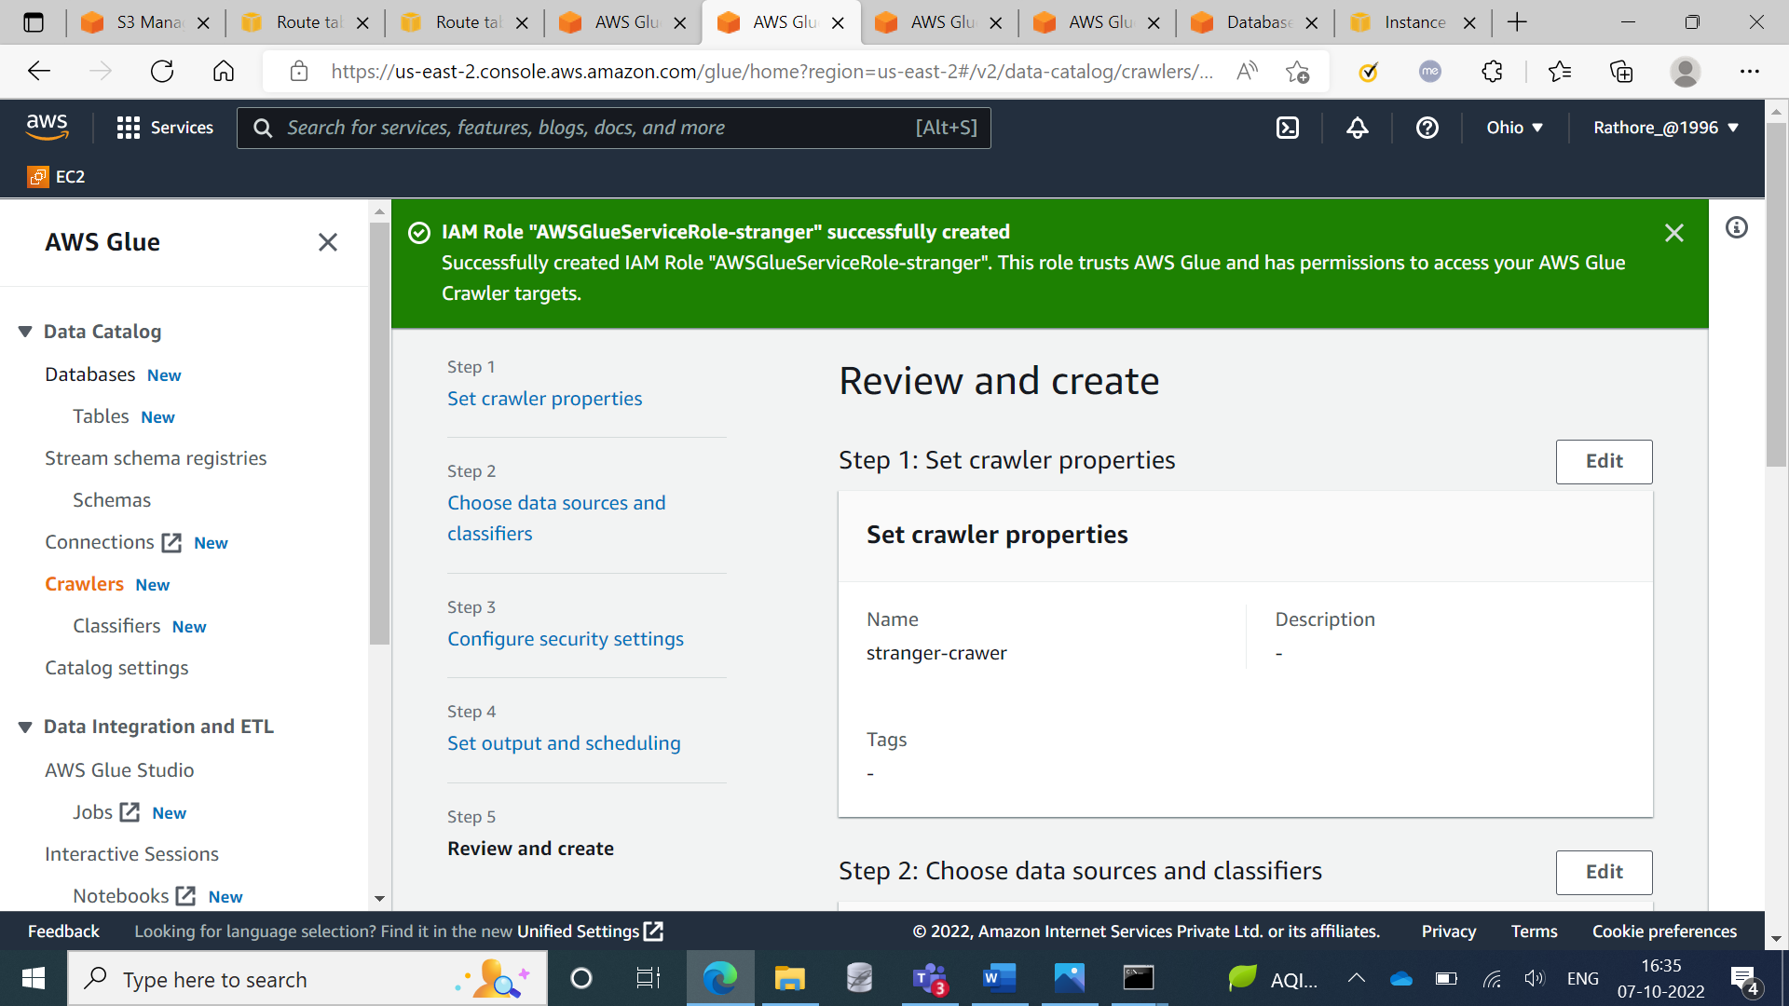

**Step 2:** Created crawlers

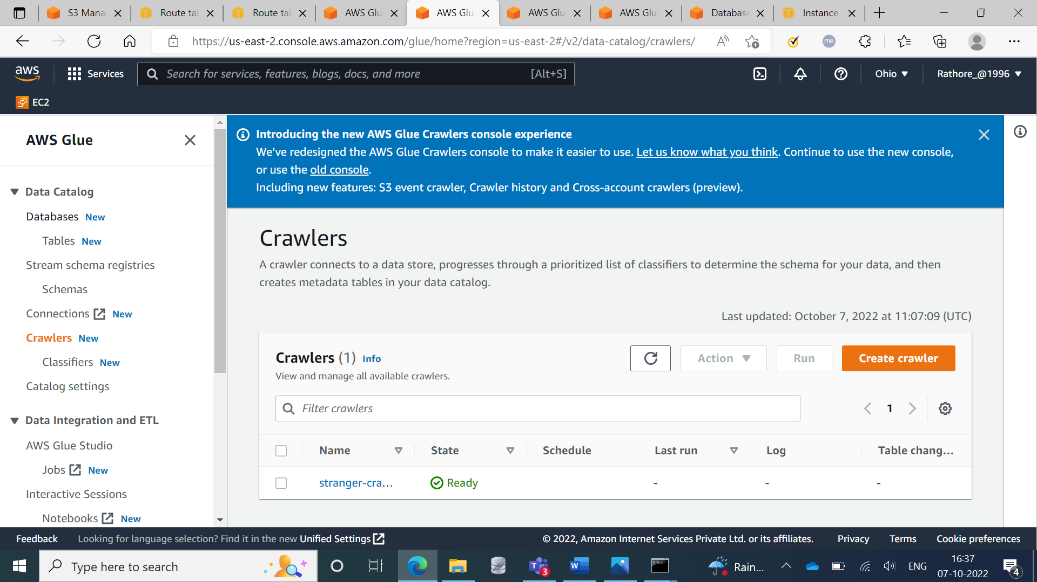

**Step 3:** Showing the description of crawlers

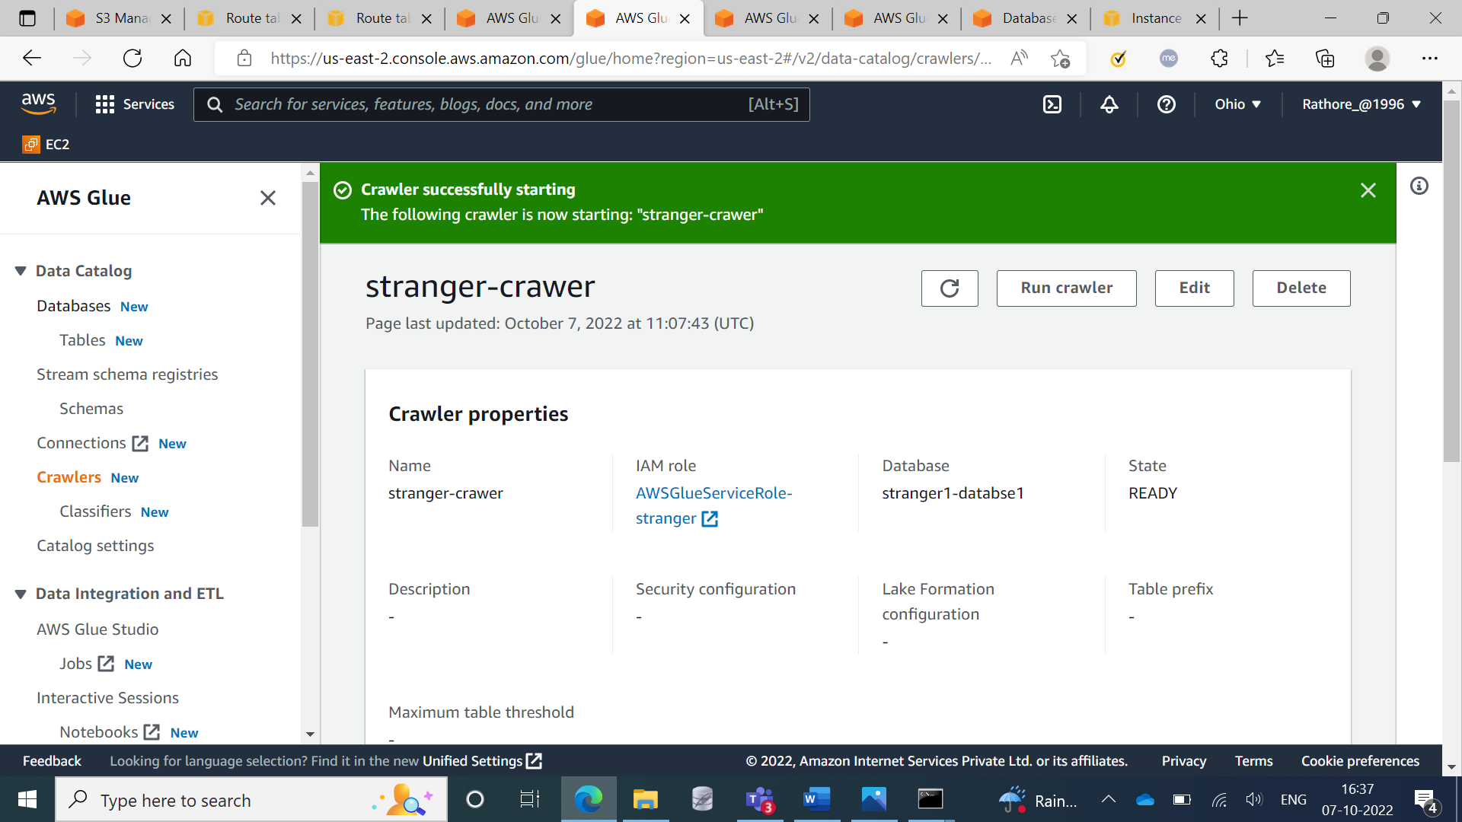

**Step 4:** Editing the schema

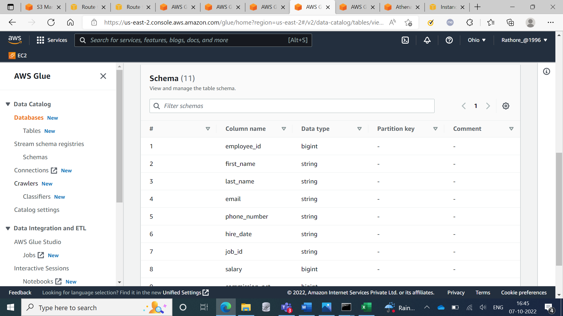

**Step 5:** Executing the Query in Athena

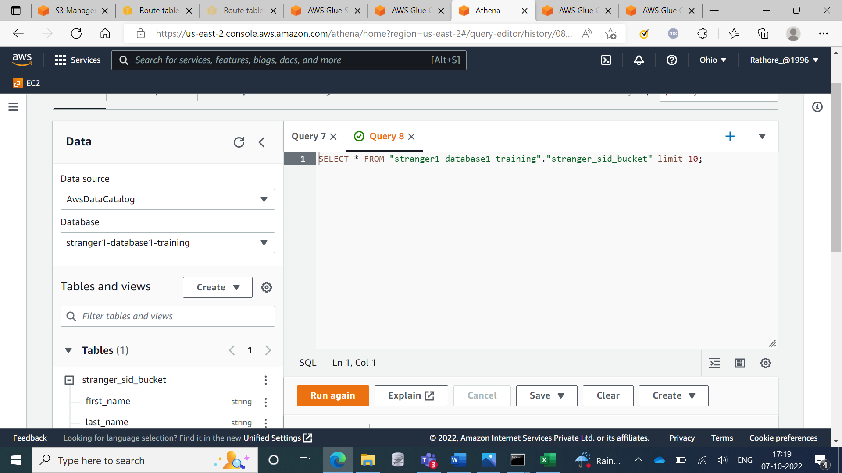

**Step 6:** Showing the results

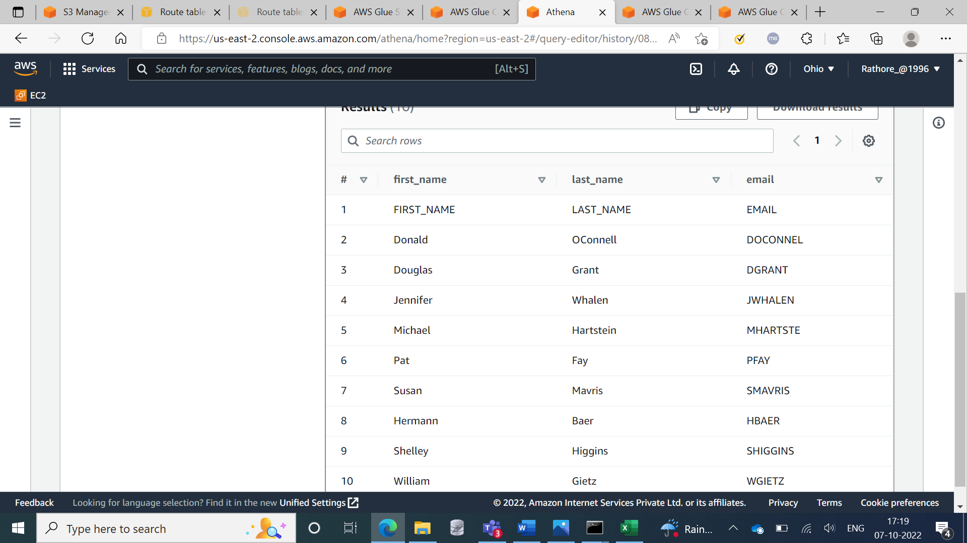

**Glue With Redshift**

**Step 1:** Creating Database

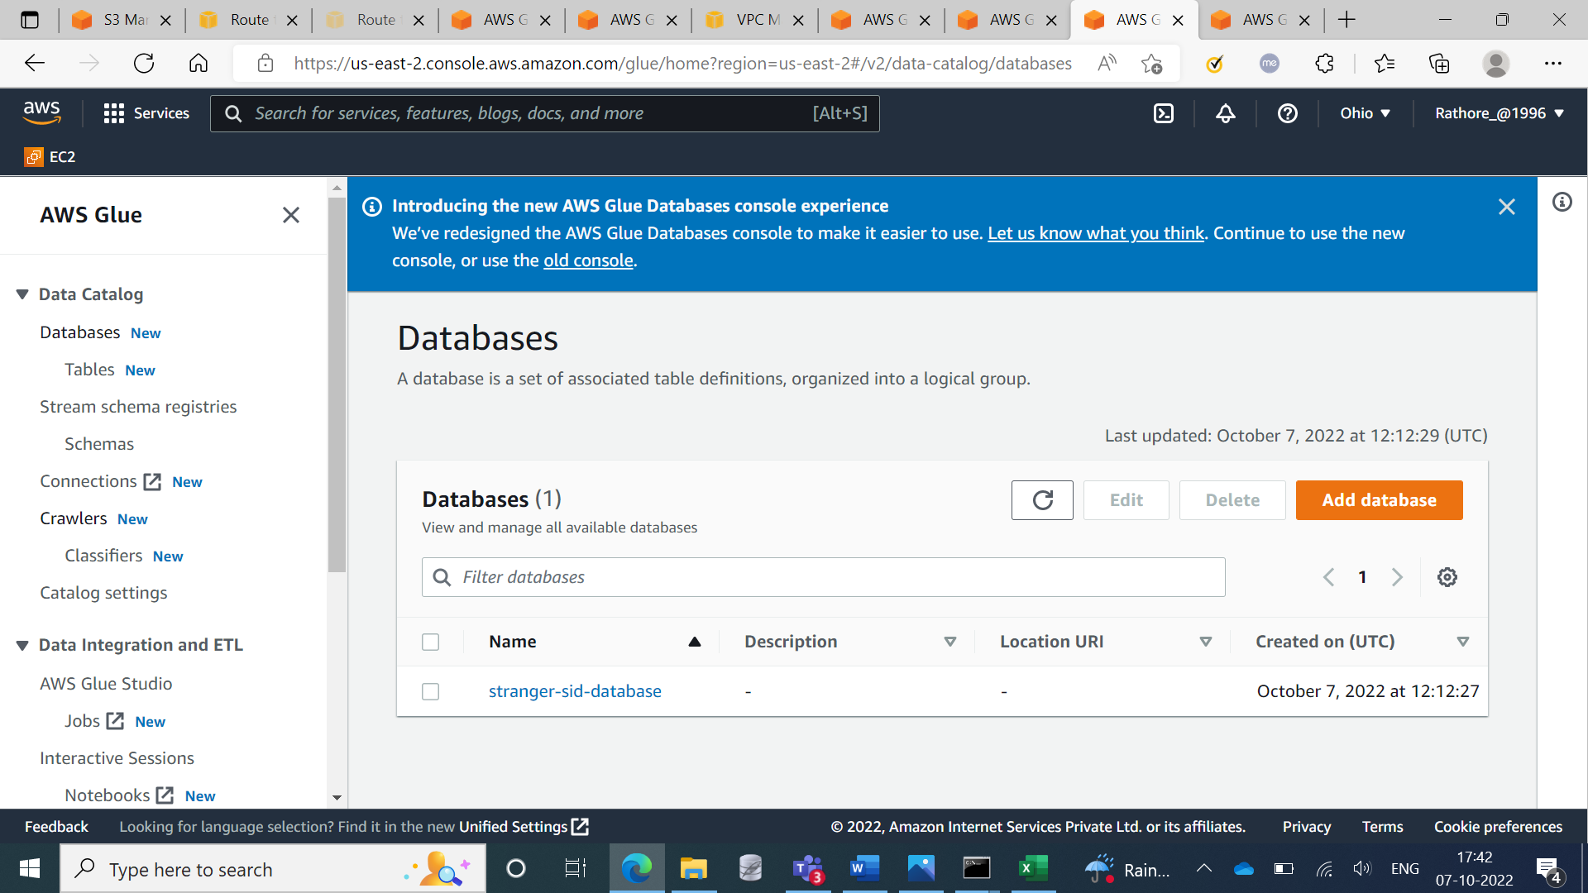

**Step 2:** Created Crawlers

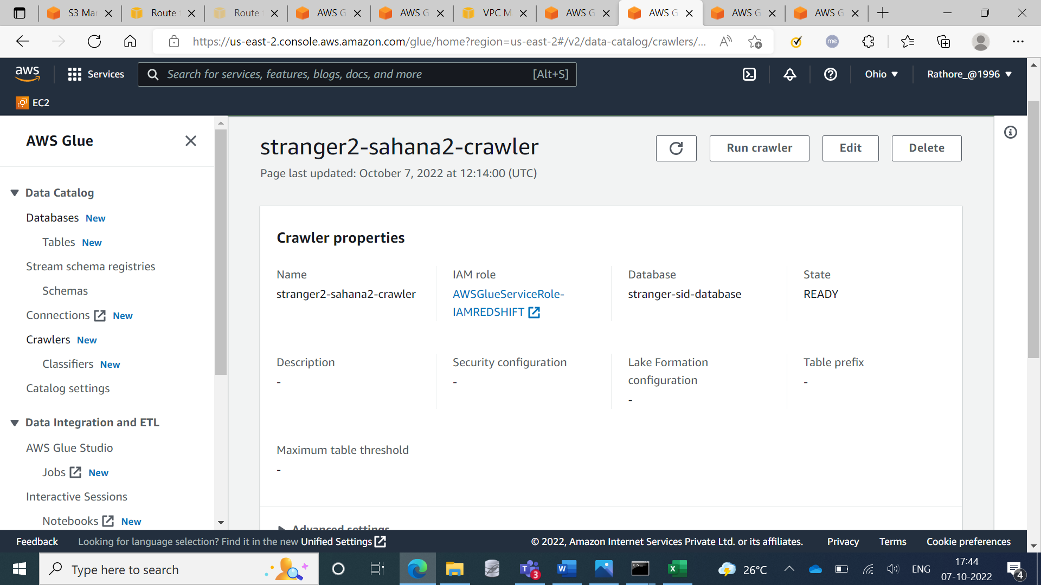

**Step 3:** Editing the table Configuration

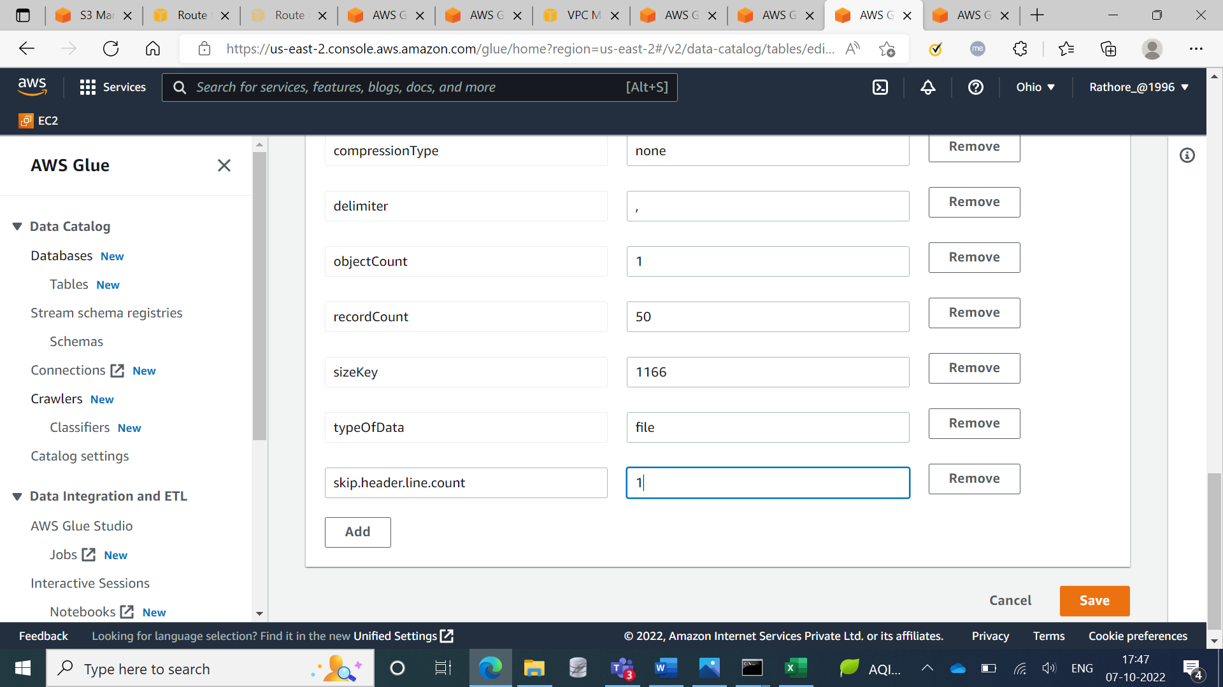

**Step 4:** Created Amazon Redshift Cluster

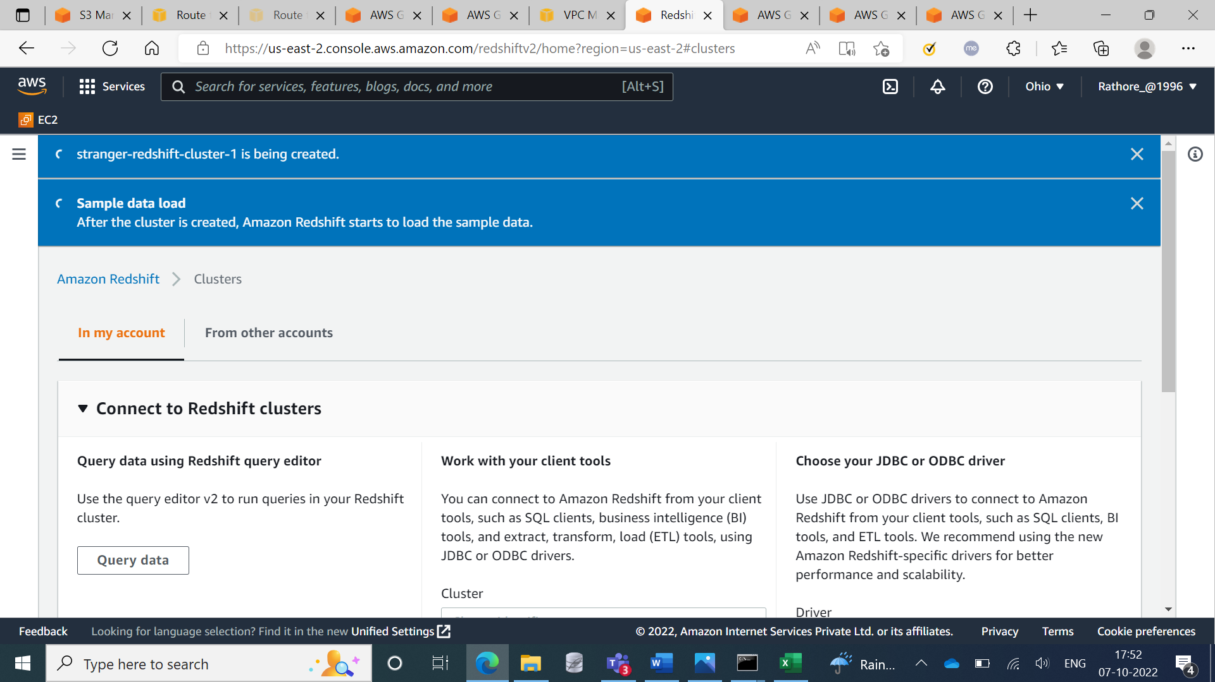

**Step 5:** Created Clusters

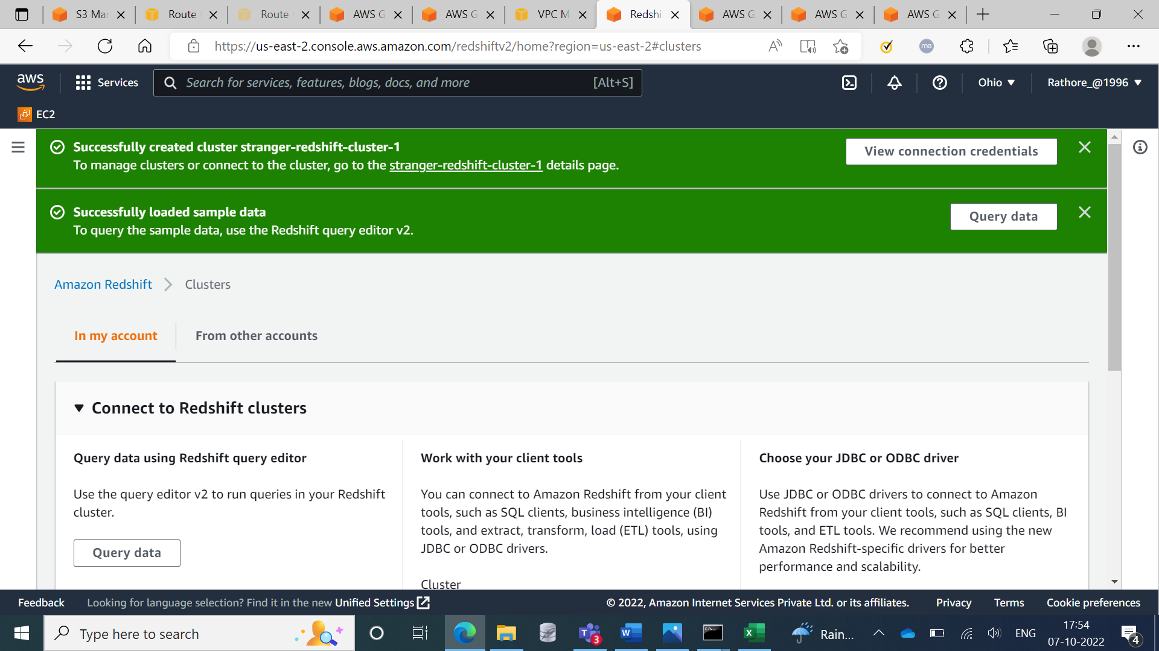

**Step 6:** Executing the query in the redshift query editor

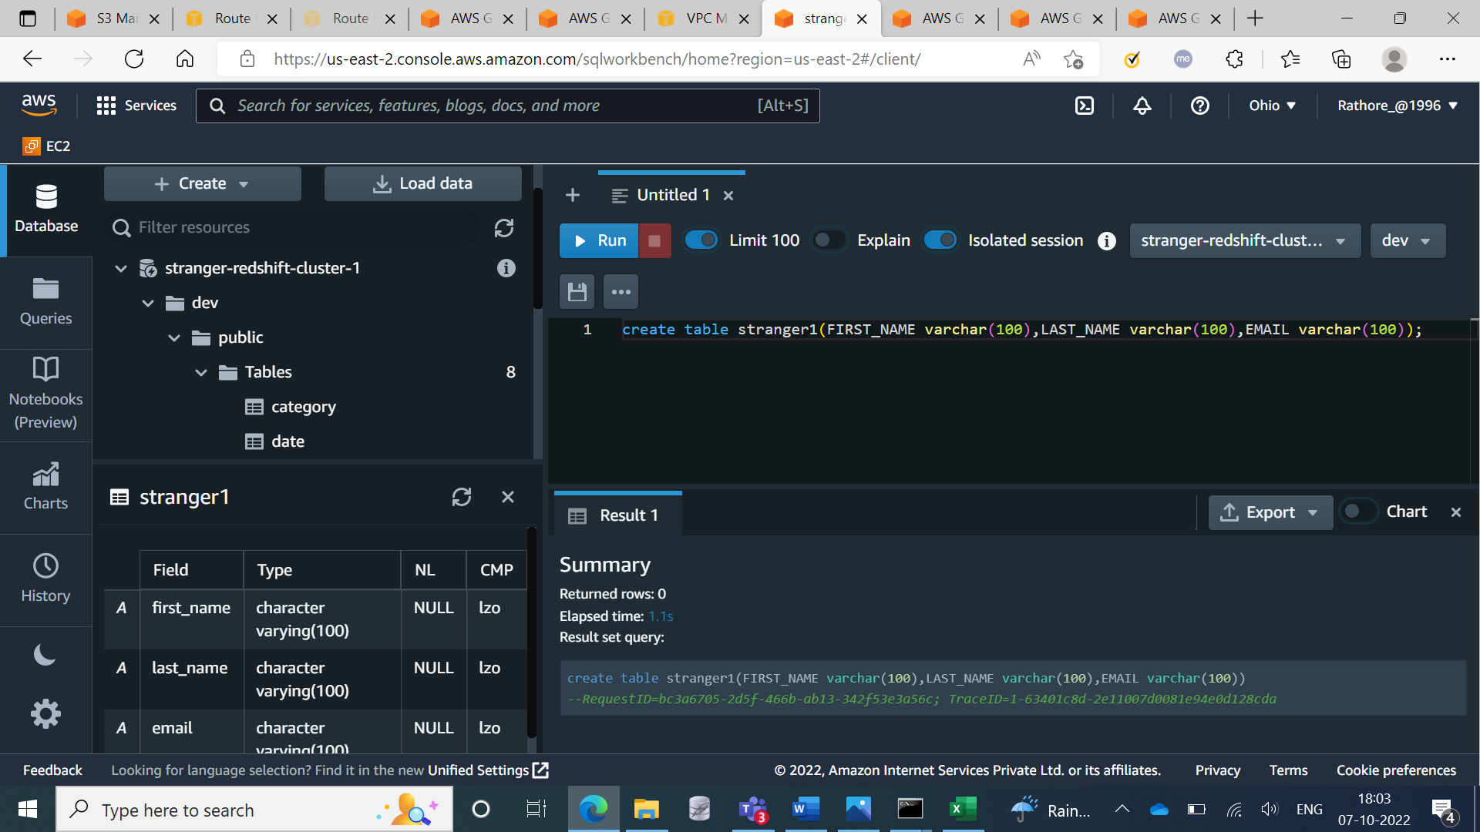

**Step 7:** Created another crawler for the destination

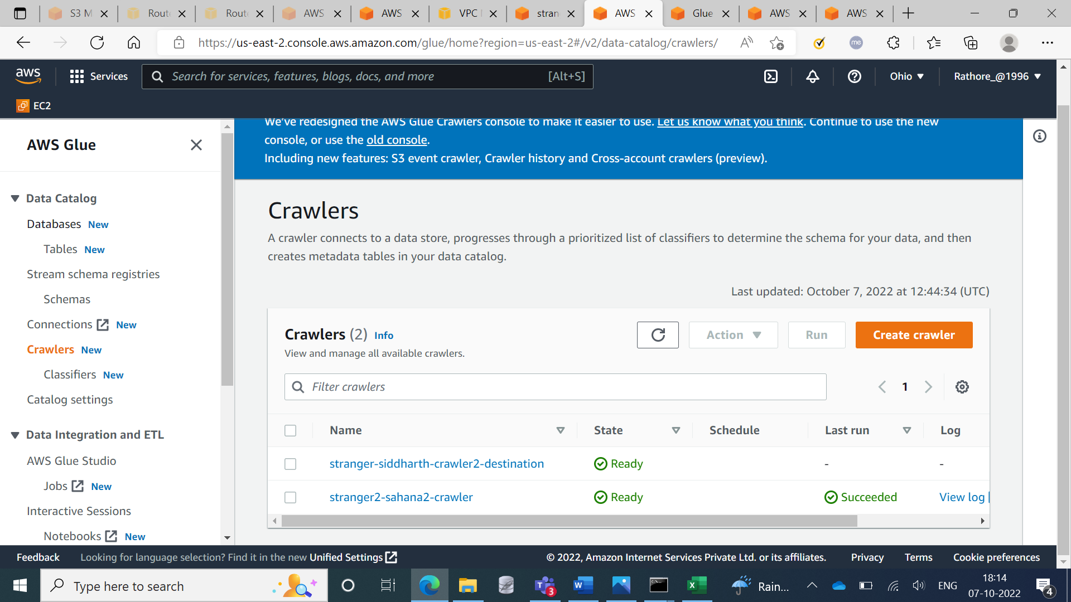

**Step 8:** Details of 2nd Crawler

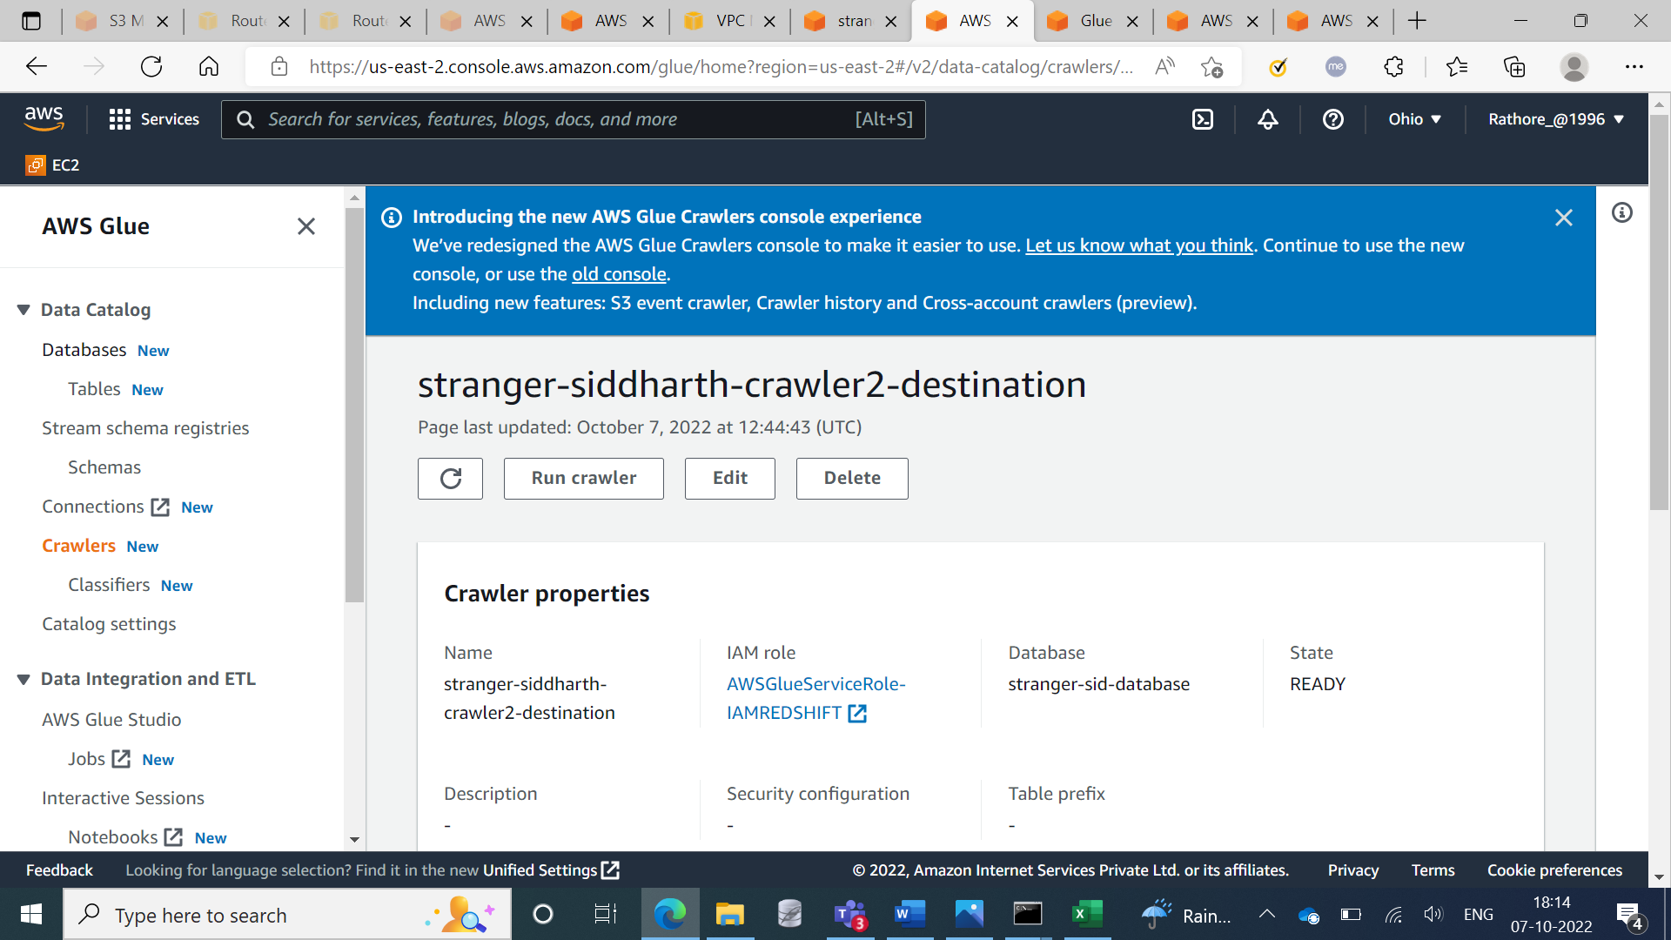

**Step 9:** Updating the security group of VPC2

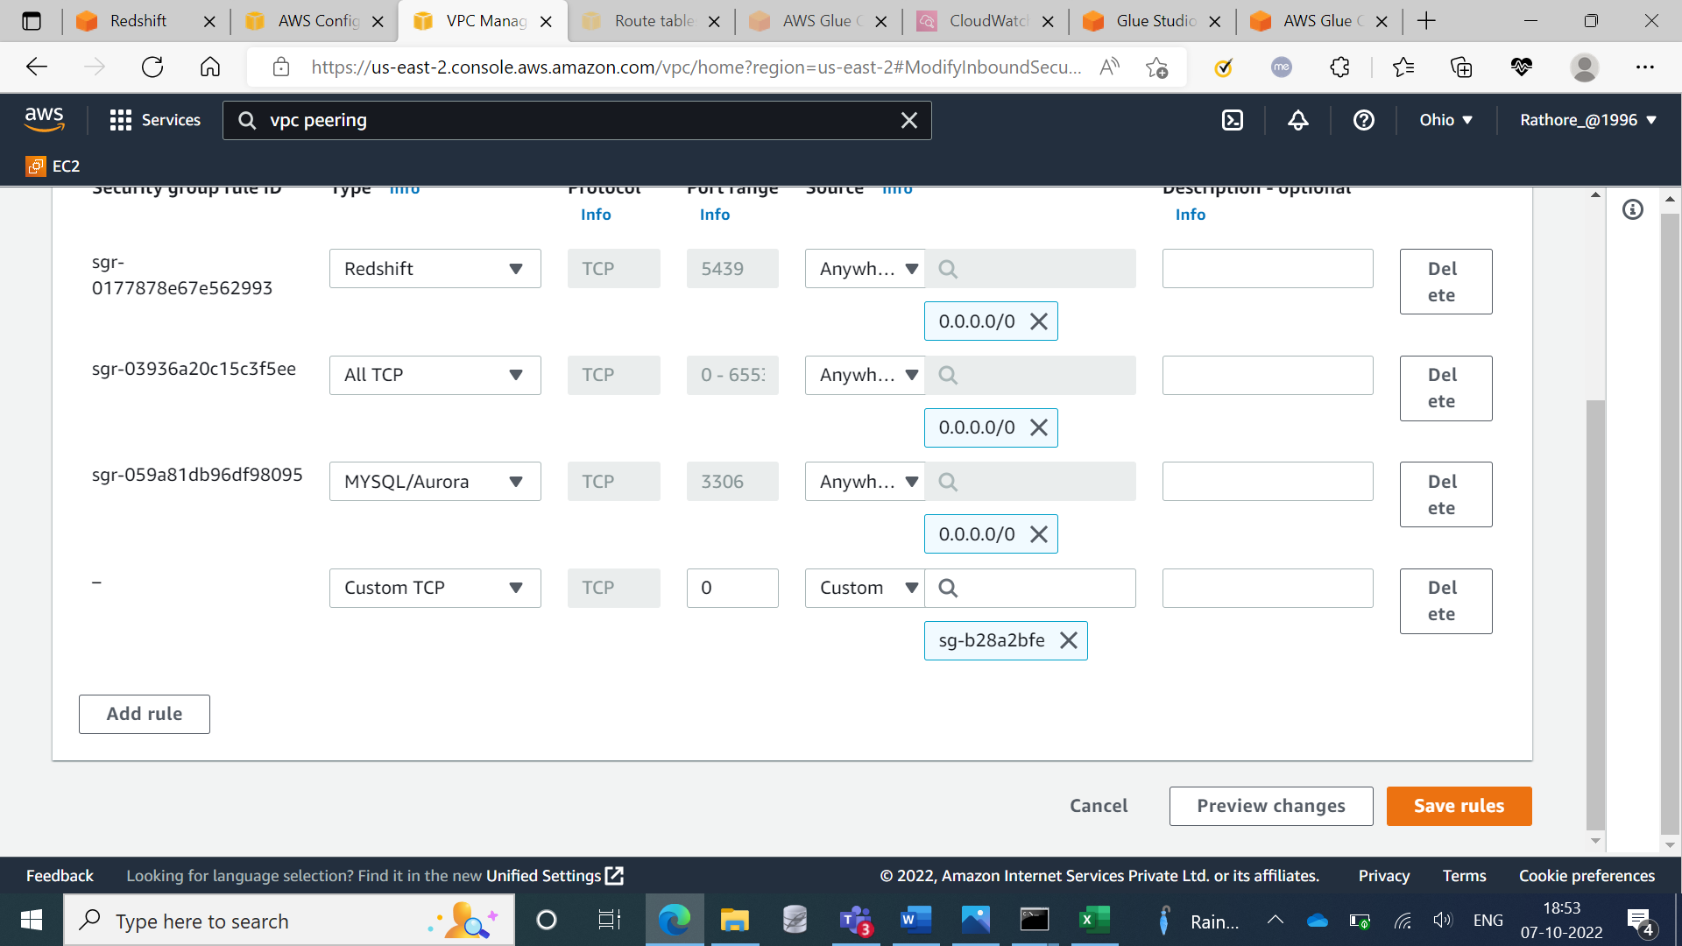

**Step 10:** Created Endpoints

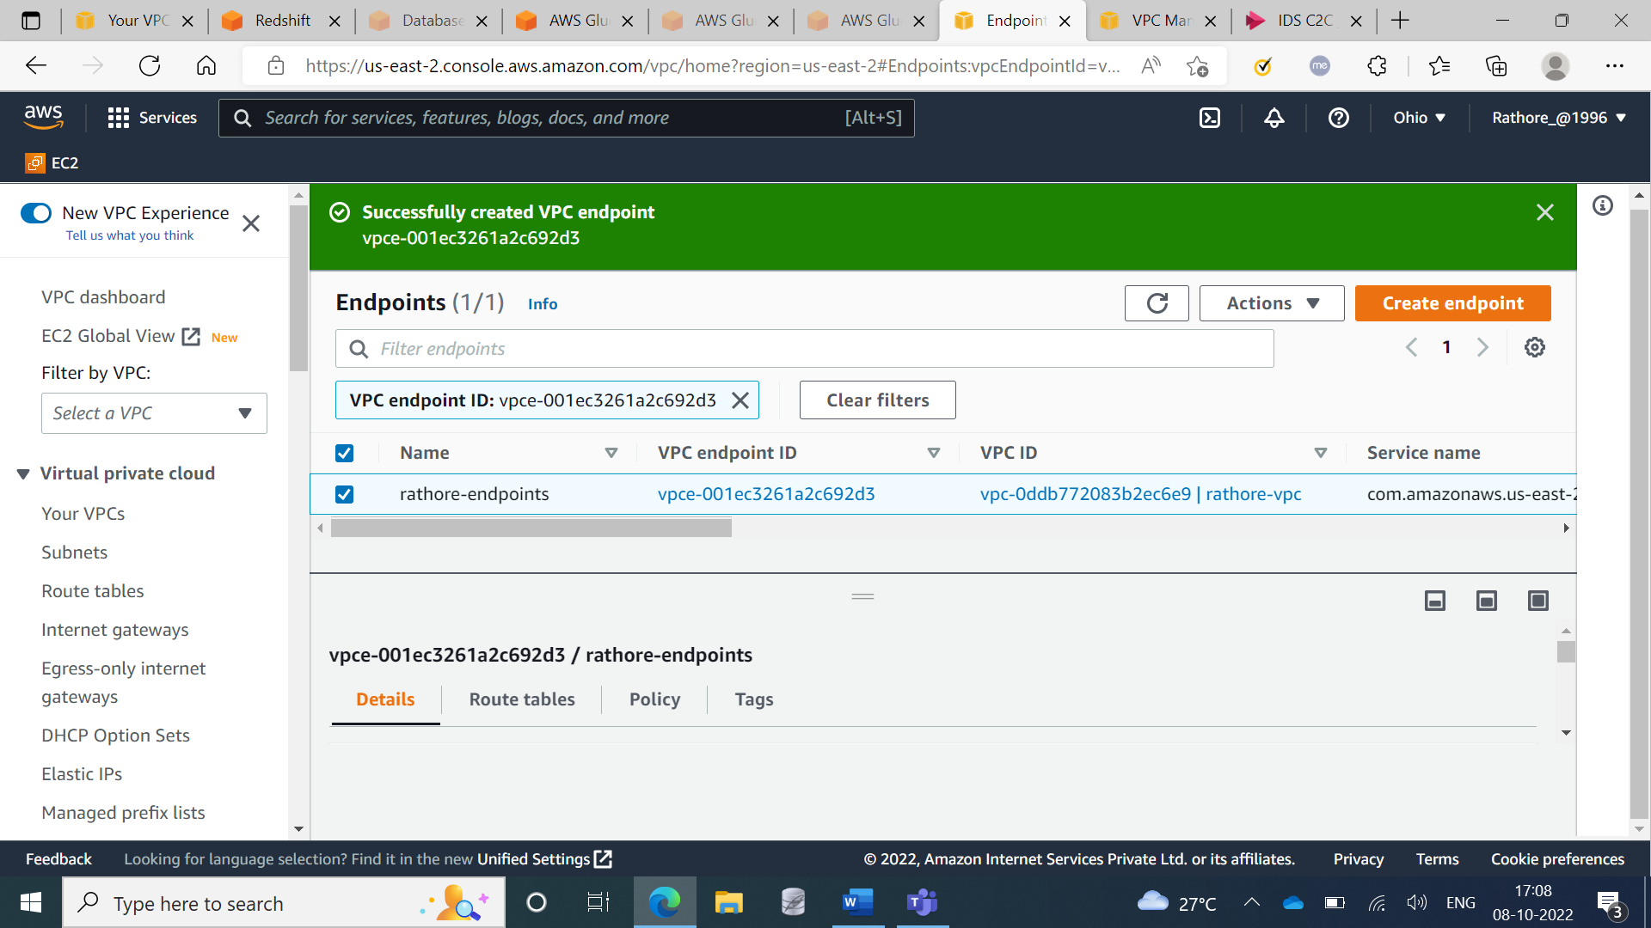

**Step 11:** Executing the query in Amazon redshift query editor

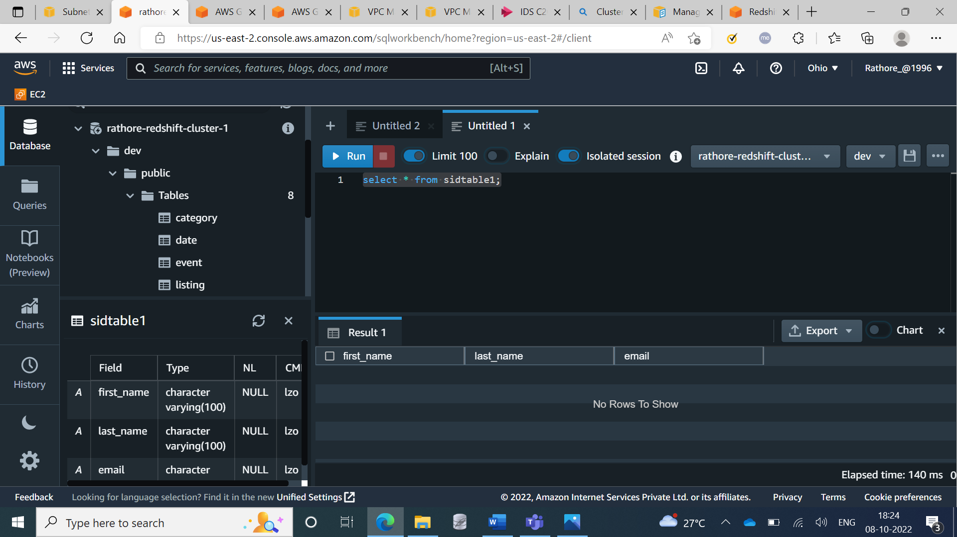

**Step 12:** Creating connectors

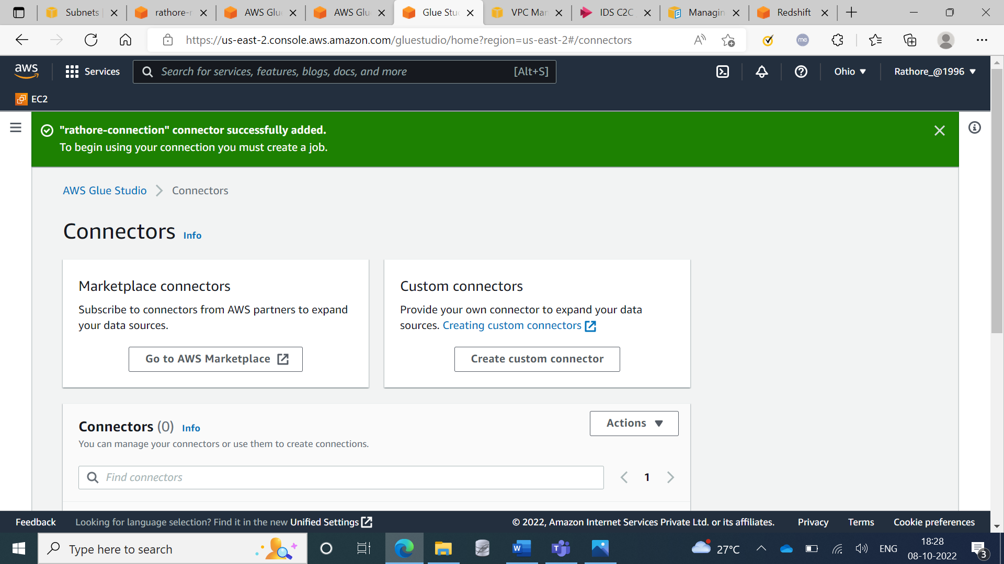

**Step 13:** Crawlers executed successfully

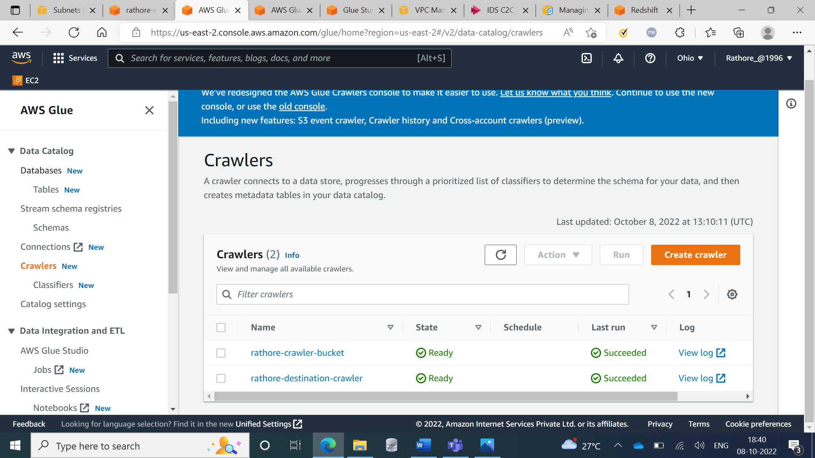

**Step 14:** Created Job

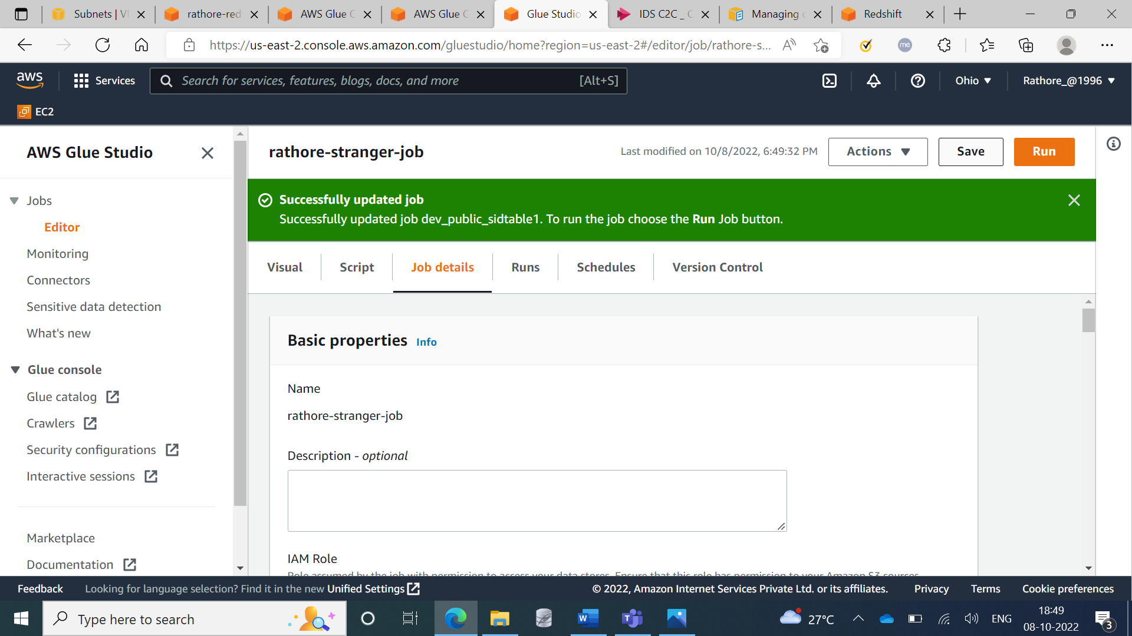

**Step 15:** Job Started

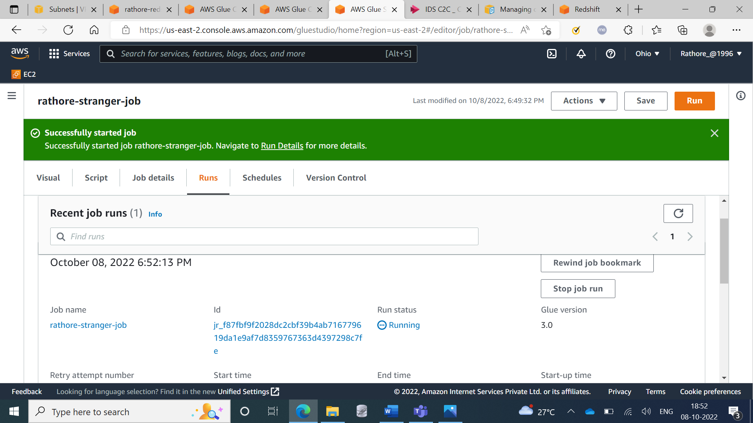

**Step 16:** Executed the query and showing the results in Amazon Redshift

